Rainbow Science: Rainbow Peephole
Inspired by The Physics Teacher’s
“Two Simple Activities to Bring Rainbows into the Classroom” by Hakan Isik and Kemal Yurumezoglu

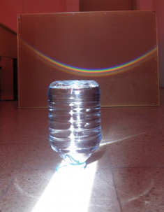
Description: Students explore diffraction and white light.

Purpose: Students will observe diffraction and realize that white light is made up of all colors.

NGSS Connections:
Disciplinary Core Ideas & Performance Expectations
- ESS2.D: Weather and Climate
- PS4.B: Electromagnetic Radiation
Crosscutting Concepts:
- Cause and Effect
- Patterns
- Structure and Function
Science and Engineering Practices:
- Constructing Explanations and Designing Solutions
- Scientific Knowledge is Based on Empirical Evidence
- Obtaining, Evaluating, and Communicating Information
Performance Expectations: Waves and Their Applications in Technologies for Information Transfer (1-PS4)
- 1-PS4-3
- MS-PS4-2

Materials:
- Rainbow Peephole (OSA Optics Suitcase)
or diffraction gratings or “rainbow glasses”
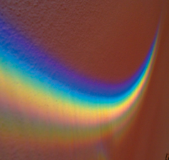
- Water bottle with a coned bottom, filled with water
- White light or flashlight
- Monochromatic light: party bulb lights work well
- Colored pencils: ROYGBIV

Advanced Preparation:
- Part 2 requires bright sunlight in the classroom.

Lab Activities for Students: Rainbow Peephole

PART 1: Rainbow Peephole

- Consider the following questions: Where and how do you see rainbows? What does this suggest about where color comes from? What is the difference between a white light and a blue light? Have you ever seen a rainbow in the sky, or formed by a sprinkler or mister? White light is a combination of all colors and all frequencies, whereas blue light is just one color/frequency.
- Place the Rainbow Peephole (or other diffraction grating) over your eye, and look at a white light. Look to the side of the light, and draw what you see:
- How do you think the peephole works? How is this similar to other objects that create rainbow patterns?
You are seeing all of these colors because the white light you are used to seeing is in fact made up of all of the colors. White light is not the absence of color, but rather the combination of all colors! The Rainbow Peephole simply spreads out the colors so you can see each of them individually.
- Try looking at a light that is only a single color. What do you see? Is there a rainbow, like with the white light? Why, or why not? Draw a picture in the box below. There is still only one color. The diffraction grating does not create a rainbow, it simply spreads out all of the colors that are already in the light that enter it. If the light entering the peephole is monochromatic, that is all you will see.
PART 2: Rainbow Bottle
- Place the full water bottle upside down in a ray of bright sunlight. What do you see on the wall behind the bottle? This should form a nice rainbow on the wall – you may need to spend a minute adjusting it.
- What is a rainbow? What is necessary to create one? (Hint: Think about the activities we just did with the Rainbow Peephole! A rainbow is simply when sunlight gets diffracted by passing through another medium (like water particles in the air) and the white light gets spread out into all of its component colors.

