Glowstick Science: Glowstick Color Lab
Inspired by The Physics Teacher’s
“Glow Sticks: Spectra and Color Mixing” by Jennifer Birriel and Ignacio Birriel
and
“As Easy as R, G, B” by Leonard Parsons

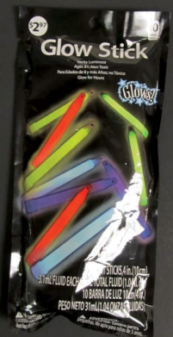
Description: Students explore mixing light with glow sticks.

Purpose: Students will observe addition of light with the glow sticks, and will understand the difference between mixing light and mixing pigment.

NGSS Connections:
Disciplinary Core Ideas:
- PS4.B: Electromagnetic Radiation
Crosscutting Concepts:
- Cause and Effect
- Patterns
Science and Engineering Practices:
- Constructing Explanations and Designing Solutions
- Scientific Knowledge is Based on Empirical Evidence
Performance Expectations: Waves and Their Applications in Technologies for Information Transfer (1-PS4)
- 1-PS4-2
- 4-PS4-2

Materials:
- Glow sticks (red, green, and blue)
- Protective latex/non-latex gloves
- Protective goggles
- A toothpick or unbent paper clip
- A pipette/dropper
- A sharp knife
- Transparent plastic overhead sheet
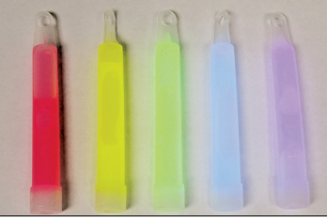
- Yellow, magenta, and cyan highlighters
- Clear or translucent plastic cups
- Various colors of markers
- Optional: Printer ink (cyan, yellow, magenta)
Advanced Preparation:
- The chemicals inside of glow sticks can cause mild inflammation with direct contact to the skin. Ensure that children wear gloves, and wash their hands thoroughly after performing this activity. Contact poison control immediately if the liquid swallowed.
- The chemicals in this lab do stain clothing, so it might be advisable to let children (and parents) know ahead of time, so that they wear something appropriate.
- Immediately before class, thoroughly prepare an appropriate number of glow sticks by cracking the tube inside them, shaking vigorously, and then cutting off the end with your knife and pouring the liquid into a cup. Each group should have one cup each with red, green, and blue liquid. If possible, remove any shards of glass from the cup that fell out of the glow stick with the liquid. Still, ensure that the students do not stick their hands in the cups as there may still be glass and the liquid itself is mildly corrosive.
- Make the room as dark as possible during the lab. Heavy-duty garbage backs can be used to cover the windows if the blinds do not keep enough light out of the classroom.

Lab Activities for Students: Glowstick Color Lab

Pre-Lab:

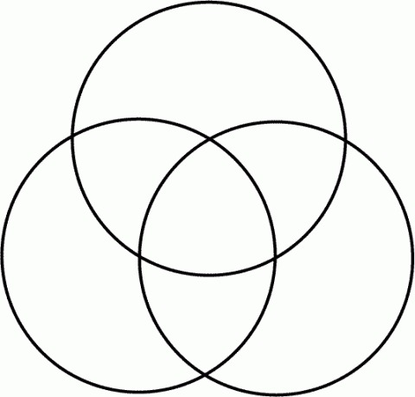
- Below, use the provided highlighters to review what you have learned about mixing the primary colors of pigment (magenta, cyan, and yellow). Fill each circle with one color, and observe what happens when they get mixed up together. Use yellow first, so as to avoid staining the yellow marker with the other colors. The combined colors should ideally be red, green, blue, and black. You can do this part of the activity by combining drops of printer ink mixed into water instead of using markers to mix pigment.
In the following activity, you will learn about the difference between mixing pigment (things like markers, paint, and ink – things that do not give off their own light) and mixing light by combining different colors of glow stick.
- The primary colors of light are red, green, and blue. Make a prediction what you will see when you mix each of the colors: Students will likely predict that light will mix like pigment, ie….
Red + Green = ________________ Students might guess brown or purple; correct is yellow.
Green + Blue = ________________ Students might guess teal or turquoise; correct is cyan.
Blue + Red = ________________ Students might guess purple; correct is magenta.
Red + Blue + Green = ________________ Students might guess brown; correct is white.
Lab: Teachers will need to turn off the lights for this. Ensure that students are all wearing gloves and protective goggles. Each group should have one shared worksheet under the plastic, as well as one other for each student where they can write their predictions and results.

- Wait until all of the lights are off. You should have in front of you three cups containing each of the three colors of glow liquid, with a dropper in each. Place your worksheet under the plastic, so that it is protected. You should prepare the cups and droppers ahead of time.
- Take your dropper, and first place 1 drop of each color liquid (use 2 drops of blue because it is dimmer) in the corresponding box on the top row of the worksheet. You should be able to observe the glowing liquid!
- Look at the second row. On the other version of your worksheet, write the color you expect to be created by each combination (what you wrote above). Make sure you mark this on the worksheet as a prediction, because you will now see if you are correct!
- Mix 1 drop each of the indicated colors in each box of the second row (again, use 2 drops of blue). Use your toothpick or paperclip to mix the liquid together. What colors are formed? Were your predictions correct? Write the actual colors in their boxes on your worksheet, under your prediction. Use the markers to color a spot in each box with the color that you observed. As above, the glow stick liquid will mix like light rather than like pigment.
- Make new predictions for the colors you will create in the third row. Write them here as well as on your worksheet: All three combinations will make white once mixed thoroughly.
Magenta + Green = ________________
Yellow + Blue = ________________
Cyan + Red = ________________
- Try it! Were your predictions right? What is going on here? Does the glow stick liquid mix like pigment, or does it mix differently? Why? Because the glow liquid gives off its own light (it is luminous), it mixes like light, not like pigment. Combining all of the colors would give white light!
- Turn the lights back on!
Post-Lab:

- What names are given to the three colors in the first row of the chart? The Primary colors.
- Why are these three colors important when adding colors of light? They are the primary colors of light – the three colors that our eyes mainly pick up. All other colors can be formed by combinations of these three colors.
- What names are given to the three colors that are produced in the second row of the chart? Magenta, cyan, and yellow: the Secondary colors.
- What color is produced in the bottom row in all three cases? What were the original colors required to produce this color? White. In all three cases, students combined all three: red, green, and blue.
- When two colors of light are added together to produce white light they are called complementary colors. List all three pairs of complementary colors of light. Cyan + Red, Yellow + Blue, Magenta + Green
- Compare your lab results to the pre-lab predictions that you made. Answer the following questions again, now that you have completed the lab:
What color will you get when you mix a green light and a red light? ____________________ Yellow
What color will you get when you mix a green light, a red light, and a blue light? ______________ White
What color will you get when you mix a yellow light and a blue light? ____________________ White
- You have likely heard that “yellow and blue make green.” Does that hold true in this case? Describe a situation in which yellow and blue combine to give green. How is this different from what you did in this lab? This is not true in this case, although it would be with any pigment including paint, highlighter, or printer ink.
- When you add red, blue, and green paint together do you get the same result that you did in this lab? How are the activities in this lab different from mixing paints together? (Hint: think about the materials you used!) No – mixing paint is mixing pigment, whereas this is mixing light. Paint is not luminous; it can reflect certain colors of light but not give off its own.

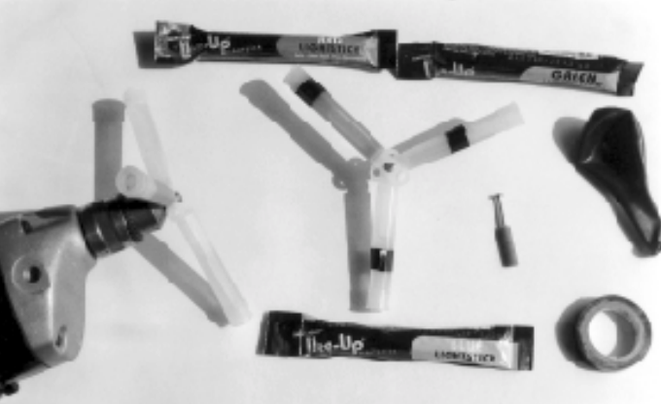
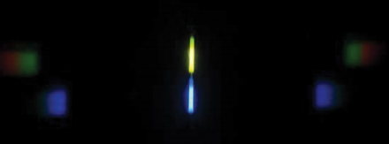
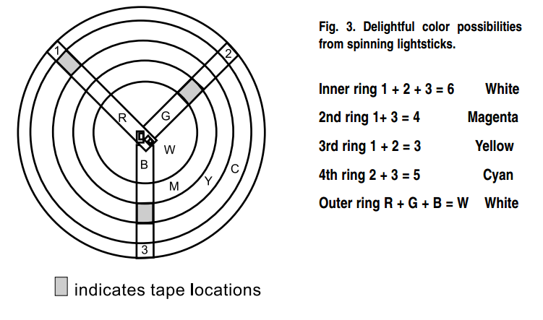

Red | Blue | Green
Magenta | Yellow | Cyan
Magenta + Green | Yellow + Blue | Cyan + Red

