Candy Science: Color and Reflection
Inspired by The Physics Teacher’s
“A Student-Centered Interactive Color Quiz” by Edward P. Wyrembeck

Description: Students learn about how we perceive color by shining pure, colored light on candies and observing how their appearances change.

Purpose: Students will describe how pigments are similar to filters (and work by subtraction of light). They will be able to predict the perceived color of an object under different colors of light. They will better understand why things look a specific color.
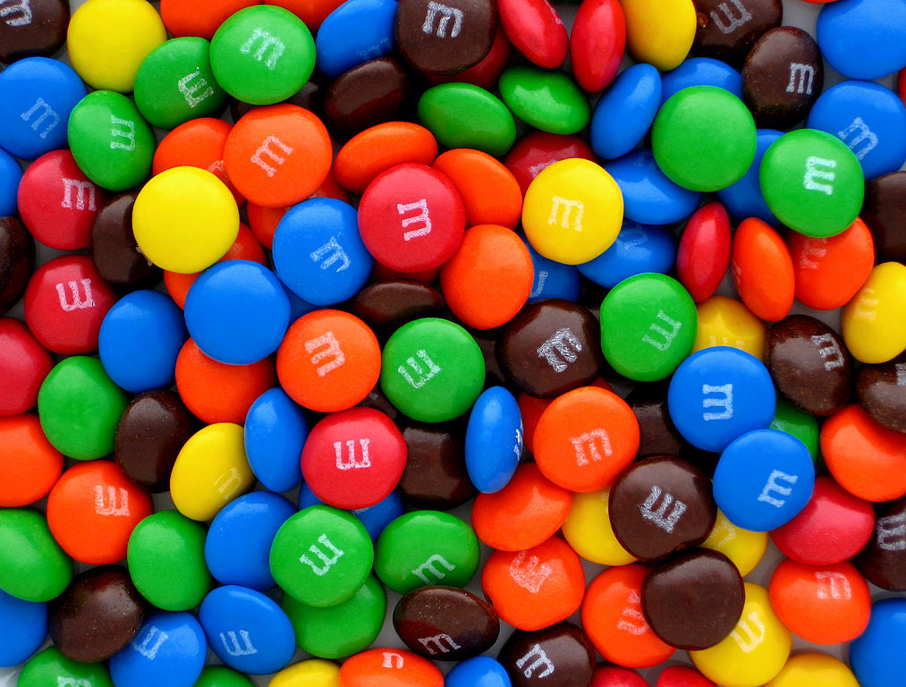
NGSS Connections:
Disciplinary Core Ideas:
- PS4.B: Electromagnetic Radiation
Crosscutting Concepts:
- Structure and Function
- Cause and Effect
Science and Engineering Practices:
- Planning and Carrying Out Investigations
- Constructing Explanations and Designing Solutions
- Developing and Using Models
Performance Expectations: Waves and Their Applications in Technologies for Information Transfer (1-PS4)
- 1-PS4-2, 1-PS4-3
- 4-PS4-2
- MS-PS4-2

Materials:
- 3 x monochromatic light source(s) – any of the following:
  - Variable-color LED lamp and controller (red, green, blue, yellow, magenta, cyan, white) (ideal)
  - Smartphone “flashlight-type” app that produces monochromatic screen colors
  - Monochromatic LED flashlights (red, green, blue, can add yellow, magenta, cyan, white)
  - Flashlights covered with filters (less ideal)
- M&M’s (or other candies that have primary colors: red, green, and blue)
- Gummy Bears (or translucent candies that are red, green, yellow, and clear – Haribo brand gummy bears have the necessary colors)
- Yellow, magenta, and cyan highlighters
- Colored Pencils

Advanced Preparation:
- Prepare small quantities of about 30-50 M&M’s per group.
- Ensure that students do not have allergies to chocolate if using candy-coated chocolate candies.
- Darken the room completely so that no extra white light makes it through – otherwise the sorting activity will not be effective!
Modifications:
- Avoid using edible foods in laboratory settings where contamination might occur.
- Alternative, colored small objects could include pieces of construction paper or buttons

Lab Activities for Students: Color and Reflection

PART 1: Pigment and Light Mixing

- Use highlighters to mix the primary colors of pigment (magenta, cyan, and yellow – do yellow first!). Write down what each combination gives you.
Pigments should mix to give: yellow + magenta = red, yellow + cyan = green, and cyan + magenta = blue). All pigments mixed together give black/brown. If highlighter pens are unavailable, this can be best observed by mixing cups of water tinted with color from an ink printer refill.
- Use the LED lamps to mix the primary colors of light (red, blue, green). Write down what each combination gives you. What is the difference between mixing light and color?
Light should mix to give: red + blue = magenta, red + green = yellow, and blue + green = cyan. This can be easily observed by shining the LED lamps on the ceiling or desk.

Pigment Light
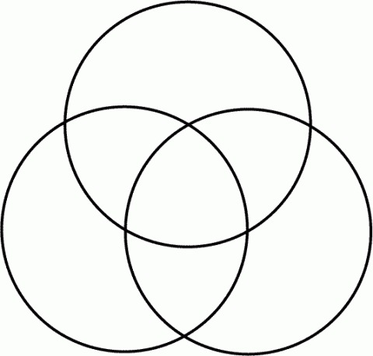

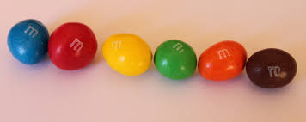

PART 2: M&M’s Color Sorting
- Turn out the lights, and turn on your LED lamp to only red, green, or blue.
Make sure that all students are using the same color at the same time.
Source: Bribri2B. Licensed under CreativeCommons
- Try to sort your M&M’s into groups based on their observed color. You might not be able to make 6 groups; that is fine.
Allow students about 90 seconds to sort 30-50 candies. Some students will have greater perception of color variations, so the groupings will be mixed.
- On your table space, circle the groups and label them with the color they appear under the light.
- Turn the lights back on, and observe the color of M&M’s in each sorted group. Why would they be grouped that way? (Hint: think about what color light was shining on them.)
Ex: Under red light, students will most likely make the following groups: (1) red/yellow/orange candies, and (2) blue, green, and brown candies. This is because the red/yellow/orange candies contain red pigment, and therefore reflect the color and appear “bright.” The blue, green, and brown candies absorb the color and appear “dark.”
- Label each group with the number and color of M&M’s in each group on the student worksheet.
- Redo steps 2-6 with each different color light (red, green, blue). Note how the M&M’s look different under different colored lights!

PART 3: White Light

- Try to draw what colors a white and black M&M would reflect to our eyes under white light. (Hint: What colors make up white light? If we see the M&M as white, what color(s) are entering our eyes?) Solutions are included. The white M&M will reflect all colors of light, and the black M&M won’t reflect any (indicated by the X)..

- Try to draw how red and green M&M’s will appear to our eyes under white light (composed of red, green, and blue), as well as under pure red light and under pure blue light. Again, the solutions are all of the lines coming off of the M&Ms. Note that students may try to solve this by saying that red light reflects off of a green M&M as green light, or that blue light reflects off of a red M&M as red light. If students are having trouble with this, offer them the opportunity to try the practical experiment again with the specific color light and M&M they are struggling with. This should allow them to see that the green M&M doesn’t reflect any red light.

White Light Red Light Blue Light

Big Idea: When we see colors of an object that does not produce its own light, we are simply seeing light that reflects off of the object coming back to our eye.

PART 4: Light Blockers

- Use the LED lamps to find out what colors of light get through (transmit) each color of gummy bear. You can do this by checking if the bear casts a shadow, or if some color of light gets through. What colors get blocked? Why? Below each color bear, draw which color of light gets transmitted through the bear!

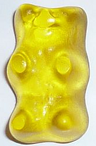
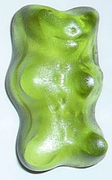
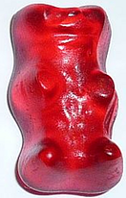

Big Idea: When light goes into an object, some of the light gets absorbed and some of it gets transmitted based on the medium.

PART 5: Color Filter Ball Game
Assign three students to be red, green, and blue “color filters” – much like the gummy bears. Ask them to think about what colors they will and will not allow through. Assign one student to be a “photoemitter,” who sends out different colored light towards the “filters.” Line up the filters in some order. Have the photoemitter throw one ball to the first filter. If the filter should allow the light to pass, have them throw it to the next filter, and so on. If the filter should stop the light, they should set the ball down at their feet. Allow the filters to rearrange periodically, so that the same color light does not always stop at the same place.

