Sound Wave Science
Inspired by The Physics Teacher’s:
“Classroom Materials from the Acoustical Society of America”
by W. K. Adams, A. Clark, and K. Schneider

Description: Students will model waves using their bodies, slinkies, a plate of water, a computer simulation, and by creating their own waves using mixed materials.

Purpose: Students will create a model of waves transferring energy and describe the relationship between speed, wavelength, and frequency.

NGSS Connections:
Disciplinary Core Ideas:
- 4-PS4-1 Waves and Their Applications in Technologies for Information Transfer
Cross Cutting Concepts:
- Patterns
- Energy and Matter
Science and Engineering Practices:
- Developing and Using Models
Performance Expectations: Waves and Their Applications in Technologies for Information Transfer
- 1-PS4-1-Develop a model of waves to describe patterns in terms of amplitude and wavelength and that waves can cause objects to move.

Materials:
- String
- Ping pong balls
- Pipe cleaners
- Slinky
- Plates with water
- Little rubber duckies (optional)
- Wave on a String PhET simulation with device
  - PhET.colorado.edu/sims/html/wave-on-a-string/latest/wave-on-a-string_en.html

Modifications:
- Various materials can be provided for student model construction
- This lesson can be completed in either a small group or individually

Sound Wave Science

Student Worksheet
Note to teacher: Italicized commentary are notes for teachers. Red statements show sample correct student responses. Highlighted yellow items are areas where students are likely to get “stumped.

Description: Students will model waves using their bodies, slinkies, a plate of water, a computer simulation, and by creating their own waves using mixed materials.

Purpose: Students will create a model of waves transferring energy and describe the relationship between speed, wavelength, and frequency.

Part I: Human Waves

In a discussion, reflect on the following questions: Close your eyes. Imagine you are sitting outside on a summer day and that pesky mosquito comes and buzzes in your ear. It is flying a few inches from your head, and you can hear the sound in your ear. However, the mosquito making the sound is not in your ear. How does the sound travel from the mosquito to your ear?

Introduce the term medium to your students. Medium is the substance through which a wave travels.

- A medium is the material a wave travels through. Reflect on the lessons you have completed previously. What are the mediums for those waves?

 | Tuning Forks | Pasta | Straw Trombones | Bottles
Medium

- Making waves with our bodies is simple. Our bodies act as the medium, or what the wave travels through. Line up with at least four other people shoulder-to-shoulder. Follow the instructions of your teacher and record your observations.

- Wave Types
This is what it looked like when we made the COMPRESSION wave...

This is what it looked like when we made the TRANSVERSE wave...

At this point, it would be beneficial to do a slinky demonstration of waves both compression and transverse. Show your students that sound actually travels like the first wave they modeled. However, it is easier to represent the waves with particles that move “up and down” rather than “side to side.”

- Reflect on the characteristics of waves below.
Student A started the wave. Did Student A move to where the wave ended?
What moved to the end of the wave?

Return to the wave formation with the entire class. Demonstrate differences in frequency and amplitude.

- Open up the following PhET simulation.
https://PhET.colorado.edu/sims/html/wave-on-a-string/latest/wave-on-a-string_en.html
- Change the setting in the upper right to “no end.”
- Change the setting to “oscillate” in the upper left.

- The string displayed on the computer is how we usually draw sound waves. It may be easier if you decrease the frequency. Pay special attention to one of the green beads. Draw arrows for the motion of the bead below.

Did the green bead move along with the wave?

What is the medium of this wave?

- Considering your human model, the PhET simulation, and consulting with your teacher, completing the following sentence.
A wave is...

Part II: Speed, Frequency, and Wavelength

Students often use the words “speed” and “frequency” interchangeable. However, they are not the same. Ensure that students see from their human modeling that the speed of a wave is “how long it takes a pulse to move across a medium” while the frequency is “how often a pulse is produced.” This activity will help to reinforce that concept.

- As you saw in the computer simulation, a wave is made when pulses are created. Using a deep plate (or wide bowl) filled with water, use your finger to tap once in the middle of the water. Draw what you see in the water.

- Use your finger to tap multiple times. Draw how the waves look different when you tap with a high and a low frequency. Describe these waves.

High Frequency
Low Frequency

High frequency waves are (close together / far apart).

High frequency waves move (faster / slower / same speed) as low frequency waves.
Low frequency waves are (close together / far apart).

Low frequency waves move (faster / slower / same speed) as high frequency waves.

Part III: Individual wave models

- Now that you have a definition of a wave, your next task is to create your own wave model. You may use any of the materials on the list below and any other materials you need as approved by your teacher. By the end, you should have a functioning wave model to show the class.
Available Materials:
- String
- Ping pong balls
- Pipe cleaners
- Slinky
- Trays of water

- Record your ideas below.

This is what our model looks like...
Materials:

- Explain, in words, how the energy was transferred in your model.
Consider what answers may be developmentally appropriate for your students. Many may explain how one object bumped into another.

- Imagine again you are sitting outside and the mosquito comes up to you buzzing. Knowing that sound is a wave, how did the sound travel from the mosquito to your ear?
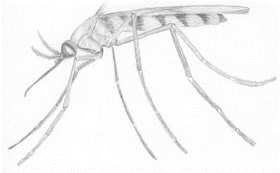
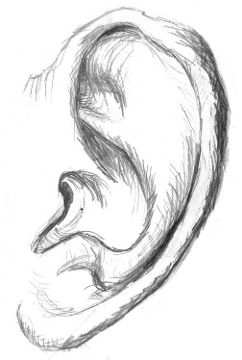

This is how sound traveled to my ear...

