Song Science
Inspired by The Physics Teacher’s:
“Classroom Materials from the Acoustical Society of America”
by W. K. Adams, A. Clark, and K. Schneider

Description: Students will explore sound as a vibration and observe changes in volume through a homemade record player.

Purpose: Students will explore volume by modifying an existing model of a homemade record player to increase the volume.

NGSS Connections:
Disciplinary Core Ideas:
- PS4.A: Wave Properties
Cross Cutting Concepts:
- Cause and Effect
Science and Engineering Practices:
- Planning and Carrying Out Investigations
- Constructing Explanations
Performance Expectations:
- 1-PS4-1. Plan and conduct investigations to provide evidence that vibrating materials can make sound and that sound can make materials vibrate.

Materials:
- Plastic cups (large and mini)
- Push pins
- Pins or needles
- Paper
- Records
- Record player (optional)
Modifications:
- Additional supplies can be given for the engineering of a louder record player.

Song Science

Student Worksheet
Note to teacher: Italicized commentary are notes for teachers. Red statements show sample correct student responses. Highlighted yellow items are areas where students are likely to get “stumped.

Description: Students will explore sound as a vibration and observe changes in volume and amplitude through a homemade record player.

Purpose: Students will explore volume by modifying an existing model of a homemade record player to increase the volume.

Guiding questions:

Safety Note: Be mindful of pins with your students. If project is done as a small-group or individual activity, and not just as a demonstration, consider safety glasses.

- Imagine you have that pesky mosquito buzzing in your ear. After you swat it away, a mosquito with much larger wings replaces it.
I think larger mosquito would sound…

because...

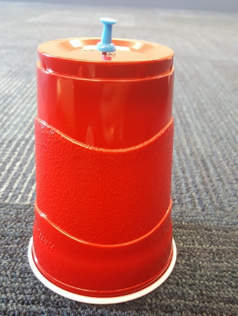

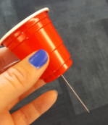
- To see how making a sound source “bigger” changes the what we hear, make a record player:
  - Flip large plastic cup upside down and poke a push pin into the center of bottom of the cup. This will serve as your base for the record player.
  - Set the record on the cup and pin.
  - With another mini plastic cup, poke a pin or needle through the center of the bottom of the cup from the inside.

- To play your record, have one partner hold the base cup of your player and spin the record at a constant pace with your fingers. The second partner should gently touch the tip of the pin in the mini cup on the spinning record.
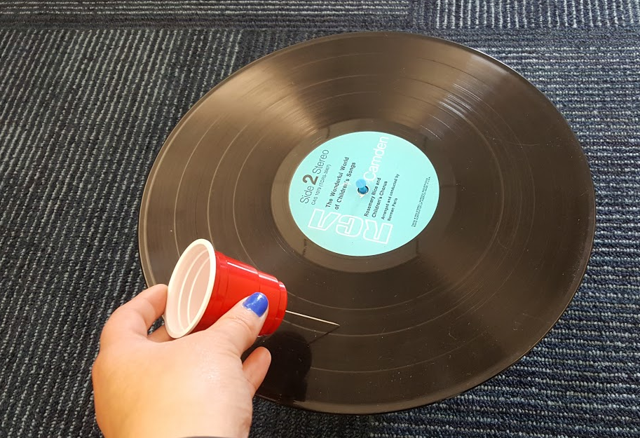

- A record is a piece of round vinyl with grooves engraved that correspond to a song. When a needle sits on top of the record while it is moving, the needle moves with the grooves on the vinyl.
Given this information and your understanding of sound, how do you think your homemade record player create sound?

- Your next task is to use the remaining materials provided by your teacher to make your record player as loud as you can. Record your process below.

Design Modification
How did you change it?
Performance
How did it work?

- When you change the volume of sound, you are changing the amplitude of the wave.

Consider doing another slinky demonstration for your students so they can visually see the change in amplitude, or height of the wave.
Before I changed my record player, the sound wave looked like this...
After I changed my record player, the sound wave looked like this...
I think my new design increased the volume because...

- Reflect on the questions below.

Consider reflecting back to the tuning forks and frequency. If you strike the fork harder to create a louder sound, the frequency and pitch are the same as when you strike it softly.

When you changed the volume of the sound, did you change the frequency? How do you know?

