Jelly Filter Science: Exploring Color with Colored Gelatin and Color Vision
Inspired by The Physics Teacher’s
“A Student-Centered Interactive Color Quiz” by Edward P. Wyrembeck
and by the work of Diane Riendeau

Description: Students explore color and filters using colored gelatin and the online PhET simulation.

Purpose: Students will learn about addition of color and how different colors of light transmit through or get absorbed by different materials.

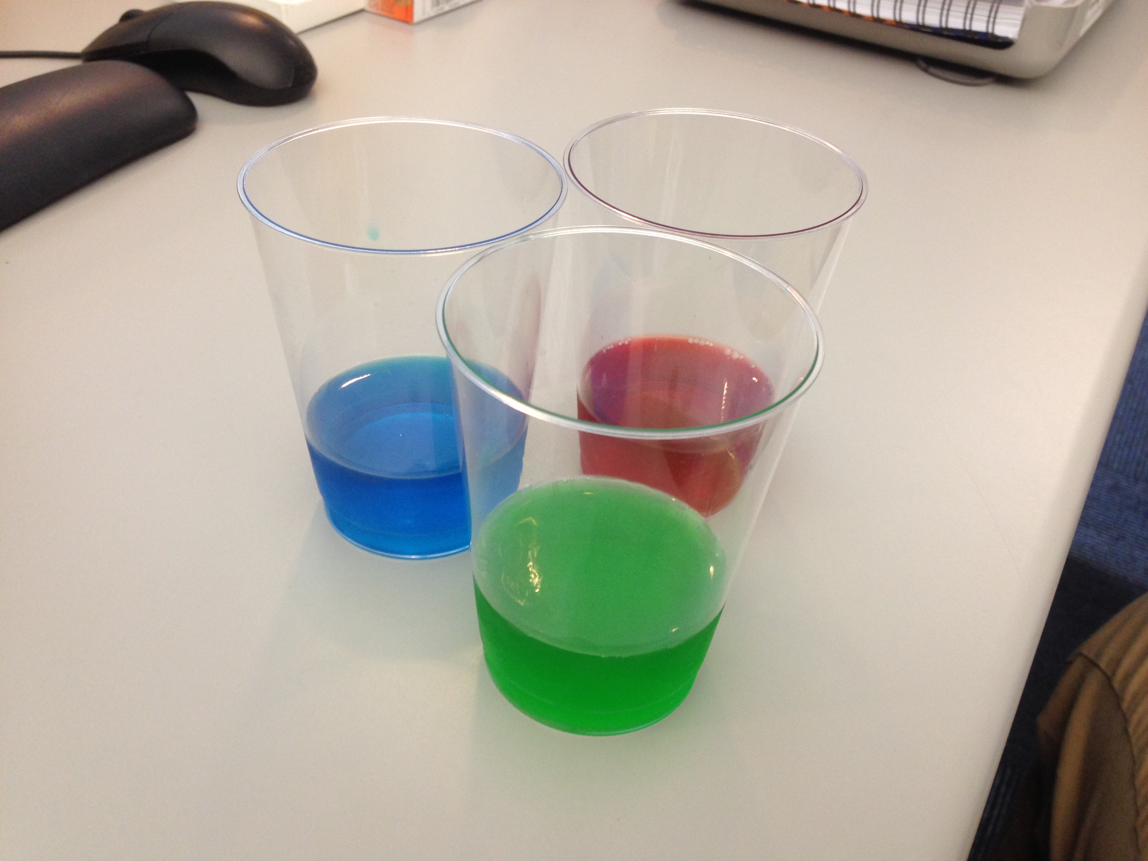NGSS Connections:
Disciplinary Core Ideas:
- PS4.B: Electromagnetic Radiation
Crosscutting Concepts:
- Cause and Effect
- Patterns
Science and Engineering Practices:
- Planning and Carrying Out Investigations
- Analyzing and Interpreting Data
- Engaging in Argument from Evidence
- Obtaining, Evaluating, and Communicating Information
Performance Expectations: Waves and Their Applications in Technologies for Information Transfer (PS4)
- 4-PS4-2
- MS-PS4-2

Materials:
- Cherry, Lime, and Berry Blue Jell-O brand flavored gelatin
- Clear plastic cups
- A computer with internet (for simulation/slides) and a projector (or monitor that students can see)

Advanced Preparation:
- Prepare the Jell-O in the bottom of clear disposable cups, about 1”-1.5” thick. Ensure that the Jell-O is set thick in the cups, as it is easier to handle.
Modifications:
- Students can play with the PhET simulation themselves, or it can be a demo done by the teacher. This will depend on the availability of materials and the age of the students.
- Alternate gelatin brands can be used instead of Jell-O brand, but be aware that the colors may not be the same and your results may vary.

Lab Activities for Students: Jell-O Filters and Color Vision

PART 1: Jell-O Filters

Show slide 1: Primary Colors
- An image will be projected at the front of the class. Take a look at this image, and then, in the table provided, write a prediction about what you think the image will look like through the corresponding filter. Then, make a hypothesis (potential explanation) for why you expect to see that. Finally, color the image the way you see it through the filter.
 | Prediction  “How will the image look different?” | Hypothesis  “Why will the image look different?” | Observation
Red Filter | Students will likely make predictions as though they are mixing pigments; they might predict that the red filter will create brown and purple when looking at green and blue. Alternatively, students might assume that it is the same as mixing light. | Students might say things like “red and blue makes purple!” They will eventually realize that a color filter is not the same as mixing pigments.
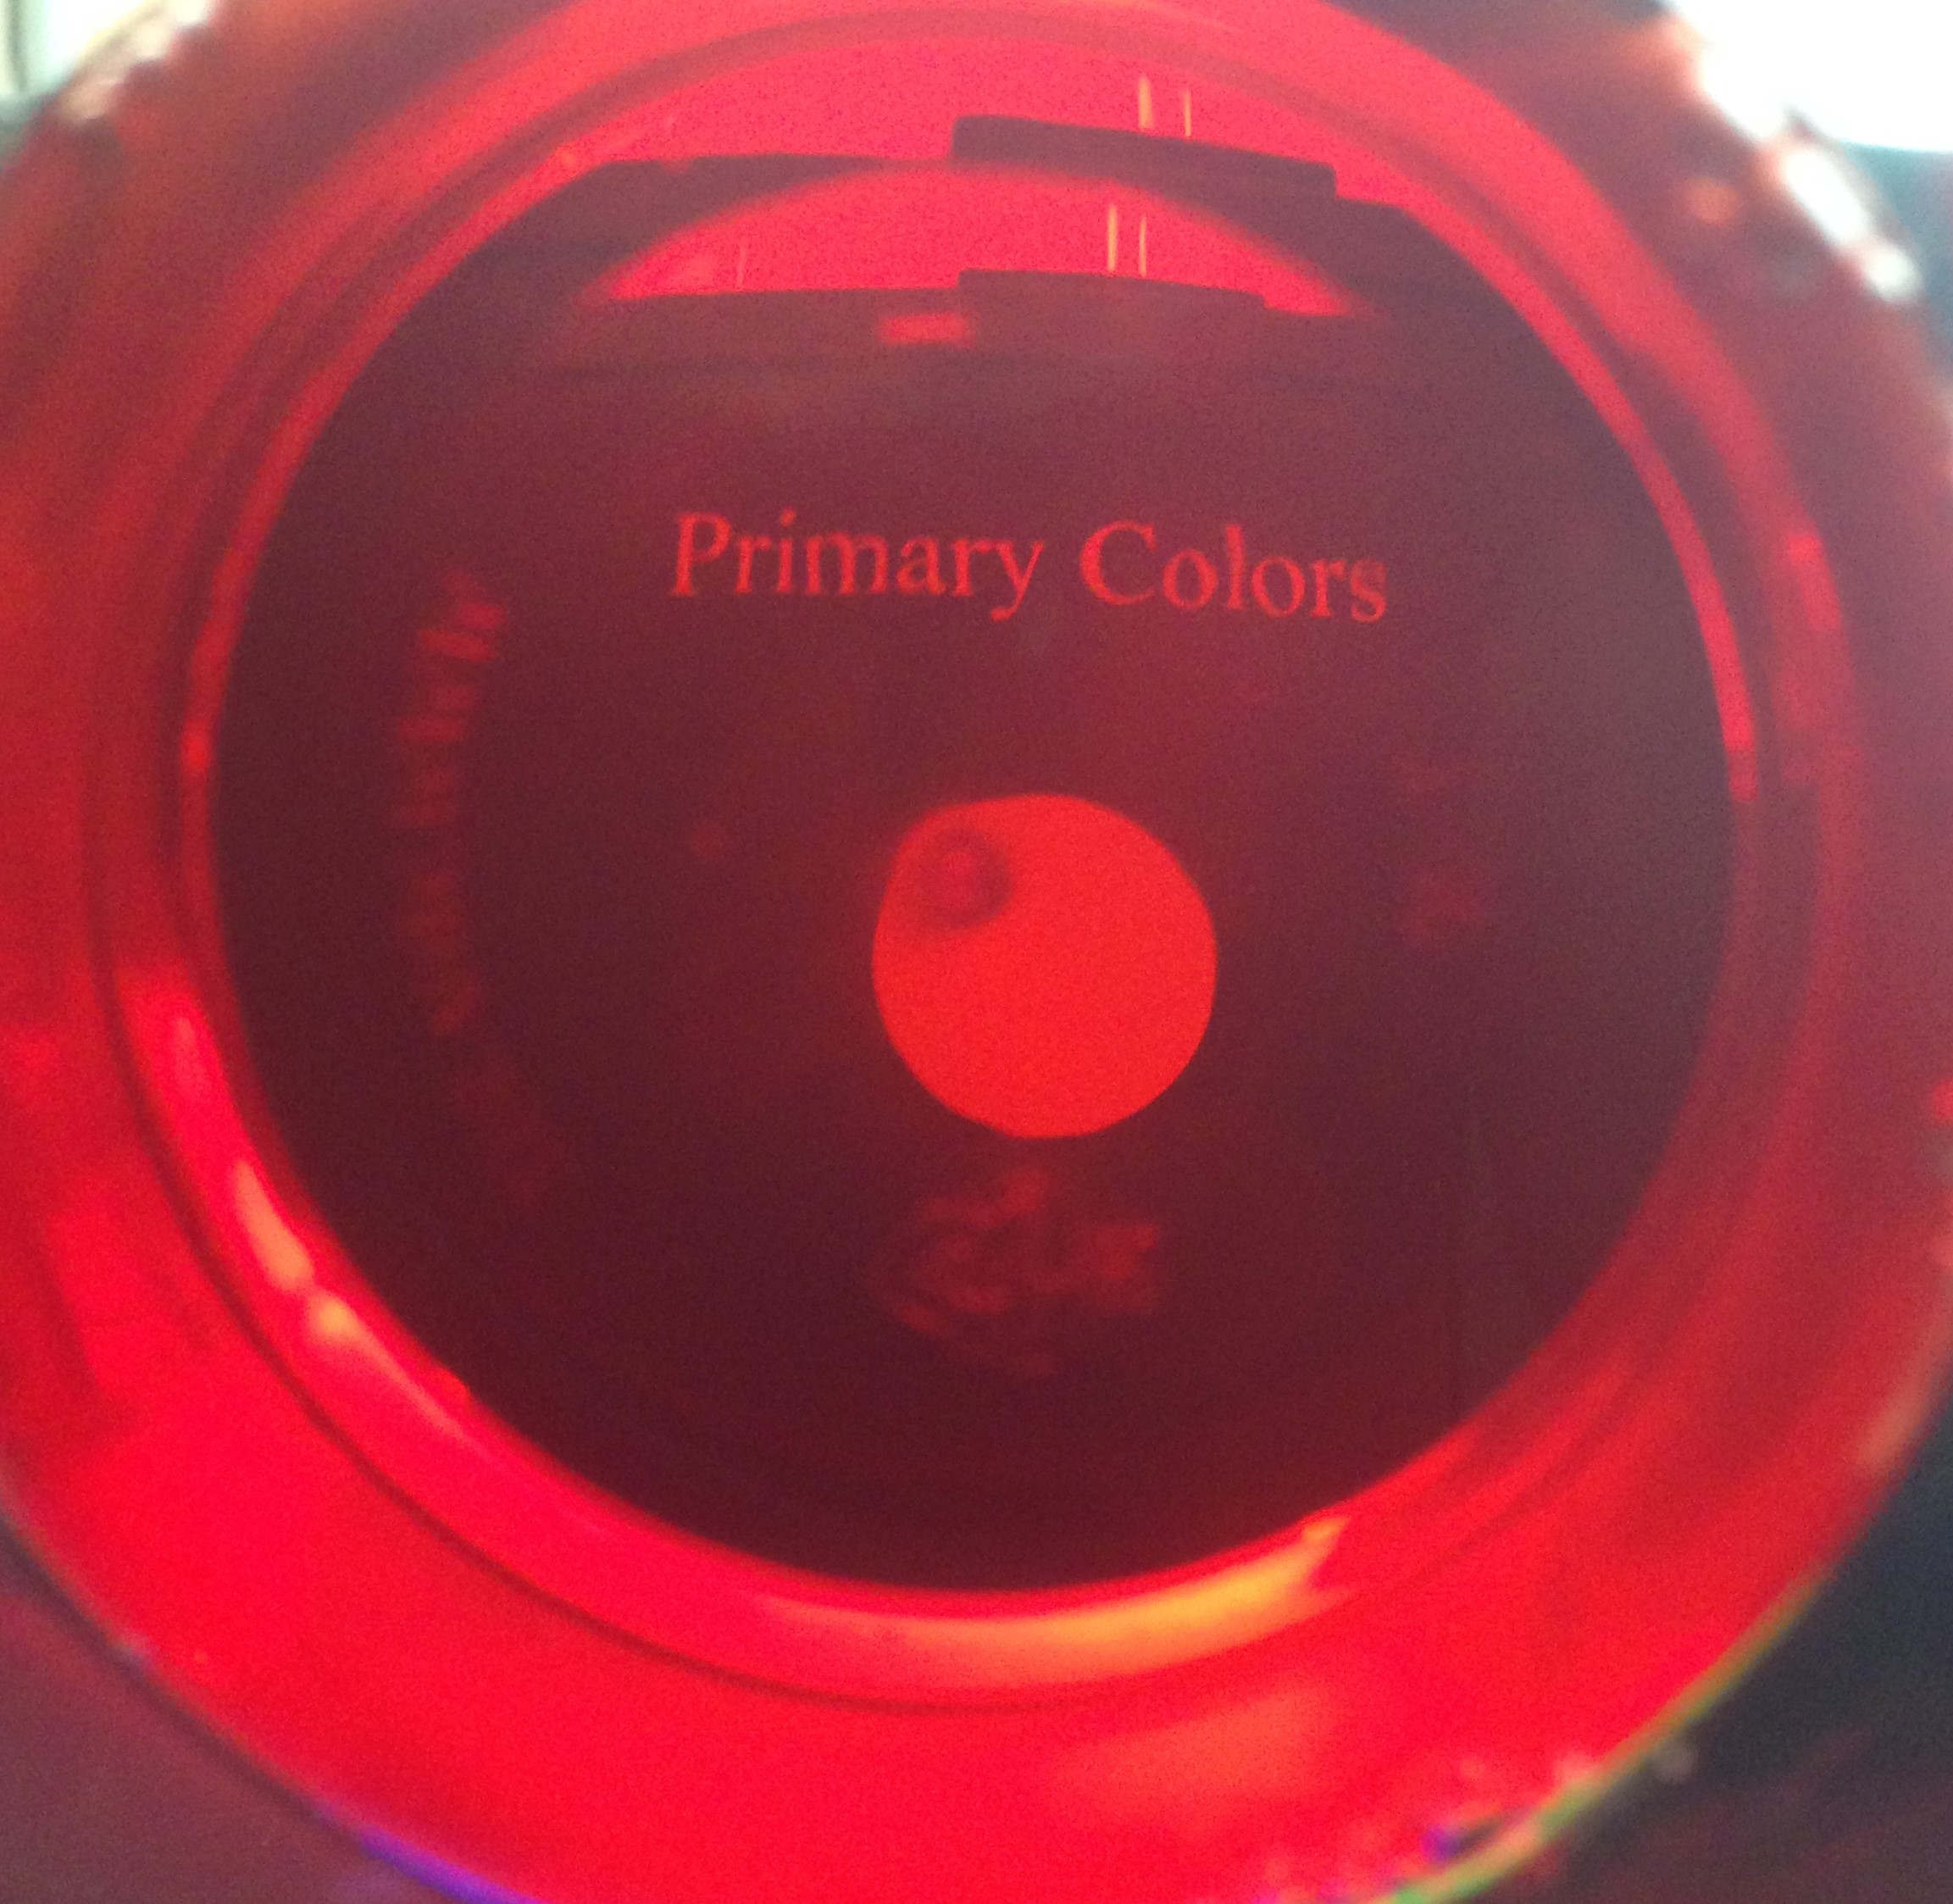
- Was your prediction correct? Why or why not?
- Did your observation support your hypothesis? Why or why not?

Image will look like this: only the red dot will be visible.
- Write predictions and hypotheses for the other two filters.
 | Prediction  “How will the image look different?” | Hypothesis  “Why will the image look different?” | Observation
Blue Filter
Green Filter

Show slide 2: Colored Numbers
- Look at the numbers that are now being projected. Which numbers do you expect to see through which filter? Circle which numbers you expect to see, and then check to see if you are right! Why can you only see those numbers?
Red filter: 1 2 3 4 5 6 7 Should circle 1, 2, 5, 7
Blue filter: 1 2 3 4 5 6 7 Should circle 1, 4, 6, 7
Green filter: 1 2 3 4 5 6 7 Should circle 1, 3, 5, 6
- Look at the image that is now being displayed. Try to predict, again, which circles you will see through which filters. Make drawings of what you expect them to look like. (Hint: Think about what is different in this case compared to the previous cases. What is white light made of? How is it affected by a filter?)
Red: Green: Blue:
PART 2: Exploring color filters with PhET

- Open up the “PhET Color Vision” simulation (found here: https://phet.colorado.edu/en/simulation/color-vision). You should be able to run it in your web browser without downloading anything else.
Addition of Color In this section, students will understand what happens when you mix colors.
- Choose “RGB Bulbs.”
- Use the sliders to add or subtract colored light. Describe what the person sees when you mix the following colors:
a. Red and Green: Yellow b. Green and Blue: Cyan
c. Blue and Red: Magenta d. Red, Green, and Blue: White
- Use the sliders to make other combinations. What colors and in what amounts (a lot or a little) do you need to make the following:
Orange: Full red, half green
Black: No light; students may try all colors at once, but that of course makes white.
White Light In this section, students will understand that white light is made up of a combination of colors of light. It is important for students to understand that filtering light is different from mixing light and mixing pigment.
- Click the button on the bottom labeled “Single Bulb.”
- Click the red button on the flashlight in order to turn it on. What happens when you move around the slider labeled “Bulb Color”? Students will notice that the emitted and perceived colors change together.
- Light is sometimes represented as particles. Click the button that shows the particles being emitted from the flashlight. Since we are seeing just one color, the light particles are only one color. This introduces students to the “particle” display of light in this simulation, which they will need in order to see in a minute that while single colored light is made up of just that one particle, white light is made up of all colors.
- Change the flashlight back to a beam, and then change the color to white by clicking the white lightbulb next to the yellow one. What color is the beam now? What color does the person see? White and white
- Try to predict what will happen when we change the setting back to the particles. Will they all be white? How do you know? What color does the person see? The particles are all colors, but the person still sees white.
- Turn on the color filter by clicking the switch attached to the bottom spectrum. What color particles make it through the filter? What does the person see? Only the light that is the same color as the filter gets through, and the person sees that color.
- How is this simulation different from and similar to what you saw with the Jell-O filters. With the Jell-O filters we noticed that the filter only allowed through its own color when looking at the white background.
Color Filters
- Change the flashlight back to being colored, and play with both sliders. What do you notice? What happens when they are the same? Different? Very close, but not quite the same?
For teachers of younger students, try showing them one color at a time and asking what will happen if you put another color filter in front of it. Will the colors mix? What color filter will allow the light to pass?
- Recall the activity with the filters and the colored numbers. What colors were allowed through the filters in the following situations? How is this different from what we observe in this simulation? Why might that be? The solutions are the arrows to the right, but the teacher could also allow the students to draw the arrows leading from the colored numbers in order to ensure understanding of mixed light. The simulation does not account for “mixed” colors like magenta; it only allows colors that are “pure” (a single wavelength) and filters that filter based entirely on wavelength.
- Make another comparison to the exercises we did with the Jell-O filter. Change the filter color to red, and then change the flashlight color to green, then red, then blue. Write down what the person sees from each color. Does this match what you saw with the Jell-O filters?
What does the person see when the flashlight is…
Red: _____________ The person sees red.
Green: _____________ The person sees black.
Blue: _____________ The person sees black.

