Ear Science
Inspired by The Physics Teacher’s:
“Classroom Materials from the Acoustical Society of America”
by W. K. Adams, A. Clark, and K. Schneider

Description: Students will explore sound within their bodies through their voice and ears.

Purpose: Students will apply their understanding of dangerous sounds to identify situations in their life where they may encounter damage to their hearing. Students will draw conclusions about the safety of their music habits by measuring the intensity of sound through their headphones.

NGSS Connections:
Disciplinary Core Ideas:
- 4-PS4-1 Waves and Their Applications in Technologies for Information Transfer
Cross Cutting Concepts:
- Cause and Effect
- Structure and Function
- System and System Models
Science and Engineering Practices:
- Analyzing and Interpreting Data
- Obtaining Evaluating and Communicating Information

Materials:
- Laptops or tablets to access the internet
- Pipe cleaners
- Sound meter
  - Mobile app alternatives include Physics Toolbox Suite or Sound Decibel Detector
- Headphones and device to music sound from
- Ruler

Ear Science

Student Worksheet
Note to teacher: Italicized commentary are notes for teachers. Red statements show sample correct student responses. Highlighted yellow items are areas where students are likely to get “stumped.

Description: Students will explore sound within their bodies through their voice and ears.

Purpose: Students will apply their understanding of dangerous sounds to identify situations in their life where they may encounter damage to their hearing. Students will draw conclusions about the safety of their music habits by measuring the intensity of sound through their headphones.

Guiding questions:
- Our bodies are made to use sound everyday.
What parts of our bodies can observe or make sound?

- We know that sound is produced from a vibration, so our voice must have a source of vibration to make the sound.
What parts of your body can you feel the vibrations?
Where is the vibration the strongest? What is actually vibrating inside your body?

- When the mosquito makes a buzzing sound that travels in a wave through the air it reaches your ear. Your ear is able to pick up sound vibrations, like that from a mosquito and convert them into electrical signals that your brain can interpret.

Our ears are affected by different sound intensity and volume. To understand the effect of different volumes of sound, explore the ear model by using the following link.
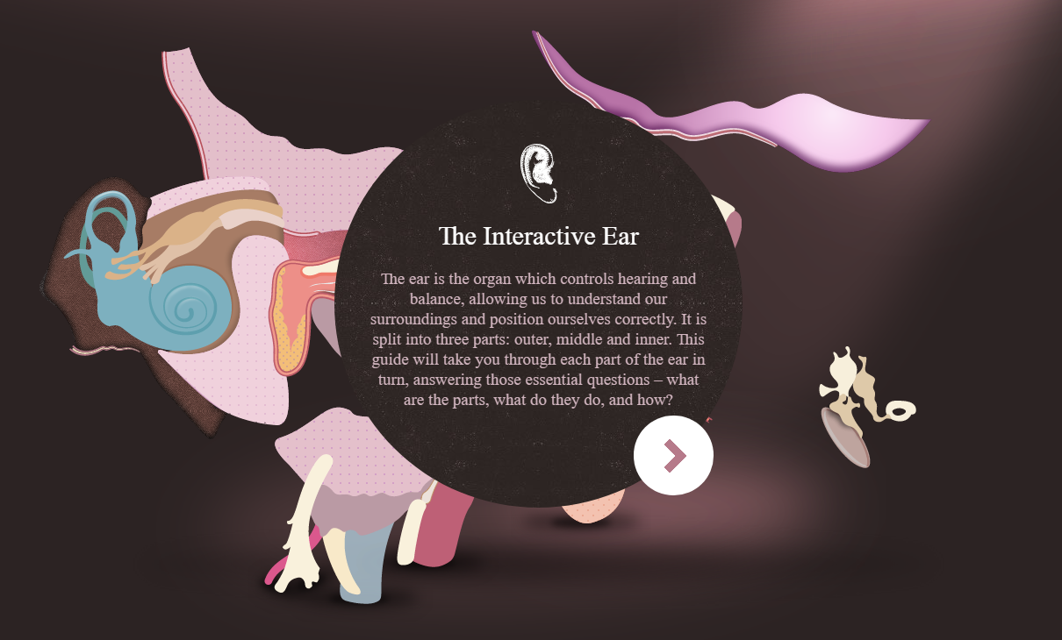
http://www.amplifon.com/web/uk/interactive-ear/index.html

4. select the pulsing plus sign on the left of the screen. Then move your cursor throughout the image to see the path of a sound wave through your ear.

5. Draw the path of sound on the diagram below.
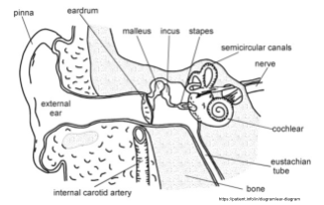

6. In the cochlea, there are tiny hair cells that look like the image below. These tiny hair cells vibrate as sound is transmitted through them. In an intricate design, the hairs change the vibration to an electrical signal. How much they vibrate depends on the volume and intensity of the sound.

7. To model this vibration, take two pipe cleaners and wrap them around your fingers as shown.

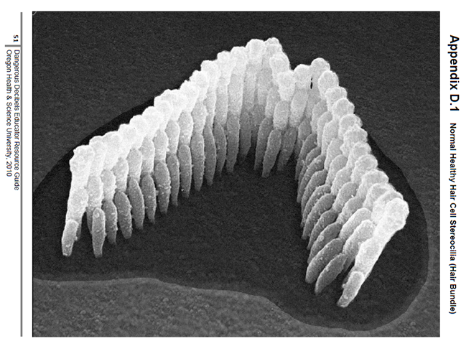
8. Take a moment to look at the image below of healthy hair cells. What similar about this picture and what you are holding in your hand?

9. Talk to your partner in a normal voice, and gently push the tips of your pipe cleaners back and forth.
Before we talked, the hair cells looked like this...

After we talked, the hair cells looked like this...

10. Now pretend you are in a crowded room and everyone is talking. You have to shout to be heard. Talk to your partner, and push the tips of your pipe cleaners a bit more intensely.
Before we talked, the hair cells looked like this...

After we talked, the hair cells looked like this...

11. Now you are walking by a really loud construction site. It is so loud that you cannot even be heard when you shout! Vigorously brush the pipe cleaners with your hand.
Before we talked, the hair cells looked like this...

After we talked, the hair cells looked like this...

12. How do the pipe cleaners in your hand now look? These hair cells are no longer able to function how they should. They will not vibrate with the sound moving through the ear. The more intense the sound, the more damage to the hair in the cochlea. The hairs in the cochlea are not able to repair themselves, so when they are damaged like this, the hearing loss is permanent.

The following a couple of questions to ask yourself to determine if you are in an environment that could be damaging your hearing.

Check the statements that apply to you.

Are you often in an environment where the sound is so loud that you have to shout to make yourself understood?

After hearing a loud sound, have you ever noticed a ringing in your ears?

Does music sound strange or distorted after you’ve been listening for a while?

Do voices sound muffled after you’ve been around loud music or other loud sounds for a long time?

After exposure to loud sound, do your ears sometimes feel “full” or “stopped up”?

When you are listening with headphones, can the person standing next to you hear it too?

List at least three situations where someone may experience hearing damage.

Part II: Decibel Measurement

- You’re sitting on the bus on the way to school this morning and the person next to you is listening to music with headphones in. You can hear their music. You’ve probably heard that is bad for your ears but do you really believe that? Today you can test it by using a sound meter to measure the intensity of the sound coming from your headphones. Begin by taking out the meter, and turning it on. Test out the meter by creating some sound.

My highest reading was...

I made the highest reading by...

The meter is measuring the intensity of sound in a unit called decibels. It is represented by dB. The more decibels the more intense the sound. Sounds that are 85 dB and higher can damage the hairs in your ears.

2. Take out your headphones and play some music into them at your usual volume. Then change the volume.

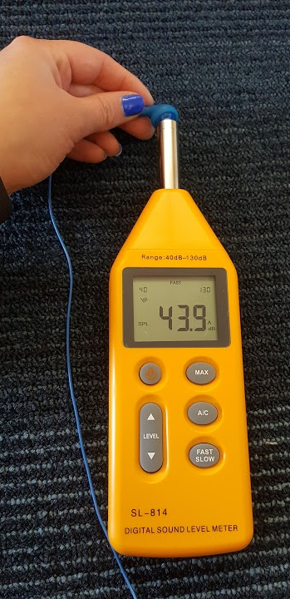

Volume
Intensity
Harmful?
Lowest Setting
Medium Setting
High
Setting

- Think about the normal volume level at which you listen to music with headphones. Are you damaging your hearing? Explain.

- How does distance from the source of the sound affect the intensity of the sound? Is it just as dangerous to be standing right next to an intense sound as it is to stand several feet away? Write a prediction.

- Test your prediction by observing the intensity at different distances from the source of the sound. Use the space below to record your data.

Distance from Source
Intensity
Harmful?
0 in
4 in

- Based on your observations, how does sound intensity change the farther away you move from a source of sound like a speaker?

- Does this hold true with a mosquito in your ear? Does the intensity change as the mosquito moves away from your ear. What about when it gets closer? Try it with your buzzer.

