Mirror Science: Flexible Mirror Lab

Description: Students explore reflection using flexible mirror paper.
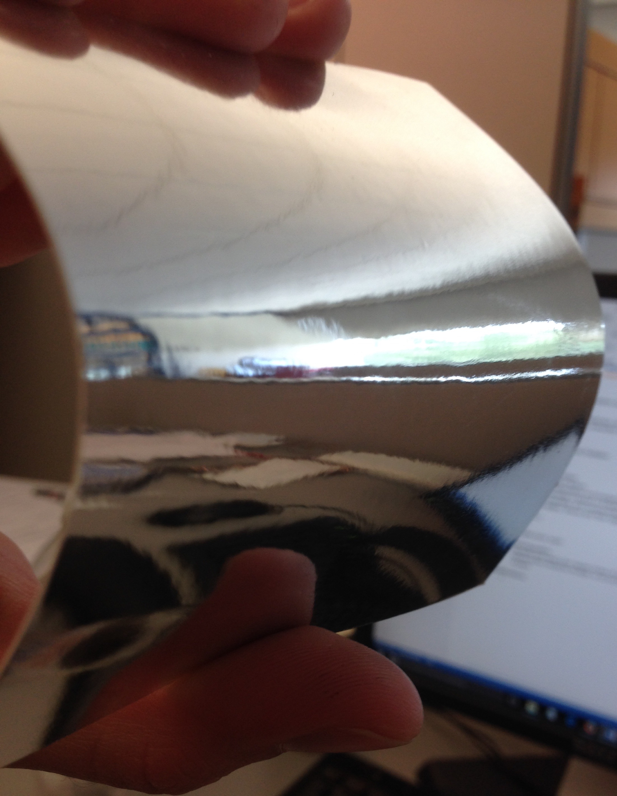
Purpose: Students will observe reflection off of curved mirror surfaces and will understand the connection with lenses.

NGSS Connections:
Disciplinary Core Ideas:
- PS4.B: Electromagnetic Radiation
Crosscutting Concepts:
- Cause and Effect
- Patterns
- Structure and Function
Science and Engineering Practices:
- Constructing Explanations and Designing Solutions
- Scientific Knowledge is Based on Empirical Evidence
- Obtaining, Evaluating, and Communicating Information
Performance Expectations: Waves and Their Applications in Technologies for Information Transfer (PS4)
- 1-PS4-3
- MS-PS4-2

Materials:
- Flexible mirror paper

Advanced Preparation:
- Students only need a few square inches of mirror paper in order to complete these activities. 4-5 square inches should be enough, so do not feel as though each student needs a full sized piece of paper.

Lab Activities for Students: Flexible Mirror

PART 1: Concave Mirror

- Hold out the mirror paper in front of you at arm’s length with the reflective side pointed towards you. Move the paper towards your face, and make a note of any changes you observe.
The image may become far less mottled when the paper comes nearer. This is an artifact of the imperfect surface of the paper – it has far more flaws than a bathroom mirror, for example.
- Again holding the mirror at arm’s length, slightly bend the paper so that the top and bottom are towards you, and the center is away from you. What changes when you do this? How much do you have to bend the paper for this phenomenon to occur? Where have you seen this before?
Once students bend the mirror paper just a tiny bit, the image will flip upside down. They should recognize this from some of the lens activities, if they have completed them.
- Draw a picture of the path of the light coming off of your face. We are going to assume that this light is collimated, meaning that all of the rays of light are parallel when they are moving towards the mirror. Remember that this is a mirror, not a lens, meaning that most of the light is reflected, not transmitted. Your lines should be on the left side of the mirror, on the same side as the incoming lines. After all, that is where your eye is! Students should be able to draw the red lines in the illustration below. They should begin to recognize features: the focus and inversion are both things they saw with lenses, only this time they are on the same side as the incoming light. They should also notice that the image is magnified if they get close enough to the mirror.
- Using your drawing, explain the phenomenon you observed in the mirror. How is this similar to what we observed with the water pearl and gelatin lens? How is it different? What similar features exist? Label them in the drawing. Students should notice a focus and inversion, though the image in this case will be on the same side of the mirror as the incident light rather than the opposite!
- Why does this phenomenon occur when you curve the mirror, but not when the mirror is flat? When the mirror is flat, the light bounces off the mirror at the same angle it had when it hit, but when the mirror is curved then the light goes in a different direction depending on how it is curved.
- Instead of bending the mirror paper along the top and the bottom, try bending it on its sides, still so that the center of the mirror paper is away from you and the sides are towards you. What happens in this case? How is it similar to and different from the previous case? What would happen if the mirror was round and the entire edge was bent forwards like this?
The image will not be upside down, but it will be backwards. If the whole mirror was a circular concave mirror, the image would be upside down and backwards. Mirrors like this are often used as bathroom mirrors, due to how well they can magnify images close to them.
- Have you ever seen a concave mirror being used in everyday life? What uses might there be for a mirror with these properties?
They are often used as hand mirrors or bathroom mirrors, as they magnify close objects very effectively.
PART 2: Convex Mirror

- Try bending the mirror the other way (center towards you, top and bottom away). Does the same phenomenon occur? Why or why not? What do you observe? The image will not be flipped, but will rather appear squashed in the middle of the mirror.
- Draw what might be happening to the parallel rays of light that reflect off of the mirror paper. Red lines are the solution.
- Why might this model be incomplete? What more could we consider that would change our diagram?
Not all light incident on the mirror will be parallel. Students do not need to draw a diagram that takes into account non-parallel light because this model can get complicated quickly, but students should be advised to consider the case and how it connects to what they observe in the convex mirror.
- 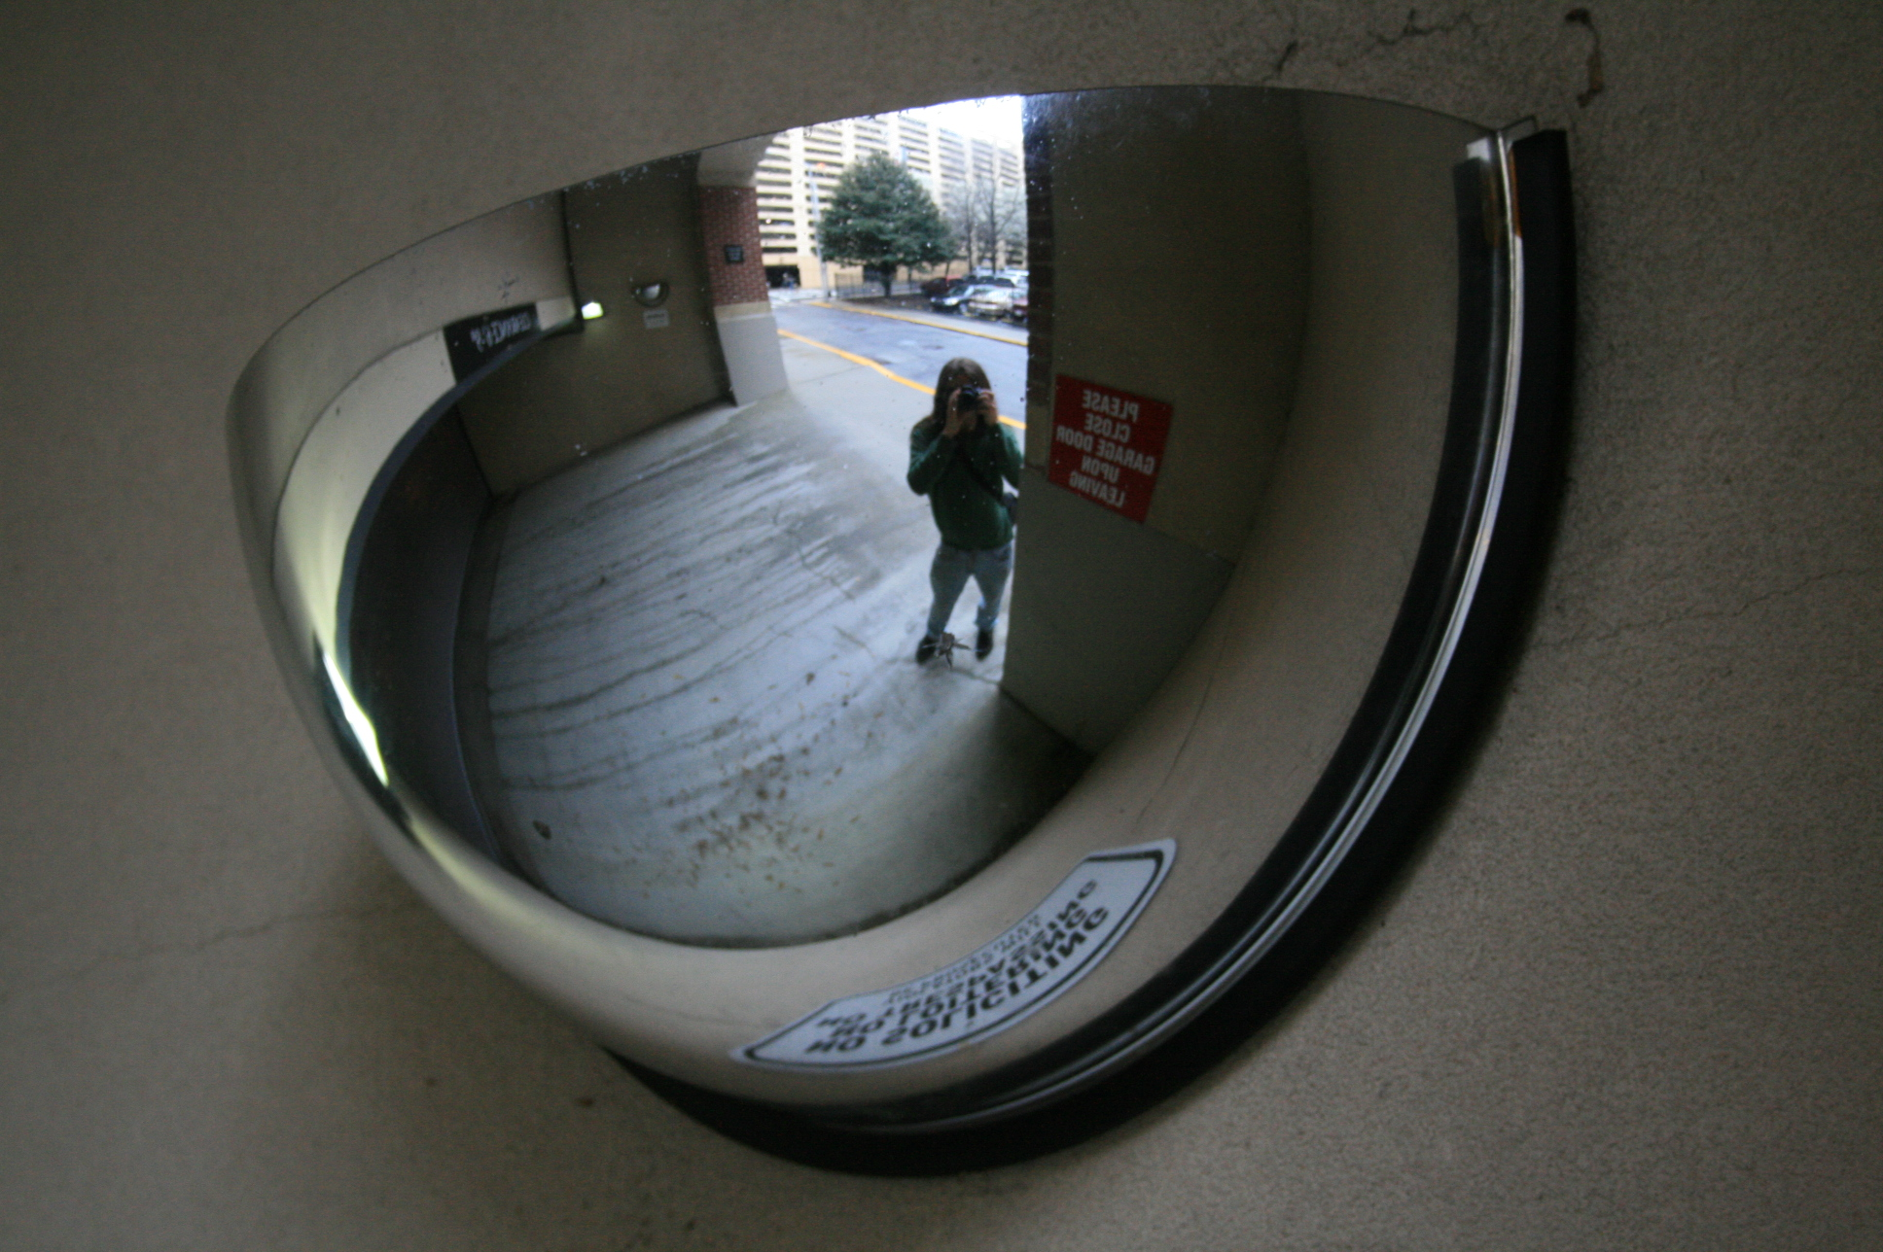What uses might we have for a convex mirror? What could they help us do?
Convex mirrors are often used to help us see a wider field of view than a flat mirror, which can let us do things like see around corners and notice environmental dangers. They are sometimes used in rear-view mirrors for cars and trucks, as well as in stores and parking garages to give a more complete image of what is going on in the environment.

