DNA Science: Modeling Rosalind Franklin’s Discovery
with a Pen Spring

Student Worksheet

Purpose: Determine the information that can be inferred from a light pattern produced by an object.

Background (from “How Rosalind Franklin Discovered the Helical Structure of DNA: Experiments in Diffraction” by Gregory Braun, Dennis Tierney, and Heidrun Schmitzer.)

Rosalind Franklin, a chemical physicist (1920-1958), used x-ray diffraction to determine the structure of DNA. What exactly should she read out from her x-ray pattern? In lecture notes dated November 1951, R. Franklin wrote the following: “The results suggest a helical structure (which must be very closely packed), containing 2, 3, or 4 co-axial nucleic acid chains per helical unit, and having the phosphate groups near the outside.” This was 16 months before J.D. Watson and Fr. Crick published their description of DNA, which was based on R. Franklin’s x-ray photos. How they gained access to her x-ray photos is a fascinating tale of clashing personalities and male chauvinism.

Guiding questions:
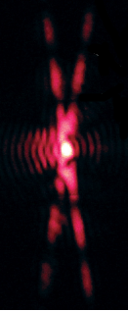
  - Rosalind Franklin attempted to learn more about DNA by shining a beam of X-rays through it and observing the pattern that resulted. To do this, she suspended a bundle of about 20 strands of DNA (about the width of a human hair) vertically.

Perform a similar investigation by holding a pen spring vertically and shining a laser beam through it. Make the projection as big as possible, and observe everything you can. Draw a sketch below. (You might need to have someone else hold the laser and spring at a distance so that you can see it up close).

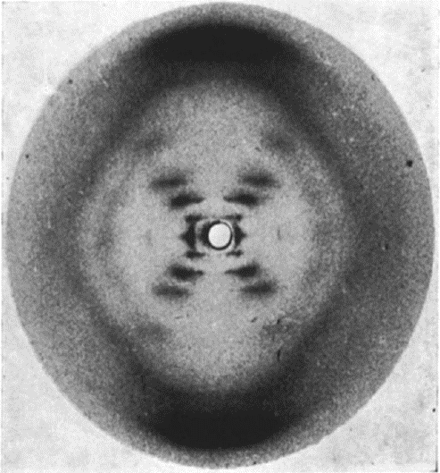

  - How is your project above different from or similar to Rosalind’s famous Photo 51 of DNA?

© Raymond Gosling / King’s College London

  - What are some questions that you have about the meaning of your projection? (What kinds of questions do you think that Rosalind had about the meaning of her picture?) List at least three.

  - To start making some sense of what is happening, hold the spring near your eye and look through it. Draw a picture of what you see – this is what the laser beam “sees” when it passes through it. Provide an explanation for where you think the “X” in the projection might come from.

  - One thing that can provide some help in understanding is “Babinet’s Principle.” Just like light diffracts as it leaves a slit (which have internal edges), it diffracts as it goes around objects (which have external edges). Babinet’s Principle states that light will produce a pattern that is almost exactly the same whether it is going around an object, or going through a hole that has the same outline as the object.

Using Babinet’s Principle, explain how shining a laser beam through a spring is similar to what you have observed when shining lasers through slits.
Spring
“Cut-out” of a spring

  - Let’s focus on TWO individual slits – one at a time.

What kind of pattern would be produced from the TOP slit, on the image below? Draw a simple sketch showing the correct type of pattern and angle of the pattern for the white, top slit. Explain your reasoning.

What kind of pattern would be produced from the BOTTOM slit, on the image below? Draw a simple sketch showing the correct type of pattern and angle of the pattern for the white, bottom slit. Explain your reasoning.

  - Given your answer to #5 above, what do you predict will happen to your projection if you squeeze the coils closer together? Draw a sketch, and explain why.

  - Observe changes in the projection when you squeeze the spring. What happens? Is this different from what you predicted?

  - Using only the projection on the wall, a protractor, and geometry, predict pitch angle of coils, 2α. Explain how you will accomplish this.

2α

  - Using Photo 51 on the following page, and a protractor, what information can you glean about the geometry of DNA? How is it different from your spring?

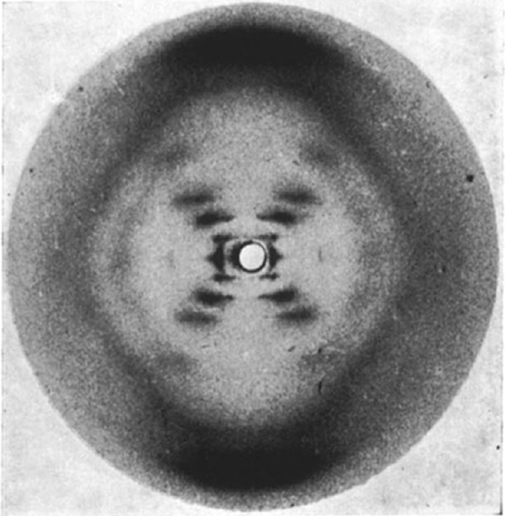

© Raymond Gosling / King’s College London

  - What other geometric properties of DNA might be necessary to get a full sense of what it looks like? What kind of test with your springs could you perform to find out how Rosalind might have gotten that information?

Lastly, one of Franklin’s great insights was that DNA was not a simple helical structure like a single piece of metal bent into a coil. In fact, DNA is composed of two strands wound together, more like a ladder that has been curved into a coil. She concluded this based on the missing spots in the axes of the X on Photo 51, caused by destructive interference of light resulting from the second coil.

