Body Science: Determining the percent body fat of a sausage “cadaver” through the lenses of biology, chemistry, and physics
Inspired by The Physics Teacher’s:
“Use of Bratwurst Sausage as a Model Cadaver in Introductory Physics for the Life Sciences Lab Experiments” and Lab Worksheets
by David Sidebottom.

Description: Determine the percent fat of a sausage, and analyze how this lab can be done in the context of a biology, chemistry, or physics course.

Purpose: Students will determine the percent body fat of a “cadaver” through hydrostatic weighing.

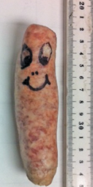
NGSS Connections:
Disciplinary Core Ideas:
- Matter and its Interactions: MS-PS1, HS-PS1
- Motion and Stability: Forces and Interactions: MS-PS2, HS-PS2
Crosscutting Concepts:
- Scale, proportion, and quantity
- Systems and system models
Science and Engineering Practices:
- Developing and using models
- Analyzing and interpreting data
- Using mathematics and computational thinking
- Obtaining, evaluating, and communicating information

Materials:
- Bratwurst/hot dogs/veggie dogs (they must sink when placed in water) – although raw bratwurst are likely to produce results most similar to the human body, take safety precautions if handling raw meat.
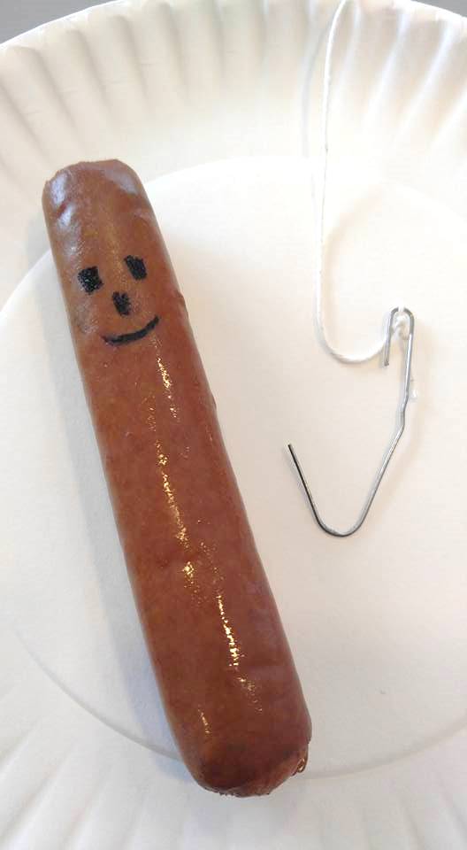
- electronic balance
- string and small hook (fashioned from a paper clip)
- large cup or beaker without precise gradations, filled with water

Prior Conceptual Understandings Required
- Buoyant Force (variables that influence it, and how it is calculated) F_{B}=ρ_{fluid}gV_{displaced}
- Free body diagrams (balanced and unbalanced systems, force vectors)
- Newton’s 3rd Law (force pairs)

Modifications:
- Substitute any “sausage” (including hotdogs or veggie dogs) so long as they sink in water.

Lab Activities (in brief):
- Suggested pre-lab activity: Derive the expression for buoyant force.
- Investigate Newton’s 3rd law with electronic balance and force meter
- Discuss values that might be influenced by percent body fat (how could it be measured?)
- Measure the mass of the sausage.
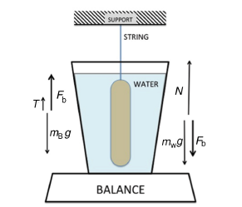
- Determine buoyant force on the sausage using reaction force on balance, to calculate volume and density.
sausage
water
- Collaboratively derive the PBF equation from known densities of fat and tissue.
- Apply the PBF equation to determine percent body fat.
- Compare experimental value to packaging.
- Suggested post-lab activity: Check personal PBF (using resistance…on a bathroom scale).
- Suggested post-lab activity: Discuss error, wider impact, etc.

Body Science: Determining the percent body fat of a sausage “cadaver” through the lenses of biology, chemistry, and physics.

Student Worksheet
Note to teacher: Italicized commentary are notes for teachers. Red statements show sample correct student responses. Highlighted yellow items are areas where students are likely to get “stumped.
Original worksheets by the article’s author can be found here: Lab Worksheets

Purpose: Determine the percent body fat of a “cadaver” through hydrostatic weighing.

Guiding questions:

- What kinds of factors influence your total body density? (...or the body density of various sausages?) Why is an understanding of this important?
The components of your body (different tissues, gas, and fat) and total volume of your body impact your body density. This important to understand, because “total weight” per height (BMI) doesn’t always give an accurate indication of a person’s health. Some people are “all muscle” while others have a greater proportion of fat.

- Describe what fundamental factors you will need to measure in order to get the body density for your cadaver, and explain how you will measure it. If you can make the measurement, record it!

Factor | Describe how it could be measured | Record the measurement
m, mass | Place the cadaver directly on the electronic balance. | X g
V, volume | No graduated cylinder is available to make precise volume measurements. Instead, volume can be calculated from an understanding of buoyant force. | ?

- As you will note, no tool is available to measure the displaced volume of water by the sausage! Instead, you will need to determine the buoyant force acting on the sausage. Using only an electronic balance, your cadaver, and a string, explain how you will determine the buoyant force acting on the cadaver when it is suspended in the water. Draw a force diagram for the cadaver and for the water (before and after the cadaver is submerged) to accompany your explanation.
The sausage can be placed in the cup of water (without touching the bottom) to experience a buoyant force. The buoyant force is the “upward” force of the fluid on the cadaver. However, the cadaver exerts a net “downward” force on the fluid, and this is ultimately what translates to the digital readout. Hence, when the apparent “weight” of the cup/water/sausage system increases due to the cadaver being submerged in the water, any increase is equal in magnitude to the buoyant force.

Cadaver and water before the sausage is submerged in the water:

cadaver
cup of water
F_{T} string on cadaver
F_{g} Earth on cadaver
F_{N} scale on cup of water
F_{g} Earth on cup of water

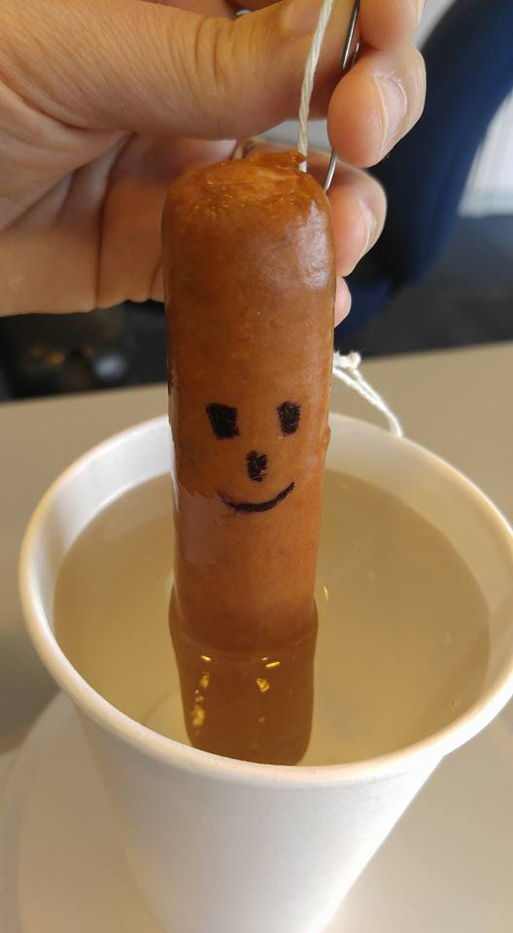

Cadaver and water after the sausage is fully submerged in the water:
sausage
cup of water
F_{g} Earth on cadaver
F_{g} Earth on cup of water
F_{B} water on cadaver
F_{T} string on cadaver
F_{”B-reactive”} cadaver on cup of water
F_{N} scale on cup of water

- Create an expression for the force of the scale when the cadaver is fully submerged in the cup of water. Explain how buoyant force can be measured indirectly.
F_{N scale on cup of} _{water} = F_{g Earth on cup of water} – FB-reactive cadaver on cup of water

The “B-reactive” force is equal and opposite to the buoyant force. Compare the force diagram of the cup of water before and after the cadaver is submerged. After it is submerged, the normal force from the scale on the cup of water (what is read on the digital read-out) is greater by the B-reactive force after it is submerged. Hence, the magnitude of the buoyant force after submersion is greater by the magnitude of the buoyant force than before it is submerged. All that you need to do is to subtract the pre-submersion read-out value from the post-submersion read-out value.

- Describe how you will use the measurement of buoyant force to determine the volume of the cadaver, and then solve for the volume of the cadaver. Hint: ρ_{water} = 1 g/cm³
From previous experiences we have determined that F_{B} = ρ_{fluid} g V. The density of water at room temperature is 1 g/cm³. V = F_{B} /( ρ_{fluid} g). V = X cm³

- Solve for the total body density of the cadaver.
ρ_{body} = M_{body} /V_{body} = (X g) / (X cm³) from #2 and #4 above.

- Reflect on the total density of the cadaver compared to the known density of water. Do your results make sense? Why or why not?
The total body density for the cadaver is nearly the same as for water. It is slightly greater than water, which makes sense, because the cadaver sinks in water.
If students find that the total body density is lower than the density of water, encourage students to reflect on the potential reasons for error. If time allows, encourage them to take additional measurements.

- The density of fat is 0.9 g/cm³, and the density of muscle tissue is 1.1 g/cm³. What does your value of total body density from #6 above suggest about the percent body fat (PBF) of your cadaver? Explain.
Because the value is slightly above 1.0 g/cm3, this suggests that the cadaver has a higher composition of muscle tissue than fat.

- The PBF of a person’s body is very important to health. Explain why it is not enough to know a person’s weight to determine if they are overweight or obese. Explain why it is not enough to know a person’s BMI (Body Mass Index).
Two people with the same weight can have very different body compositions. A person can be short and stout, and another person can be tall and skinny. BMI is insufficient (but better than weight alone), because a person can have “bulk” but actually be quite muscular, while “bulk” for other people might be fat.

- To determine the actual PBF, we need to differentiate between the total body, the tissue (muscle), and the fat.

$$M_{body}= ρ_{body}V_{body}= ρ_{fat}V_{fat}+ ρ_{tissue}V_{tissue}= ρ_{fat}V_{fat}+ ρ_{tissue}{(V_{body}-V}_{fat})$$

PBF is then defined as the total fat mass divided by total body mass.

$PBF= \frac{M_{fat}}{M_{body}}= \frac{ρ_{fat}V_{fat}}{ρ_{body}V_{body}}$ = $\frac{ρ_{fat}}{ρ_{body}}(\frac{V_{fat}}{V_{body}})$

Show, algebraically, how the above two expressions can be combined to result in:

$$PBF= \frac{ρ_{fat}}{ρ_{body}}(\frac{ρ_{tissue }- ρ_{body }}{ρ_{tissue }- ρ_{fat }})$$

Hint: Show that:

${ρ_{body}V_{body}= ρ}_{fat}V_{fat}+ ρ_{tissue}{(V_{body}V}_{fat})$ is equivalent to $\frac{V_{fat}}{V_{body}}= \frac{ρ_{tissue }- ρ_{body }}{ρ_{tissue }- ρ_{fat }}$.

$${ρ_{body}V_{body}= ρ}_{fat}V_{fat}+ ρ_{tissue}{(V_{body}V}_{fat})$$

Divide both sides by V_{body}.

$$ρ_{body}= \frac{ρ_{fat}V_{fat}}{V_{body}}+\frac{ρ_{tissue}V_{body}}{V_{body}} - \frac{ρ_{tissue}V_{fat}}{V_{body}}$$

Simplify.
$$ρ_{body}- ρ_{tissue}= \frac{ρ_{fat}V_{fat}}{V_{body}}- \frac{ρ_{tissue}V_{fat}}{V_{body}}$$

$$ρ_{body}- ρ_{tissue}= \frac{{(ρ}_{fat}{-{ ρ}_{tissue})V}_{fat}}{V_{body}}$$

Rearrange to solve for V_{fat}/V_{body}.
$$ρ_{body}- ρ_{tissue}= \frac{{(ρ}_{fat}{-{ ρ}_{tissue})V}_{fat}}{V_{body}}$$

$$\frac{V_{fat}}{V_{body}}= \frac{{(ρ}_{body}- ρ_{tissue}) (-1)}{{(ρ}_{fat}- ρ_{tissue}) (-1)}= \frac{{(ρ}_{tissue}- ρ_{body})}{{(ρ}_{tissue}- ρ_{fat})}$$

- Using the expression above, and the densities of fat and muscle from #7, show how the PBF equation can be expressed as:
$$PBF= \left(495/ρ_{body }\right)-450 \%$$

$$PBF= \frac{ρ_{fat}}{ρ_{body}}(\frac{ρ_{tissue }- ρ_{body }}{ρ_{tissue }- ρ_{fat }})$$

$$PBF= \frac{0.9}{ρ_{body}}\left(\frac{1.1- ρ_{body }}{1.1-0.9}\right)= \frac{4.5}{ρ_{body}}\left(1.1-ρ_{body }\right)= \frac{4.95}{ρ_{body}}-4.5$$

- Calculate the PBF of your cadaver. Is your cadaver clinically obese? (Clinical obesity is body fat percentage in excess of 25% for men, and in excess of 32% for women).

- If available, check the nutrition information for your sausage. Does the calculated PBF value match up with the percentage of calories per sausage from fat? Explain how you made this comparison, and provide a rationale for why your calculated value might be different.

- The use of the sausage was a “model” for the human body. How might the sausage model be accurate or deficient? Explain.
Like the human body, the sausage is a mix of tissue and fat. Unlike the human body, the sausage does not have cavities of air (like the lungs) or fluid (like the stomach).

