Exploring Light with Gelatin Lenses

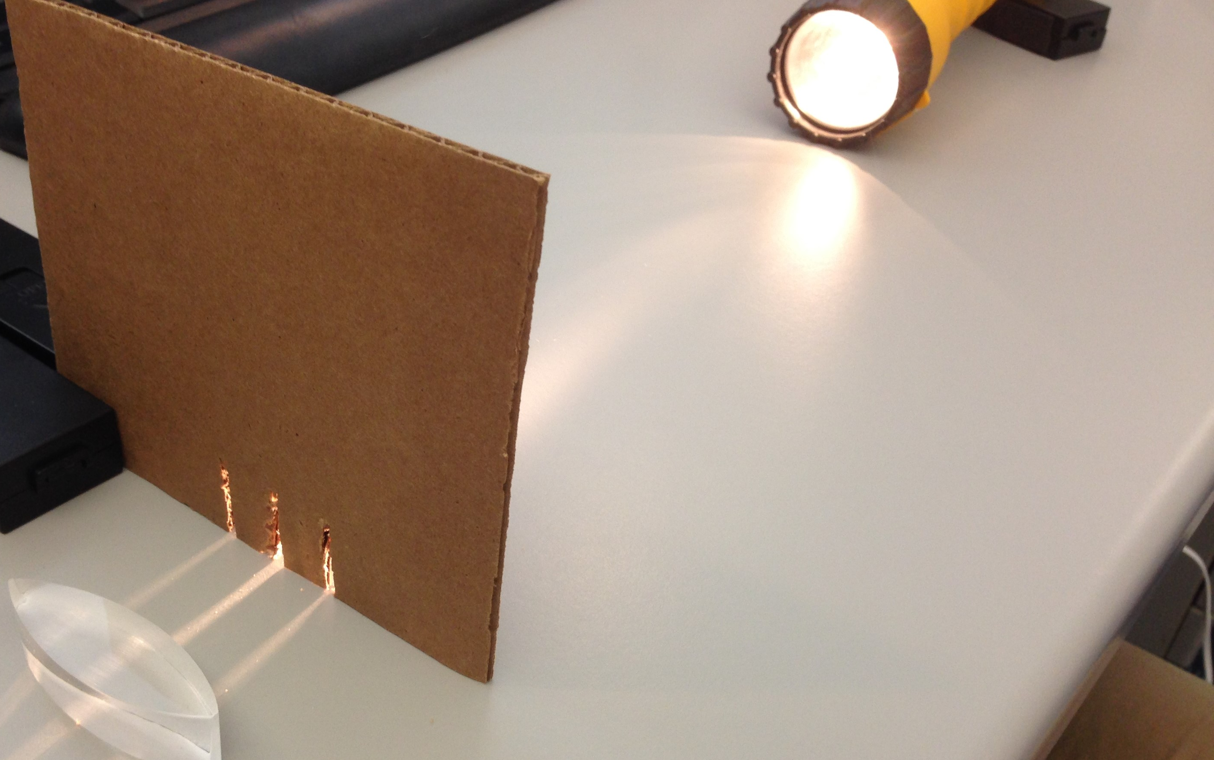
Student Worksheet

Purpose: Observe the refractive properties of light using simple gelatin “lenses” and use these lenses to model lens function in a human eye.

Lab Activities for Students: Gelatin Lenses

PART 1: Observing properties of convex lenses

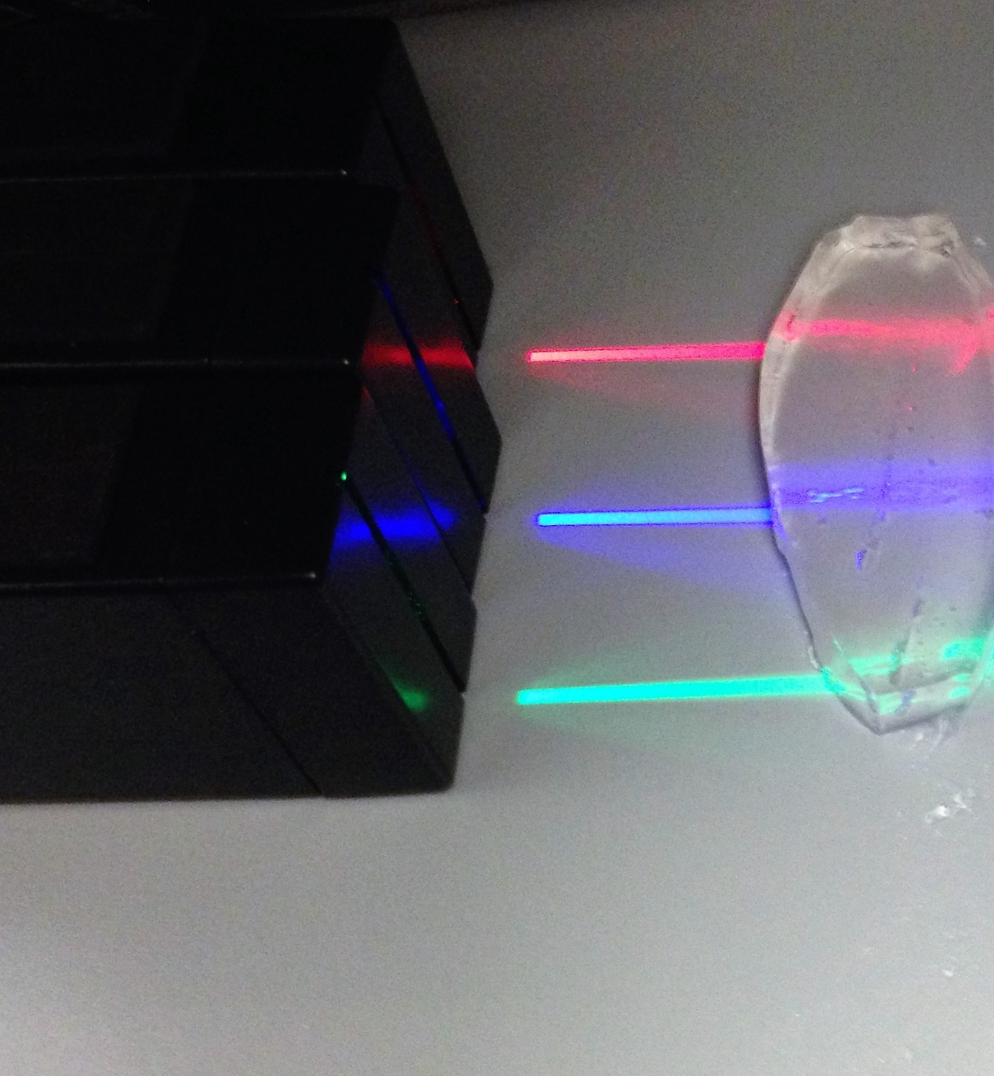
- Lay on the table the lens that is thin on the top and bottom, and thick in the middle. This is called a “convex” lens. Take your three parallel beams of light and line them up so that their beams enter the lens at the bottom, middle, and top. What happens? Measure the distance and complete the picture below, writing down the distance from the center of the lens to the intersection. This distance is called the “focal length” of the lens.

- Now we will see what happens when we use just one beam of light. Switch to the single slit, and move the slit and the light back and forth so that the beam of light travels up and down the lens. Make note of the changes in the angle at which the light exits when you are at different positions on the lens. Are there more than three angles the light can exit at?

- Switch back to the three beams of light. Place a marker where the beams intersect, and draw a picture of the lens and three beams. Label the distance from the center of the lens as “focal length.” Now, gently squeeze the bottom and top of the lens, but not so hard that it cannot return to its original shape. Has the intersection of light beams moved? Is it now closer than the marker, or farther? Draw another picture of the light beams and label the focal length again, but also mark whether the new focal length or shorter or longer than the original. What does this tell us about how the size and shape of a lens affect its focal length?

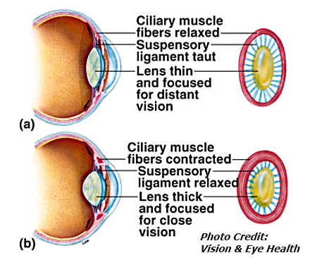
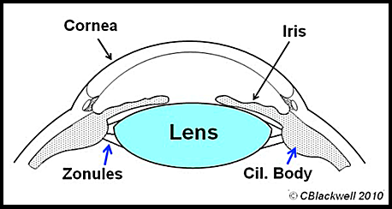
- The activity above models how the human eye responds to focusing on near versus far objects. Using the images below and to the right, describe how the shape of your eye’s lens changes as you “accommodate” to the various distances of objects.

PART 2: Observing properties of concave lenses

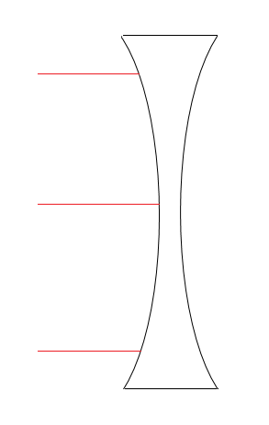
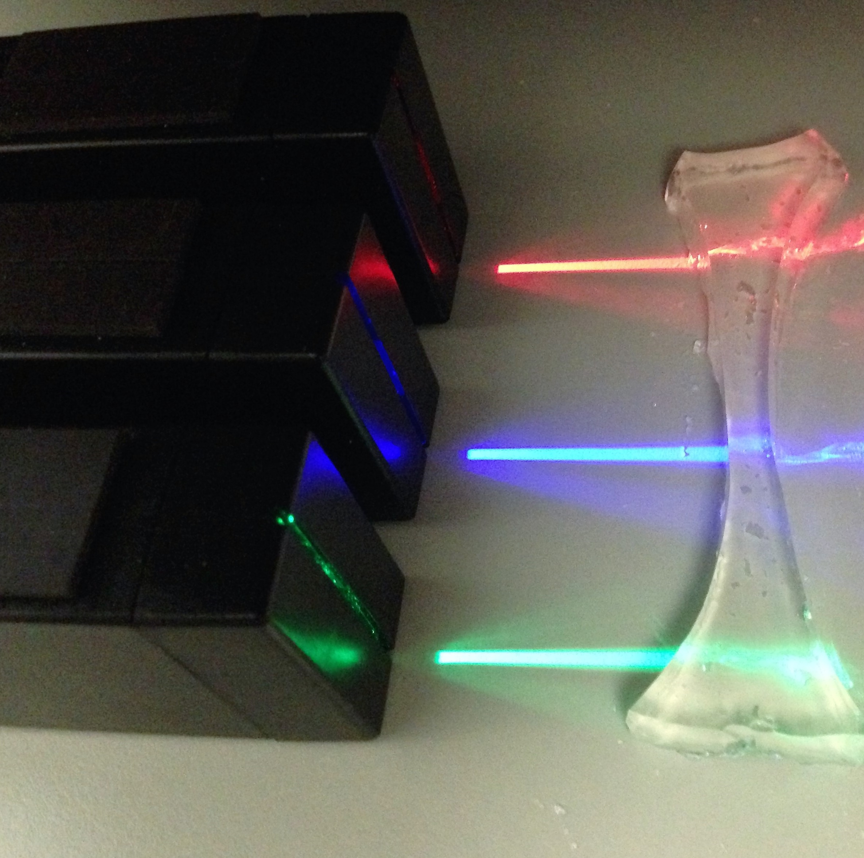
- Repeat step 1. Make the appropriate drawing below. How is this different from the convex lens? What is missing from this lens that the convex lens had?
We call this a “diverging lens,” because the light passing through it separates, or “diverges.”

