Jelly Science: Exploring Light with Water Pearls

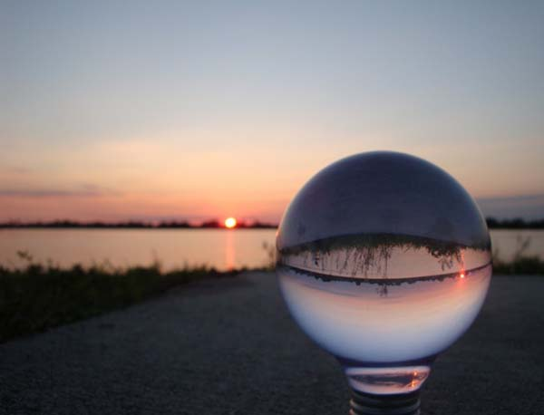
Student Worksheet

Purpose: In this activity, you will observe refraction in a unique way, learn about the focal length of a lens, and build your understanding about why images seen through certain lenses are inverted.

PART 1: Looking at images through the water pearl

- Hold the water pearl between two fingers, and look through it at arm’s length. Try pointing it at a window and observe the image in the water pearl. What do you see? How does the image you see in the water pearl look different from the image you see when looking with your naked eye?

- Now, place your water pearl on the table on top of the emoji on the last page of this worksheet. What does it look like? Draw a picture here of what you see:

- Slowly pull the water pearl away from the emoji. What happens?

- How far does it have to be before the image changes dramatically? What does it look like once it is pulled far away?

- After the image flips, look carefully at it through the water pearl for a little while. Draw the new image:
What is different? Try looking at your drawing through the water pearl. Does it look like the original picture?

PART 2: Observing light pass through the water pearl

- Have a friend hold a flashlight pointed down at a blank piece of paper. Place the water pearl on the paper. Slowly lift the water pearl up from the paper, and watch the shadow of the pearl. Make sure your hand doesn’t get between the flashlight and the pearl, or between the pearl and the paper! Use your thumb and index finger. After raising it just a little bit, you should see a dot of light appear in the shadow! Move the pearl up and down a tiny bit.
What happens to the dot of light? About how far away from the paper does the pearl have to be to see the dot?
See if you can get the dot to be as small and as bright as possible. If you can, measure the distance from the pearl to the paper at this point! This is called the focal length of the lens.

PART 3: Observing water pearls immersed in liquid

- Get a clear cup mostly full of water, and place your water pearl gently into it. What happens? Why might the water pearl do that when it is in the water? (Hint: What do you think the water pearl is made of?)

- Fish your water pearl out of the cup. Make sure not to spill! Put the water pearl in the other cup containing the oil or soap. Can you see it? What does it look like? Is this different from how it looked in the water?

- Look at an image through the fishbowl full of water. How does it compare to the image we see through the water pearl? What happens if you move the image closer and farther away from the fishbowl? Is this what you expected?

PART 4: Changing the shape of the water pearl
- Ask your teacher to cut the water pearl in half. Look through it again. Has it changed? What is different?

- Repeat the directions for numbers 2 and 3. Compare the images. Is the image bigger or smaller once the pearl has been cut in half?

- Repeat the directions for number 6. Is there any change? Does the pearl have to be any closer or farther from the paper to make the dot the smallest and brightest it can be? Try to measure again, and compare the numbers. About how much has it changed?

Image for Observation with the Water Pearl for numbers 2-5:

