Geo-Electric Field Science: Using Topographic Maps and Clay Models to Teach Electric Field and Potential

Inspired by The Physics Teacher’s:
“Using Contour Maps to Teach Electric Fields and Potential”
by Barbara S. Andereck
and
“Electric Field Patterns Made Visible with Potassium Permanganate”
by James Lincoln

Description: This activity is an application and extension activity once students have been introduced to the concept of electric forces, fields, and potential. (This is recommended as a follow-up, to take place after a physical or virtual “mapping” experience of a conductive paper or tank of water). In this activity, students first draw relationships between gravitational fields and electric fields, and describe how topographic maps and electric field maps are similar and different. Then, students use a non-uniform topographic map to create a physical clay model representing an electric field formed from charges. An extension activity includes a demonstration of electric field lines using potassium permanganate.

Purpose: Draw, build, and interpret electric fields using topographic maps.

NGSS Connections:
Disciplinary Core Ideas:
- Motion and Stability: Forces and Interactions: HS-PS2
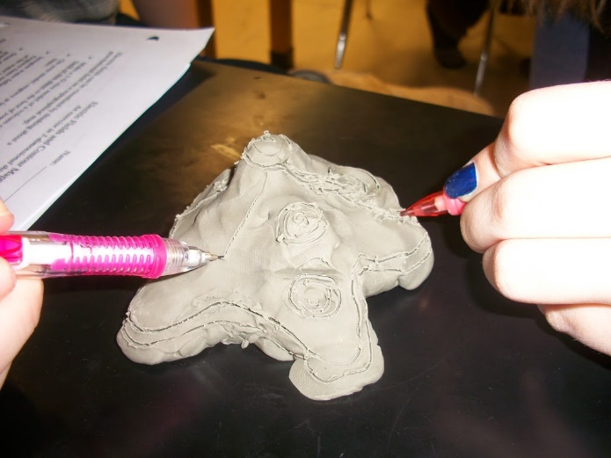
- Energy: PS3
Crosscutting Concepts:
- Patterns
- Cause and Effect
- Scale, Proportion, and Quantity
- Systems and System Models
- Energy and Matter
- Structure and Function
- Stability and Change
Science and Engineering Practices:
- Developing and Using Models
- Analyzing and Interpreting Data
- Constructing Explanations
- Engaging in Argument from Evidence

Materials:
- Clay (approximately 0.25-0.5 pound per small group)
- Pencils (sharpened)
- Water and dropper
- Computer, internet access, and projector (for displaying YouTube videos)

Prior Conceptual Understandings Required
- Charge (charged particle model of electricity)
- Fields (field lines, equipotentials)
- Potential (gravitational potential is gravitational energy per unit mass, while electric potential is electric energy per unit charge)

Lab Activities (in brief):
- Suggested pre-lab activity: Standard electric field mapping activity in which students see a uniform electric field and learn about electric field lines and equipotentials (lines of equal potential).
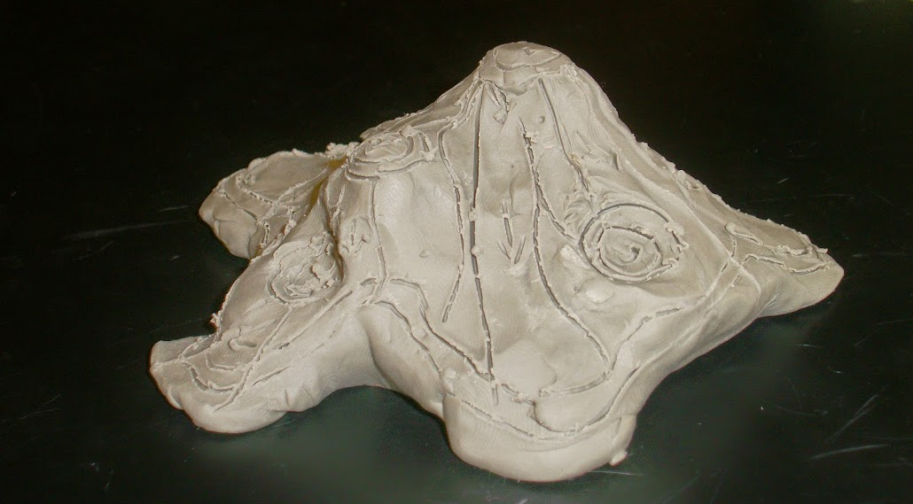
- Analyze a simple topographical map.
- Create a physical clay model of the topographical map.
- Relate the topographical map and clay model to electric fields.
- Analyze more complex topographical and electric potential maps.
- Watch James Lincoln’s Electric Field Visualized with Crystals and draw conclusions about the fields demonstrated.
- Summarize understandings about topographical and electric field maps.
- Suggested post-lab activity: Support students’ understandings through activities presented in James Lincoln’s additional videos about electric fields:
  - 10 Ways to See the Electric Field – Part 1
  - 10 Ways to See the Electric Field – Part 2

Geo-Electric Field Science: Using Topographic Maps and Clay Models to Teach Electric Field and Potential

Student Worksheet
Note to teacher: Italicized commentary are notes for teachers. Red statements show sample correct student responses. Highlighted yellow items are areas where students are likely to get “stumped.”

Purpose: Draw, build, and interpret electric fields using topographic maps.
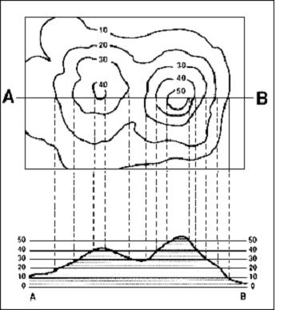
Credit: USGS
Background: Electric fields can be visualized by thinking about a gravitational field on a topographical map. In this activity, you will first make sense of a topographical map, then make a physical model to draw. Topographic maps give a sense of the three-dimensional shape of a landscape, such as in the image shown to the right. Contour lines give information about elevation. Visualizing a topographical map by looking at a profile can also be helpful. In the image to the right, a profile for the line drawn from points A to B is show immediately beneath it.

Guiding questions:

Look closely at the topographical map of a Hawaiian island on the following page. Answer the following questions in regard to the geographical information it presents.

  - What is constant along the contour lines? Height (or altitude) is constant along each contour line.

  - What is indicated by a region where the lines close on themselves, such as around points A, B, C, or D? These are generally the tops of peaks, but could also represent bottoms of dips on other maps.

  - In the space below, draw a profile view for a line that cuts directly West-East and through point D.

  - Imagine you allowed a ball to roll down from point D. How would the motion of the ball be different if it rolled eastward versus westward? Why? The ball would have a greater acceleration if it were to roll westward, as there is a steeper incline there.

Using clay, make a three-dimensional model of the island to the best of your ability. Using a sharp pencil, engrave at least 10 contour lines. Students might struggle to identify contour lines. Essentially, contour lines should be sketched at the same height (i.e. one centimeter above the surface of the workspace, two centimeters above the surface of the workspace, etc.). One effective method for helping students to visualize contour lines is to place the three-dimensional model into a tray or cooking dish. Pour various amounts of colored water onto and surrounding the model. The water will settle at points of equal elevation, thereby producing contour lines.

  - Before moving on, get approval of your clay model with contour lines by your teacher and get your teacher’s signature:

Using a dropper, drop individual droplets of water onto your clay model’s peaks, and note the direction that the droplets flow. Using a sharp pencil, draw in at least 20 small arrows showing the path of the water droplets.

  - Before moving on, get approval of your water droplet paths by your teacher and get your teacher’s signature:
Ensure that the water droplet paths are approximately perpendicular to the contour lines.

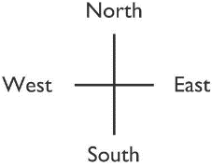
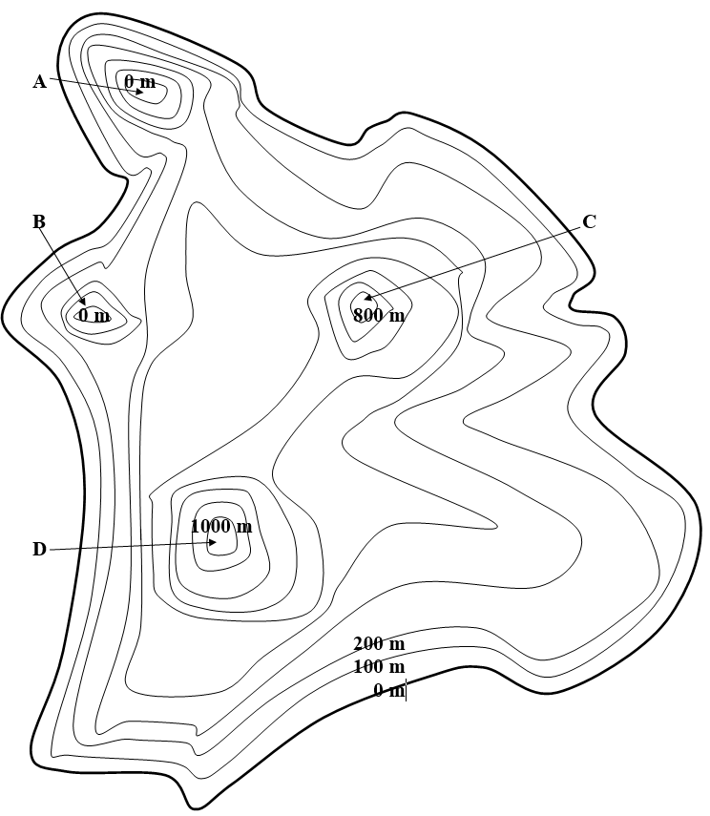
Now consider both the topographical map and the clay model of the island as if it represented an electric field. Note: For the purpose of this activity, assume that strong positive charges are the source of positive electric potential, represented by high altitude on a topographical map. In contrast, assume that strong negative charges are the source of “ground,” or a potential of zero.

  - What would be located at points A, B, C, and D? (What makes the mountains and valleys in an electric field?) Explain.
Points C and D are peaks, and are a result of a large accumulation of positive charge. Points A and B are valleys. Anything lower than this would be a result of accumulation of negative charge.

  - What would cause points C and D to have differing heights? Different amounts of accumulated charge would cause different heights, with higher points having greater positive charge.

  - What is represented by the water’s path? Explain. The water’s path would approximately show the path taken by positive charges with non-zero mass. Note that this is slightly different from an electric field line, because electric field lines show the direction of electric force acting on a positive charge.

  - What is represented by the contour lines? Explain. The contour lines show electric potential. Any points along a single line have the same potential, and is therefore an “equipotential.”

  - Return back to your profile view from question 3.

      - On which side of point D is the electric field the strongest? How do you know? Label a corresponding area on the graph as “E.” Any area where the contour lines are close together, the electric field is strong (“steep.”)

      - On which side of point D is the electric field the weakest? How do you know? Label a corresponding area on the graph as “F.” Any area where the contour lines are far apart, the electric field is weak (“shallow.”)

      - Describe how the motion of a moveable charged particle might be different if it moved down either the eastward or westward side of point D. Explain how you know. It depends upon the charge of the particle! If it is positive, it will accelerate quickly down the westward side. It will accelerate less quickly down the eastward side, because the field is not as strong (it is less steep). If the particle is negative, it will remain at the top of the peak.

  - Would it ever be possible for a charged particle to flow along a contour line? Why or why not? (Would it ever be possible for a water droplet to flow along a contour line?) No, because charge particles will only flow from high to low potential (if positively charged) or low potential to high potential (if negatively charged). Because there is no net force along an equipotential, there will be no flow.

  - What must be true about a clay model to have an electric field of zero? Can this only happen at “sea level”? Any place on the clay model where there is an area of “flatness” or a “plane of equipotential,” there is an electric field of zero. This can happen at any height/potential, not just at “sea level.”

  - Look closely at the geometric relationship between the contour lines and the rain lines. What is their relationship? They are about perpendicular to one another.

  - Describe the motion for a freely-moving positive test charge placed at the following points:
    - A: No motion – it will remain in the “valley.”
    - B: No motion – it will remain in the “valley.”
    - C: Accelerate down the “hill.”
    - D: Accelerate down the “hill.”

  - Describe the motion for a freely-moving negative test charge placed at the following points:
    - A: Accelerate out of the “valley.”
    - B: Accelerate out of the “valley.”
    - C: No motion – it will remain on the “hill.”
    - D: No motion – it will remain on the “hill.”

  - Using the image on the following page of a hilly terrain and the two sample “field lines,” draw in at least 10 field lines, including arrow heads to show direction. Note: As few elevations are given on this map, you may assume that the graph displays peaks only, and no valleys.

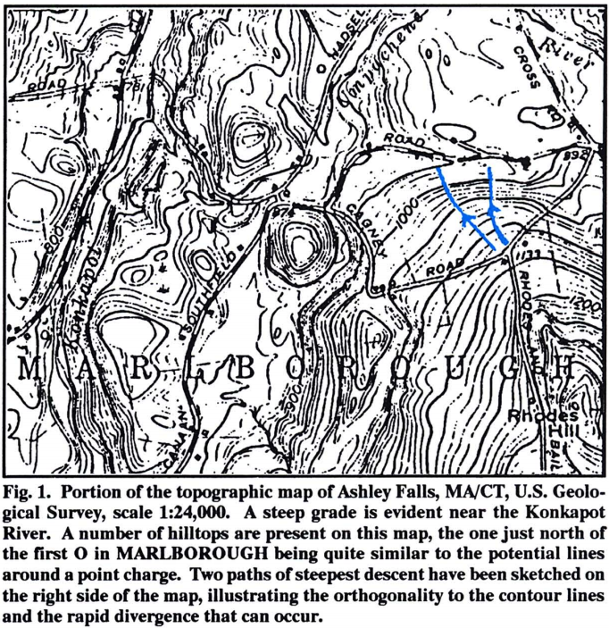

  - Using the image below, describe how you would use clay to model the two point charges below. If it’s helpful, include a profile sketch of this image, or create a clay model.
This clay model would have a large peak on the left, and a valley to the right. A profile would look something like the following:

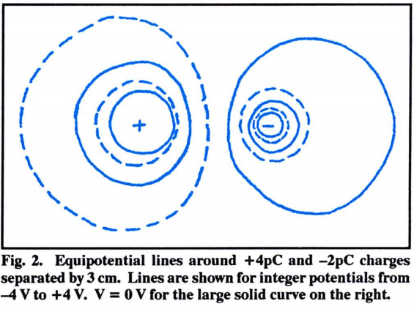

  - Observe James Lincoln’s Electric Field Visualized with Crystals YouTube video.
      - For each of the following scenarios, draw in the electric field lines (using arrows to denote direction), and equipotential lines. Note that electric field lines are typically draw from “positive to negative,” showing the direction of force acting on a positive test charge. In these videos, close observation will reveal that the colored potassium permanganate is drawn toward the positive terminal, as would be expected with a negative ion.
      - Describe the electric field as a three-dimensional shape.
      - Include a profile sketch (of a horizontal mid-line passing through it) of the three-dimensional shape.

Two Point Sources (Dipole)
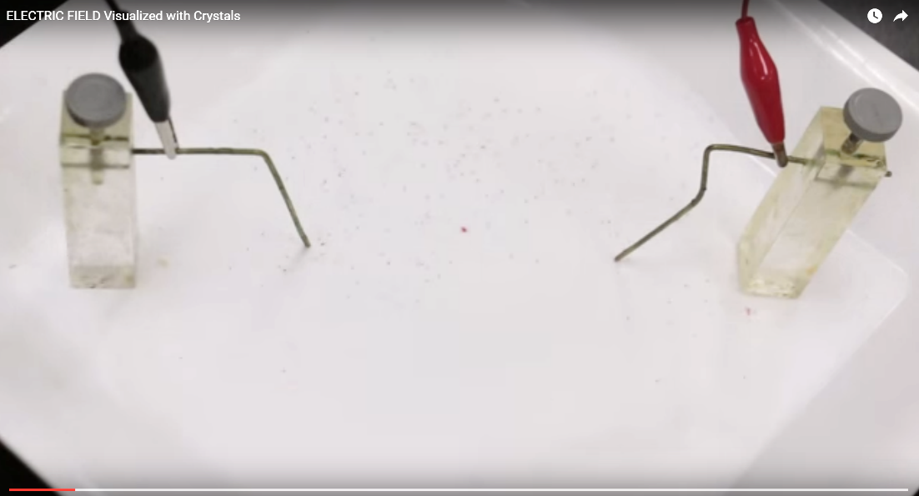
b. The field is composed of a conical “valley” and a conical “peak.”

c.

Point Source and Bar
b. The field is composed of long valley and a conical “peak.” The profile looks the same as above, although the three-dimensional shape is very different.

c.

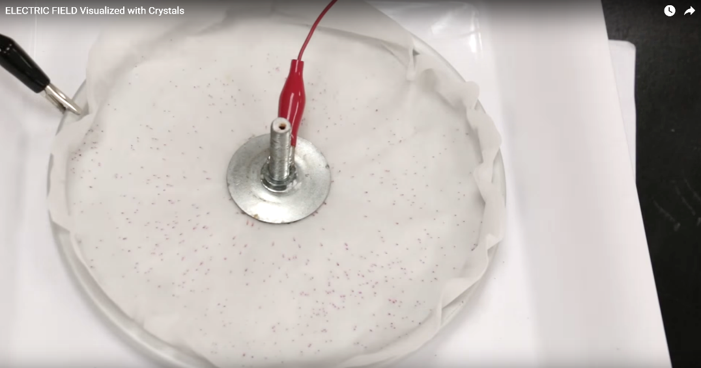
Point Source and Ring
b. The field is composed of a high middle “peak.” The “ground” is the lowest part around the peak.

c.

Two Bars (Parallel Plate Capacitor)
b. The field is composed of a long “valley” and a long “ridge.”

c.

  - Reflect back on both topographical maps and electric field maps. In paragraph form, describe the similarities and differences between them and how particles might interact differently in those fields.
In a topographical map, it is possible to infer things about how mass will move (namely, accelerate down a hill, never up a hill). In an electric field map, we can infer about how positive charges and negative charges will move – it is possible for some particles to accelerate UP a hill, while some will accelerate DOWN.

