Rocket Science: Using Conservation of Energy to Predict Max Height
Inspired by The Physics Teacher’s:
“Measuring Model Rocket Thrust Curves”
by Kim Penn and William V. Slaton
and
“This Is Rocket Science!”
by Wayne Keith, Cynthia Martin, and Pamela Veltkamp

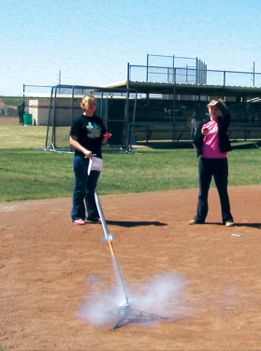
Description: In this multi-part application lab, students predict the motion and maximum height attained by a rocket, starting with a measured engine thrust curve and simplifying their study by assuming an average mass of the rocket system before and after burn-out.

Purpose: Measure the impulse generated by a rocket engine. Use the principle of conservation of energy to predict the maximum height of a rocket.

NGSS Connections:
Disciplinary Core Ideas:
- Motion and Stability: Forces and Interactions: HS-PS2-1
- Energy: HS-PS3-3
Crosscutting Concepts:
- Systems and system models
- Energy and matter
Science and Engineering Practices:
- Developing and using models
- Analyzing and interpreting data

See Page 10 for full listing of NGSS Standards connections

Materials:
- Tools for impulse Measurement:
  - Vernier or Pasco digital force meter
  - LoggerPro or SPARKvue data analysis software
- PASCO Rocket Engine Test Bracket
- For more information about PASCO’s Rocket Engine Test Bracket, see their Manual here:
- Copy & Paste Link to Manual pdf file Below:
https://www.pasco.com/file_downloads/Downloads_Manuals/Rocket-Engine-Test-Bracket-Manual-ME-6617.pdf
- PASCO Blog: Impulse of a Rocket Engine-Area Under a Force Curve
Link to Blog Page: Impulse of a Rocket Engine
- TARC-approved rocket engines
- Model rocket
- Model rocket launcher
- Inclinometer (physical or digital)

Prior Conceptual Understandings Required
- Linear Kinematics (uniform acceleration)
- Impulse-Momentum Theorem (and its mathematical and graphical representations)
- Conservation of Energy (and its representation through pie-charts)

Modifications:
- If a rocket engine test bracket is unavailable, use commercially-available thrust-curves for the rocket engines to be used.

Lab Activities (in brief):
- Activity 1: Measuring the impulse of the burn Engines apply a force to a rocket when they release their exhaust. However, two variables affect how much it will accelerate a rocket – the average force that it applies, as well as how much time elapses as the force is applied. Activity 1 requires students to develop a Force-Time graph for the engine they will be using to launch their rocket.
- Activity 2: Predicting the burn phase Students will save their engines from Activity 1. Students will determine the average mass of the rocket throughout its flight by averaging the mass and rocket before the burn in Activity 1, and after the burn. This information, along with the average net force on the rocket (ignoring friction) can be used to estimate acceleration and total height achieved throughout the burn phase.
- Activity 3: Predicting the coast phase Students will use standard kinematic equations and the maximum velocity achieved from the burn phase to determine the vertical distance achieved from burn-out to rest before it begins to move back down toward the surface of the Earth.
- Activity 4: Predicting the maximum height Students will sum the heights achieved during the burn phase and during the coast phase to estimate the total height achieved by the rocket if it is launched vertically.
- Activity 5: Calculating work, energy, and power Using the initial impulse and time, students will determine the total work done by the engine on the rocket, and use that information to draw pie charts representing changes in the forms of energy throughout the way-points along the flight path (i.e. start of launch, burn-out, maximum height). Using estimated times for each segment, students will calculate the power expended.
- Activity 6: Measuring Actual Rocket Values from a Launch Students will launch the model rocket with the same engine and body as used in all of the experiments. The rocket will be launched vertically, and the actual time to reach its apex as well as its height will be calculated using simple trigonometry.

Rocket Science: Using Conservation of Energy to Predict Max Height

Student Worksheet
Red statements show sample correct student responses.

Purpose: Measure the impulse generated by a rocket engine. Use kinematics and the principle of conservation of energy to predict the maximum height of a rocket.

Guiding questions: Consider before beginning: If impulse for a drag-free, vertically-launched rocket can be determined, how could the final height of the rocket be determined? Explain.
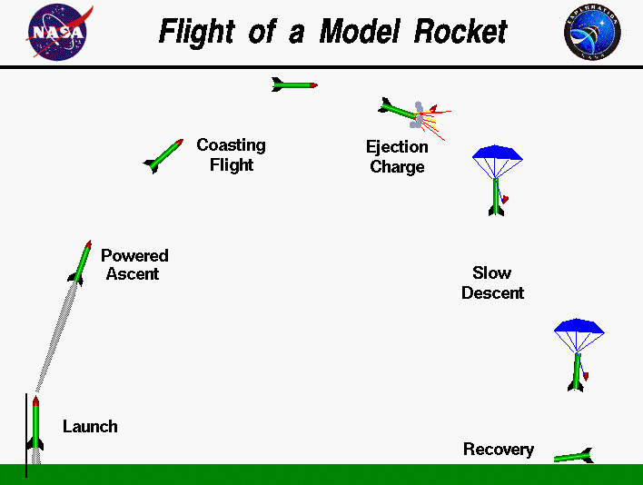
https://www.grc.nasa.gov/www/k-12/rocket/rktflight.html
In this laboratory activity, you will predict the maximum height of a rocket that is moving vertically, neglecting drag. To more fully understand the motion of a model rocket, refer to the image to the right, showing the “standard” stages of model rocket flight. Note that this image shows a parabolic flight focus on vertical launches only.

For each of the following stages, draw a proportionally-accurate force diagram showing relevant forces acting on the rocket. At this time, neglect drag.

Launch  (Engine begins burn, rocket not moving)  Thrust up < Weight down | Powered Ascent  (Engine fully burning, rocket accelerating upward)  Thrust up > Weight down | Coasting Flight I  (Engine no longer burning, rocket still moving upward)  Weight down
Coasting Flight II  (Rocket momentarily at rest)  Weight down | Ejection Charge  (Parachute releases)  Tension up < Weight down  Some thrust in one direction from the ejection charge. | Slow Descent I  (Terminal velocity not yet reached)  Tension up > Weight down
Slow Descent II  (Terminal velocity reached)  Tension up = Weight down | Recovery I  (Rocket is impacting ground)  Normal up > Weight down | Recovery II  (Rocket is at rest on ground)  Normal up = Weight down
Application Lab: Activity 1 - Measuring the Impulse of the Burn

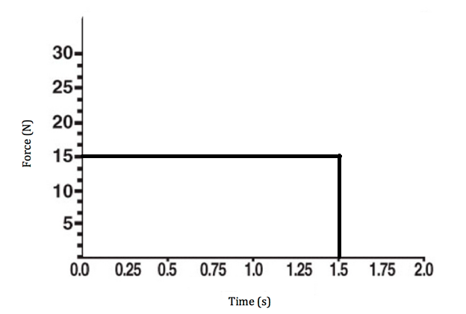
- When a rocket takes off, it is fueled by a burning engine. As the engine pushes the exhaust downward, which way must the rocket go? Why? Explain this in terms of Newton’s Laws and conservation of momentum.
The rocket must go up. The thrust of the rocket pushing down on the gas below the rocket is equal to the force of the gas pushing up on the rocket. Applying conservation of momentum, the rocket/gas system starts at rest with a momentum of 0. As the rocket goes up (with a positive momentum), the gas goes down (with a negative momentum), resulting in a net 0 momentum, as before it launched.

- Consider, for example, a situation in which a constant force is applied to a rocket.

  - How much force is applied during the engine burn in this graph? 15 N
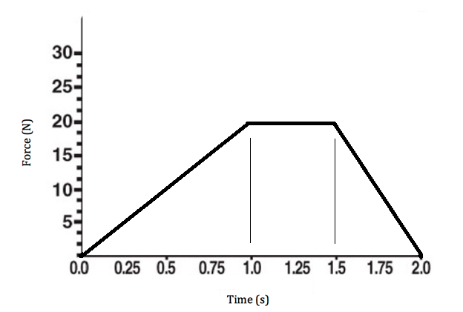
  - For how much time was the force applied? 1.5 s
  - How much impulse did the engine produce? Show work. 15 N * 1.5 s = 22.5 Ns

You might have noticed that by calculating the impulse of the engine that you were actually just multiplying the length by the width of the rectangular area made by the graph – impulse is the area of a Force-Time graph! Calculating the area under a curve is known – in calculus – as integration.

- How would you calculate the impulse of an engine with a Force-Time graph like the one to the right? Calculate it, and show work!

½ (20 N * 1 s) + (20 N * 0.5 s) + ½ (20 N * 0.5 s) = 25 Ns
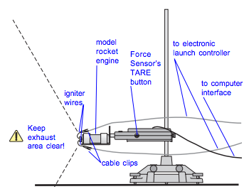
- Using a rocket engine test bracket, force meter, and data analysis program, create a Force-Time graph for a single-stage engine. Often times, the curves produced by these graphs are called thrust curves. Sketch the graph below. Use the integration tool to estimate the area under the curve, and list the total impulse. Follow all instructions and safety precautions explained by your teacher!

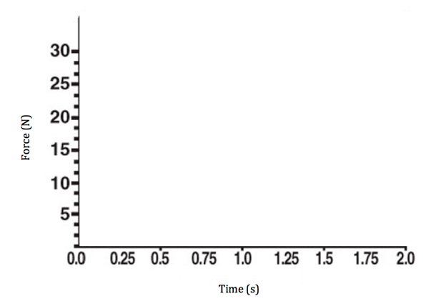

- If possible, get data from multiple trials or other groups who tested the same type of engine (ensure that the engines are from the same batch). List your impulse values below:

Trial | Total Impulse
1 | Answers will vary.
2
3

- How do the values of impulse compare across engines of the same type? If there are any differences, are they different by a significant amount? Provide a rationale.
Answers will vary. Engines from the same “batch” should show little variation.

- Refer to the engine user manual or an online guide from the company that produced the engines you tested. How does your data compare to “commercial specifications” provided by companies? Consider both total impulse as well as time and magnitude of peak force. Explain.
Answers will vary.

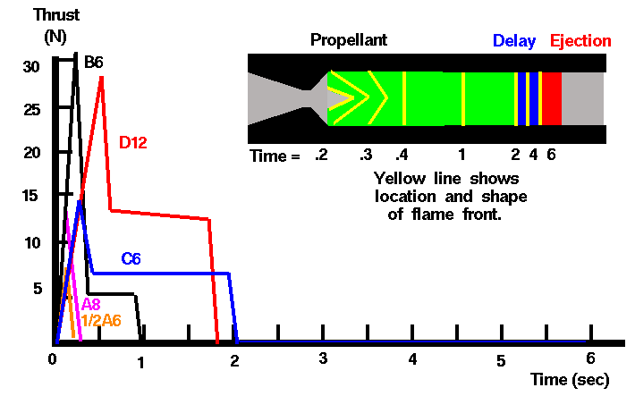

No matter the model rocket engine, most single-stage engines demonstrate the same force-time curve. Carefully study the yellow lines within the engine diagram above, representing the flame fronts, inside of the engine. Use your observations to answer the following questions about the graphs:

- Why is there an initial quick increase in force, a maximum peak, and then a nearly constant thrust thereafter, until the engine burns out? (Hint: Consider the surface area of the flame front).
From 0 to 0.2 s, there is a rapid increase in the surface area of the flame front, suggesting that fuel is being burned more quickly. From 0.3 to 0.4 s, the flame front quickly loses surface area, and therefore decreases the thrust. From 0.4 s to 2 s, the flame front continues to have the same surface area.

- How must an engine be designed to get greater thrust? If possible, look at a variety of engines with their associated thrust curves. An engine that has a greater diameter will have a larger surface area. An engine that is longer will burn for more time. The chemicals in the engine might also combust more efficiently and produce more thrust.

Example Estes engine thrust curves: http://www2.estesrockets.com/pdf/Estes_Time-Thrust_Curves.pdf

- Provide at least three possible sources of error (in manufacturing, the investigation’s procedure, or in the equipment used). Answers will vary.

Application Lesson: Activity 2 - Predicting the Burn Phase

- From your thrust curve in Activity 1, determine the average total impulse (I) produced by the engine you will use to launch you rocket later in this activity. Record this value here: Answers will vary

- From your thrust curve in Activity 1, determine the average burn time (t_{b}) of the engine you will use to launch your rocket later in this activity. Record this value here: Answers will vary

- For this activity, assume that friction is negligible. Using the values from questions (1) and (2) above, determine the average net force (F_{net}) acting on the rocket. Average net force = impulse / time

- Determine the average mass of your rocket during its flight. (Hint: The mass of the rocket + engine at the start of the launch is not the same as the mass of the rocket + engine at the end of the rocket’s flight!) Feel free to use fresh and burned engines from Activity 1, and to use an electronic or triple-beam balance. List your average mass, and explain how you got it. Average mass = (Mass before burn + Mass after burn)/2

- Draw a diagram of the rocket and the forces acting on it during the burn. Ignore drag. Identify the net force, F_{net}, acting on the rocket. (Hint: There is more than thrust acting on the rocket!)
During the burn, there is F_{g}, the force of gravity downward pulling on the rocket, F_{t}, the force of the thrust pushing upward on the rocket. The net force is the difference between the magnitude of the thrust and the weight.

- Using F_{net}, estimate the average acceleration on the rocket during the burn. Show work.
Average acceleration = Average net force / average mass

- Determine the maximum velocity during the burn phase (v_{maxb}) from the burn time and average acceleration.
Maximum velocity = average acceleration * burn time

- Starting at rest, calculate the average velocity of the rocket during the burn phase.
Average velocity = (maximum velocity + initial velocity)/2

- Determine the height gained during the burn from the average velocity and burn time.
Height = average velocity * time

Application Lesson: Activity 3 - Predicting the Coast Phase

- Assuming no drag, estimate the time that elapses from the moment of maximum velocity at the end of the burn, to the moment the rocket vertically stops moving at the peak of its trajectory.
v initial = maximum velocity from #7
v final = 0

v_{f} = a t + v_{i}

- Calculate the average velocity during the coast phase. (Is it the same as the average velocity during the burn phase? Explain.)
Average velocity = (maximum velocity + initial velocity)/2

- Determine the height gained during the coast phase.
Height = average velocity * time

Application Lesson: Activity 4 - Predicting Maximum Height

- Estimate the maximum height achieved from both the burn and the coast phases.
Answers will vary.

- Explain how you accomplished this.
Height from Activity 2, #9 added to the height from Activity 3, #3.

Application Lesson: Activity 5 - Calculate Work, Energy, and Power
For each of the following questions, show calculations and provide a narration explaining the origin of each of your numbers, and why you chose the process you chose.

- Calculate the work done on the rocket by the motor during the burn phase.
Average force * height = work

- Calculate the power output of the rocket during the burn phase.
Power = work/time

- Calculate the potential energy of the rocket at burn-out. PE = mass * 9.8 N/kg * height

- Calculate the kinetic energy of the rocket at burn-out. KE = 0 (velocity is zero assuming it was launched straight up)

- Calculate the total energy of the rocket at burn-out. Total energy = PE + KE

- Given the total energy with which you calculated that the rocket started, draw an energy pie chart representing the forms of energy at each point in its trajectory.

Launch  (Engine begins burn, rocket not moving) | Powered Ascent  (Engine fully burning, rocket accelerating upward) | Coasting Flight I  (Engine no longer burning, rocket still moving upward)
Coasting Flight II  (Rocket momentarily at rest) | Ejection Charge  (Parachute releases) | Slow Descent I  (Terminal velocity not yet reached)
Slow Descent II  (Terminal velocity reached) | Recovery I  (Rocket is impacting ground) | Recovery II  (Rocket is at rest on ground)

- Using estimated final height of the rocket, calculate the potential and kinetic energy at the peak of its vertical motion.
Total energy = PE = final mass of rocket after burnout * 9.8 N/kg * maximum height

- Compare the work done by the motor, the total energy at burn-out, and the potential energy at the highest point. How do they compare? Explain what Law this data demonstrates.
They are all the same value. This is due to Conservation of Energy.

Application Lab: Activity 6 - Measuring Actual Rocket Values

- Go outside and prepare to launch your rocket!

- Use a method you determine with your teacher to be appropriate and safe to estimate the maximum height of the rocket, as well as the time from takeoff to maximum height. Explain your process below, and include data and calculations. Answers will vary.

- How did predicted and actual total height values compare to one another? Why might these be different? Answers will vary.

- Calculate the average velocity of the rocket during its upward motion. How does this compare to the average velocities for the separate burn and coast phases that you predicted? Why? Answers will vary.

- Calculate the average velocity during the descent phase. Answers will vary.

- Calculate the actual potential energy at the height reached by the rocket. Answers will vary.

- How many g-forces did the rocket experience during launch? Answers will vary.

- How do the predicted potential energy at the peak of the rocket’s motion compare to one another? What must account for this difference? (Work done by drag!) Answers will vary.

- Calculate the average force of drag on the way up. Answers will vary.

NGSS Standards
Performance Expectations

Physical Science – Forces and Motion
- HS-PS2-1: Analyze data to support the claim that Newton’s second law of motion describes the mathematical relationship among the net force on a macroscopic object, its mass, and its acceleration.
- MS-PS2-2: Plan an investigation to provide evidence that the change in an object’s motion depends on the sum of the forces on the object and the mass of the object.
Physical Science – Energy
- HS-PS3-3: Design, build, and refine a device that works within given constraints to convert one form of energy into another form of energy.

Disciplinary Core Ideas

Physical Science DCIs – Forces and Motion
- HS-PS2.A.1: Newton’s second law accurately predicts changes in the motion of macroscopic objects.
- MS-PS2.A.1: For any pair of interacting objects, the force exerted by the first object on the second object is equal in strength to the force that the second object exerts on the first, but in the opposite direction (Newton’s third law).
- MS-PS2.A.2: The motion of an object is determined by the sum of the forces acting on it; if the total force on the object is not zero, its motion will change. The greater the mass of the object, the greater the force needed to achieve the same change in motion. For any given object, a larger force causes a larger change in motion.

Physical Science DCIs – Conservation of Energy
- HS-PS3.B.3: Mathematical expressions, which quantify how the kinetic energy depends on mass and speed, allow the concept of conservation of energy to be used to predict and describe system behavior.

Engineering and Technology Standards (ETS)

Disciplinary Core Ideas: Engineering & Technology

Developing Possible Solutions
  - When evaluating solutions it is important to take into account a range of constraints including cost, reliability, and aesthetics and to consider social, cultural, and environmental impacts.
  - Both physical models and computers can be used in various ways to aid in the engineering design process. Computers are useful for a variety of purposes, such as running simulations to test different ways of solving a problem or to see which one is most efficient or economical.

Crosscutting Concepts

Cause and Effect
- Systems can be designed to cause a desired effect.

Systems and System Models
- When investigating or describing a system, the boundaries and initial conditions of the system need to be defined and their inputs and outputs analyzed and described using models.
- Models can be used to predict the behavior of a system, but these predictions have limited precision and reliability due to the assumptions and approximations inherent in models.

Energy and Matter
- Energy cannot be created or destroyed – it only moves between one place and another place, between objects and/or fields, or between systems.
- Changes of energy in a system can be described in terms of energy and matter flows into, out of, and within that system.

Stability and Change
- Changes and rates of change can be quantified and modeled.

Science and Engineering Practices

Analyzing and Interpreting Data
- Analyze data using tools, technologies, and/or models in order to make valid and reliable scientific claims or determine an optimal design solution.

Designing Solutions
- Apply scientific principles and evidence to provide an explanation of phenomena and solve design problems, taking into account possible unanticipated effects.

Developing and Using Models
- Use a physical model to predict the relationships between systems or between components of a system.

Planning and Carrying Out Investigations
- Plan and conduct an investigation individually and collaboratively to produce data to serve as the basis for evidence, and in the design: decide on types, how much, and accuracy of data needed to produce reliable measurements and consider limitations on the precision of the data (e.g., number of trials, cost, risk, time), and refine the design accordingly.

Using Mathematics and Computational Thinking
- Use mathematical representations of phenomena or design solutions to describe and/or support claims and/or explanations.
- Use mathematical representations of phenomena to design solutions to support and revise explanations.
- Use mathematical models to predict the effects of a design solution on systems and/or the interactions between systems.

