Star Spectra Science: Using Balloons and Buttons
to Model Spectroscopy
Inspired by The Physics Teacher’s
“Balloon and Button Spectroscopy: A Hands-On Approach to Light and Matter” by Joseph Ribaudo

Description: Students model spectroscopy through the analysis of colored buttons (“photons”) found inside colored balloons (“stars”).

Purpose: Interpret spectra of stars by sorting colored buttons.

NGSS Connections:
Disciplinary Core Ideas:
- Waves and Their Applications in Technologies for Information Transfer: MS-PS4-2, HS-PS4-1, HS-PS4-3
- Earth’s Place in the Universe: HS-ESS1-2, HS-ESS1-3
Crosscutting Concepts:
- Scale, proportion, and quantity
- Systems and system models
- Energy and matter: Flows, cycles, and conservation
Science and Engineering Practices:
- Developing and using models
- Analyzing and interpreting data
- Obtaining, evaluating, and communicating information

Materials:
- buttons (per full set-up to be shared among a small group)
  - Violet – 85 buttons
  - Blue – 120
  - Green – 80
  - Yellow – 70
  - Orange – 60
  - Red - 60
- balloons (per full set-up to be shared among a small group)
  - Red - 1
  - White - 1
  - Blue - 1
- sandwich bags or small cups – 3
- pushpins or scissors for popping balloons (optional)
- colored pencils/markers (optional)

Advanced Preparation:
- Prepare the following astronomical objects and spectra:
  - If you choose to inflate the balloons, ensure they are the same size.
  - Red star
    - Inside a red balloon, place the following types of buttons: 4 violet, 5 blue, 5 green, 6 yellow, 8 orange, and 7 red.
    - Blow up the balloon and tie it off (optional).

  - White star
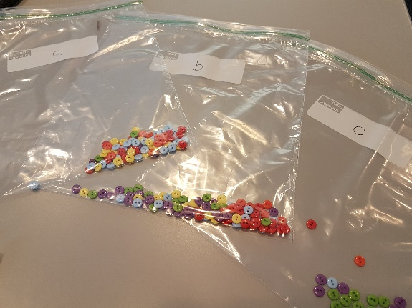
    - Inside a white balloon, place the following types of buttons: 12 violet, 12 blue, 13 green, 12 yellow, 11 orange, and 10 red.
    - Blow up the balloon and tie it off (optional).
  - Blue star
    - Inside a blue balloon, place the following types of buttons: 25 violet, 30 blue, 25 green, 20 yellow, 15 orange, and 13 red.
    - Blow up the balloon and tie it off (optional).
  - Spectra from blue star with absorption
    - Label the plastic baggie as “a.”
    - In the plastic baggie, place the following types of buttons: 4 violet, 30 blue, 2 green, 20 yellow, 14 orange, and 10 red.
  - Spectra from white start with discrete emission
    - Label the plastic baggie as “b.”
    - In the plastic baggie, place the following types of buttons: 25 violet, 12 blue, 13 green, 12 yellow, 10 orange, and 20 red.
  - Spectra with discrete emission
    - Label the plastic baggie as “c.”
    - In the plastic baggie, place the following types of buttons: 15 violet, 1 blue, 20 green, 1 yellow, 1 orange, and 1 red.

Activities (in brief):
- Discuss the nature of light and the various ways light can be categorized (color, energy, wavelength, frequency).
- Ask students to assign a wavelength (in nm) and calculate the corresponding energy (in eV) for each color in the visible spectrum.
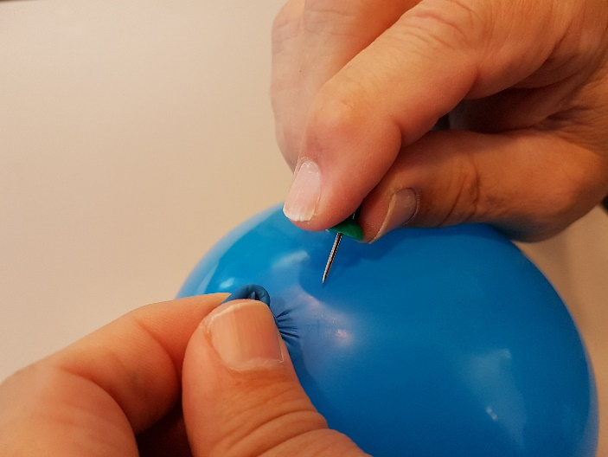
- Identify energy transitions and corresponding color for energy-level diagrams for model atoms. Note that only visible wavelengths of light are modeled in this activity.
- Pop the balloons or remove buttons from each balloon. Do this by using scissors or a push pin to carefully deflate the balloon near the tie, to avoid the balloon exploding.
- Sort buttons separately for the red, white, and blue stars. Plot the number of buttons per color on histograms.
- Identify the peak emission wavelengths for each star and estimate the surface temperature of each.
- Compare the luminosity of the three stars, assuming equal size.
- Analyze spectra of three mystery objects by sorting buttons separately for baggies a, b, and c. Plot the number of buttons per color on histograms.
- Describe the spectra of each mystery object in terms of known star spectra and given energy-level diagrams for model atoms.
- Observe emission features of gas discharge tubes.

Prior Conceptual Understandings Required
- Dual nature of light (wave-particle theory)
- Planck’s equation
- Energy-level diagrams for atoms
- Wien’s law
- Stefan-Boltzmann law

Modifications:
- Use various hues of each color of button in order to extend a discussion of instrument sensitivity and resolution.
- Vary the size of balloons to represent stars (and proportionally increase the number of buttons used to represent spectra intensity)
- Extend the lab with a quantitative spectrometry lab.
- Assess student understanding before and after instruction with the Light and Spectroscopy Concept Inventory.
- Be aware of potential colorblindness among students. Consider having each button of each color have a different shape or texture so that they can be differentiated independently of their color.

Star Spectra Science: Using Balloons and Buttons to Model Spectroscopy

Student Worksheet
Note to teacher: Italicized commentary are notes for teachers. Red statements show sample correct student responses.
Purpose: Interpret spectra of stars by sorting colored buttons.

Guiding questions:
Astronomers can learn an immense amount about starts from their spectra. In this activity, you will model how astronomers do this using colored buttons.

- In this activity, you will see colored buttons (violet, blue, green, yellow, orange, and red) that will represent photons. For each color, determine the corresponding wavelength (using a textbook or digital resource) and calculate the energy of a single photon of that color (show work).

Students are likely to find that the wavelength will vary slightly depending upon the resource they use (where one color begins and ends along the continuous spectrum is somewhat subjective). Before continuing the lab, allow students to discuss the discrepancies, and encourage all students use the following wavelengths.

Energy can be calculated using Planck’s equation. Ensure that students correctly convert from Joules to eV.

Color | Wavelength (nm) | Energy (eV) | How energy was calculated  E = hc/λ in Joules  Convert J to eV (1J / 6.242x10¹⁸ eV)
Violet | 400 | 3.10 | E = (6.6×10⁻³⁴ Js) * (2.9×10⁸ m/s)/(4x10⁻⁷ m)
Blue | 475 | 2.61 | E = (6.6×10⁻³⁴ Js) * (2.9×10⁸ m/s)/(4.75x10⁻⁷ m)
Green | 525 | 2.36 | E = (6.6×10⁻³⁴ Js) * (2.9×10⁸ m/s)/(5.25x10⁻⁷ m)
Yellow | 575 | 2.16 | E = (6.6×10⁻³⁴ Js) * (2.9×10⁸ m/s)/(5.75x10⁻⁷ m)
Orange | 600 | 2.07 | E = (6.6×10⁻³⁴ Js) * (2.9×10⁸ m/s)/(6x10⁻⁷ m)
Red | 650 | 1.91 | E = (6.6×10⁻³⁴ Js) * (2.9×10⁸ m/s)/(6.5x10⁻⁷ m)

- Look at the following energy-level diagrams for Model Atom #1 and Model Atom #2 below. For each energy transition (absorption or emission), label the color photon that corresponds.

Students are likely to immediately note that not all of the energies are listed in their table on the previous page. As such, this is a valuable opportunity to discuss that this lab will only model visible light, although astronomical objects can absorb and/or emit light from the full electromagnetic spectrum. Correct labels to be placed by students are boxed in red.

Model Atom #1 Model Atom #2
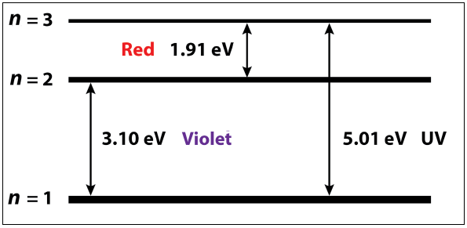
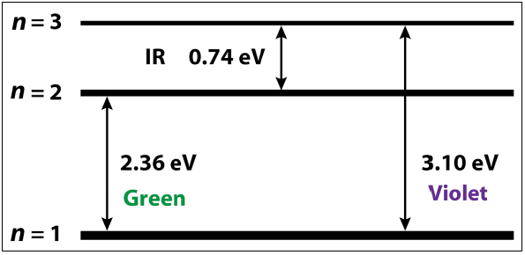

Provide a filled red, white, and blue balloon to each student group.

- Collect three “stars” (balloons) from your teacher. What similarities and differences do you notice about each “star”?

Similarities: same size
Differences: different colors (different temperatures), different weights/number of photos

- Separately, you will now analyze the spectrum of each “star.” One at a time, separate the “photons” into their respective colors, and count them. Create a histogram of the colors for each star on the following page. If you have colored pencils, color the histogram bars with their respective color.

Sample completed histogram bars are found in the charts on the next page, in the red boxes.

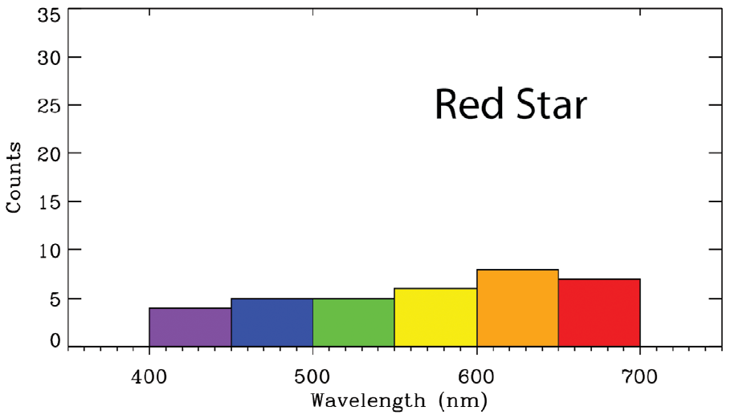

Peak: 600 nm

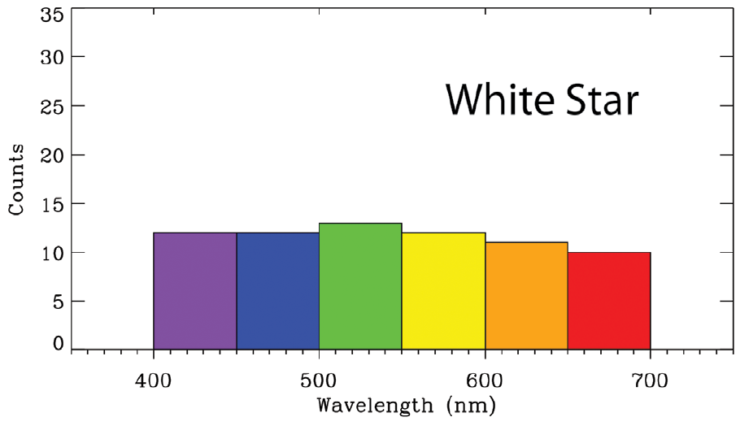

Peak: 525 nm

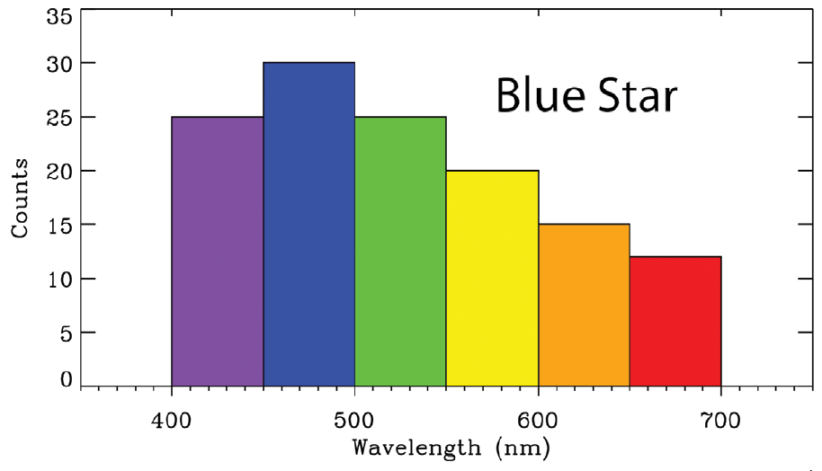

Peak: 475 nm

- On the previous page, label the approximate peak wavelength for each star.

- Do you see any correlation between the peak color and the perceived color of the star? Explain.
The peak wavelength color dominates for the red star (peak color “orange”) and the blue star (peak color blue). This is not true for the white star (peak color “green”). This is likely because the start with the peak green also has a significant amount of red and blue ends of the spectrum. Combined, this is perceived as white by the human eye.

- Estimate the surface temperature of each star. Show your work.

Encourage students to use Wein’s law to quantitatively determine the temperatures.

 | Red | White | Blue
Temperature (K) | 4800 K | 5500 K | 6100 K
How temperature was calculated  T = (2.9×10⁶ K nm)/ λ_{peak} | T = (2.9×10⁶ K nm)/ λ_{peak}  T = (2.9×10⁶ K nm)/ 600 nm | T = (2.9×10⁶ K nm)/ λ_{peak}  T = (2.9×10⁶ K nm)/ 525 nm | T = (2.9×10⁶ K nm)/ λ_{peak}  T = (2.9×10⁶ K nm)/ 475 nm

- How does the luminosity of the three stars compare? Provide a justification for your answer.

If necessary, remind students that the stars are all relatively the same size. The Stefan-Boltzmann law can be applied.

L = σ ( 4 п R²) T⁴. Because the only difference between each star is the temperature, T, we need to only calculate and compare T⁴.

Red: T⁴ = (4800 K)⁴ = 5.3×10¹⁴ K⁴
White: T⁴ = (5500 K)⁴ = 9.2×10¹⁴ K⁴
Blue: T⁴ = (6100 K)⁴ = 1.4×10¹⁵ K⁴

Blue is 1.5 times as luminous as the white star.
The white star is 1.7 times as luminous as the red star.

Provide baggies “a,” “b,” and “c” to each student group.

- You will now be provided with three “mystery” astronomical objects and their absorption or emission spectra. For each of baggy “a,” “b,” and “c,” separate the “photons” into their respective colors, and count them. Create a histogram of the colors for each star on the following page. If you have colored pencils, color the histogram bars with their respective color.

Sample completed histogram bars are found in the charts on the next page, in the red boxes.

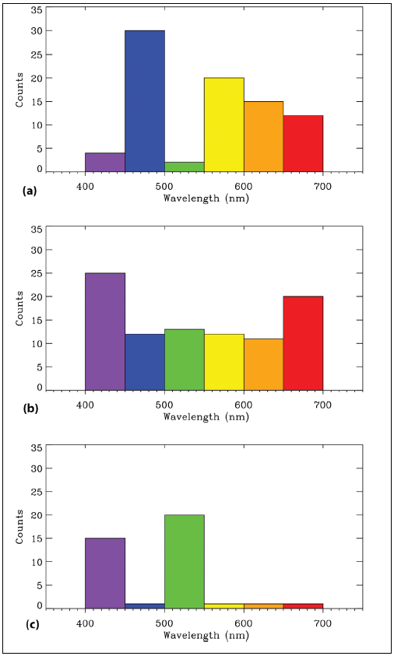
When astronomers observe spectra, they are likely to get a combination of light from various objects in their path. For example, when observing the light of a star, it is possible that the star’s light will have passed through combinations of:

Cool, diffuse gas that absorbs light

or

Warm, diffuse gas that emits light

These absorptions or emissions correspond to changes in the energy levels of electrons that are
dependent upon the type of element involved.

- Draw a diagram explaining why you observed the spectra for baggies “a,” “b,” and “c” based upon what you know about red, white, and blue stars, Model Atom #1 and #2, and how they must have been aligned in the astronomer’s line of sight

 | Diagram | Explanation
Example |  | A red star emitted a spectrum, but colors “X,” “Y,” and “Z” were absorbed by a cool, diffuse gas before being observed by the astronomer.
Baggie “a” |  | A blue star emitted a spectrum, but violet and green were absorbed by a cool, diffuse Model Atom #1 gas before being observed by the astronomer.
Baggie “b” |  | A white star emitted a spectrum, and additional violet and red were emitted by a warm, diffuse Model Atom #2 gas before being observed by the astronomer.
Baggie “c” |  | A warm, diffuse Model Atom #1 gas emitted its own light.

If possible, observe the atomic spectra of various elements directly with emission tubes and diffraction gratings.

- Based on this activity, summarize what information astronomers can gather from using atomic spectra.

Star color, temperature, luminosity, and the presence of cool or warm diffuse gases in front of the star.

- In modeling atomic spectra with balloons and buttons, what are the limitations to this activity? (How does it differ from what astronomers do?)

Spectrum analysis uses instruments that have a much higher resolution than only seven colors. Stars and gases emit (or absorb) non-visible light in addition to colors perceived by humans. Not all stars are the same size.
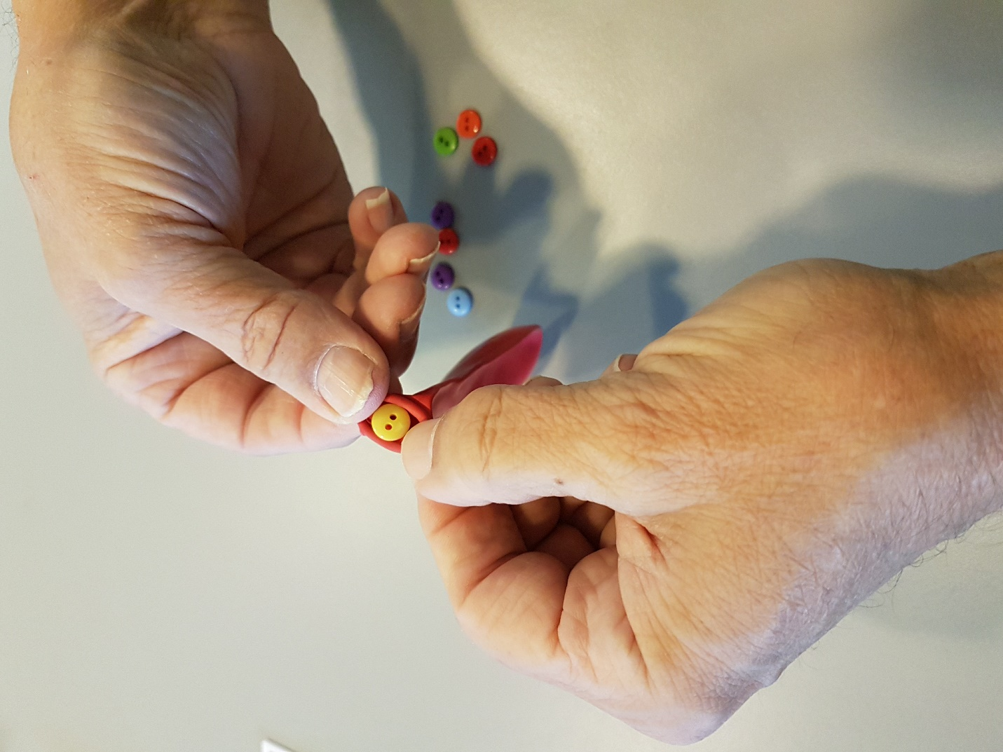

- Observe the spectral curves for stars of various temperatures below. How does the data you collected in this lab compare to the data on the curves below? Why is there a difference?

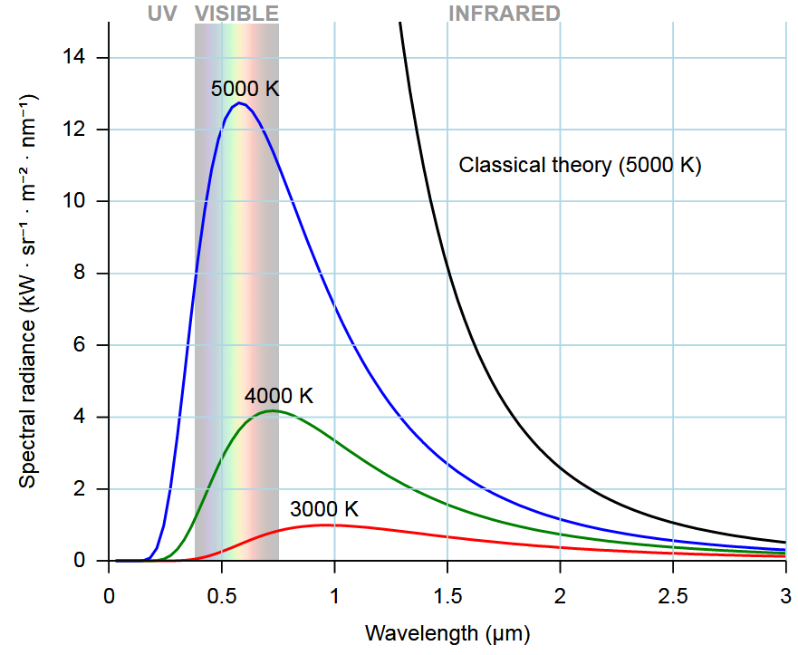
The spectral curves are much smoother, because the measurement tools likely had a much higher precision. The data here displays non-visible wavelengths of light.

The data here is also similar, however, in that the hotter stars had higher temperatures and greater radiance.

