Lecture Tutorial: Measuring the Frequency and Period of Sunspots

Description: This data analysis activity requires students to analyze sunspots on NASA’s SOHO coronagraph images to make meaning of cyclical patterns using the terms period and frequency. This resource is designed to supplement Lecture-Tutorials for Introductory Astronomy for lecture-style classrooms.

This activity requires use of the SOHO website to view images.

For question 5, we suggest the use of YouTube here:
- Sunspot Time-Lapse February 2013: https://www.youtube.com/watch?v=NA961oOs2FY
- 15 Years of Sun in 15 Minutes: https://www.youtube.com/watch?v=mi6FU_mejz8
- Sunspot Time-Lapse (graph revealed at end): https://www.youtube.com/watch?v=ntMcdg7oZlE

Additional videos of sunspots can be found on the SOHO website, but they must be downloaded to play: https://sohowww.nascom.nasa.gov/bestofsoho/Movies/sunspots.html

Prerequisite:
● None

Instructions:
In this activity, you will analyze various types of data associated with the periodic cycle of sunspots. Some of the data you will analyze was collected by scientists nearly 300 years ago!

Part 1: Define Frequency and Period

To better understand frequency and period, imagine the following scenario:

Envision yourself along with a classmate in a boat away from the beach. You are counting the wave crests that pass your boat during the span of 10 minutes. Your classmate is timing how long it takes between the arrival of one crest and the next.
- In a brief paragraph, describe what is different about the measurements each of you is taking while in the boat.

- Scientists describe these two ways of measuring cyclical patterns in terms of the following:
Period: The length of time for repetitions of a pattern to repeat itself.
Frequency: The number of repetitions in a pattern per unit of time.

Based on the above definitions, which person in the boat is measuring the period? the frequency?

- While in the boat, a storm picks up, and the wave crests come more often. How will the period and frequency change?

The terms period and frequency can be used for any kind of cyclical or “periodic” phenomenon.
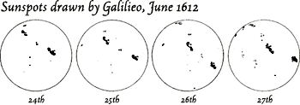
Sunspots were observed as early as the 9th century BCE in the ancient Chinese divination text, the I Ching, and again in the 4th century BCE by Theophrastus.

Galileo Galilei observed and recorded sunspots in the 1600’s and noticed that the appearance of these dark splotches on the Sun came and went in a regular pattern.

Nowadays, sunspots can be observed by anyone through a telescope using an approved solar filter, and images are professionally captured by NASA’s SOHO (Solar and Heliospheric Observatory), a camera that has been placed in space. Dark spots on the Sun are produced by strong localized magnetic fields that cause the region to be cooler and appear darker than the surrounding area.

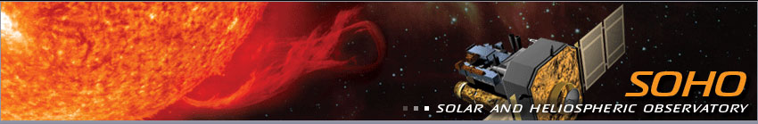
Credit: NASA
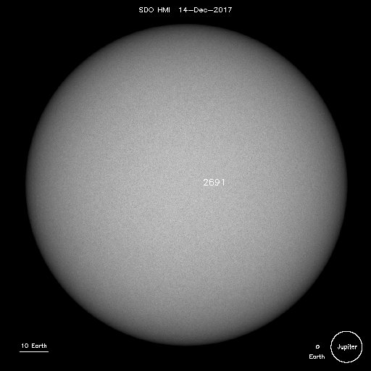
Part 2: Single Observation

- Look at an image of the Sun today on SOHO’s site: https://sohowww.nascom.nasa.gov/sunspots/

a) Sketch any sunspots on the image to the right. If there are no sunspots, click on “List of all available daily images” and find a day with clearly visible sunspots. Include the date below the image. (Hint: You might want to look at images from 2012.)

b) How big are these sunspots? (Estimate based on the diameter of Earth and/or Jupiter, which are illustrated in the low-right corner of the image of the Sun).

- Watch a sunspot time lapse video shown by your instructor. Or, see a variety of sunspot time lapses from SOHO here at the following links:

Sunspot Time-Lapse February 2013: https://www.youtube.com/watch?v=NA961oOs2FY
15 Years of Sun in 15 Minutes: https://www.youtube.com/watch?v=mi6FU_mejz8
Sunspot Time-Lapse: https://www.youtube.com/watch?v=ntMcdg7oZlE

Would it be appropriate to use the terms period and/or frequency when describing these images?
Why or why not?

Part 3: Describe Sunspot Cycles in Terms of Period and Frequency (Long Period)

People have been making observations of the Sun for a really long time. When you plot the number of sunspots produced each month, you find an interesting pattern. Two graphs below display data across the past 50 years and the past three centuries.
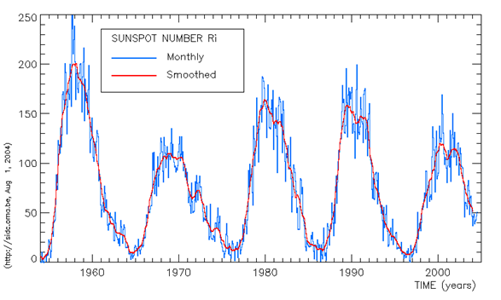

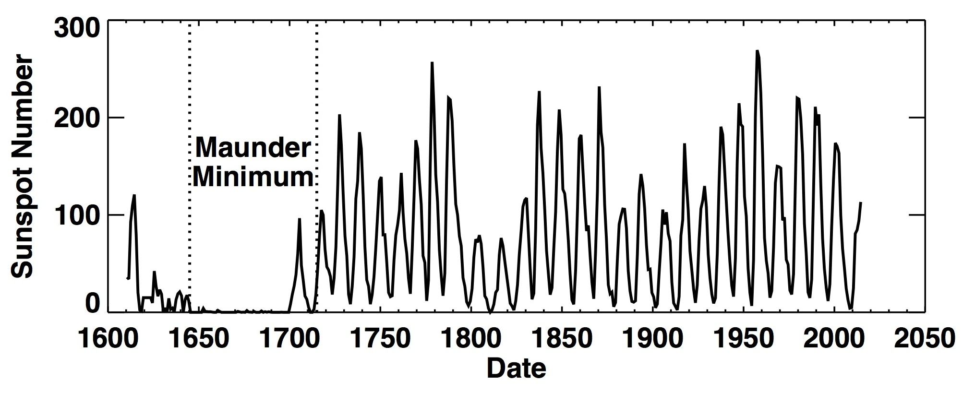
Sunspot Number
- What is similar and what is different about the two graphs above?

- What pattern or patterns do you notice about the number of sunspots produced as time goes by? Consider both graphs on the previous page.

- Describe the changes in the number of sunspots: (refer back to #2 if necessary)

- What is the period of sunspot cycles? In other words, how long is one solar cycle?
(Explain how you calculated this).

- What is the frequency of sunspot cycles? (Explain how you calculated this).

Part 4: Maximum and Minimum

- Using the 1950-2005 graph, in what years do you see a solar maximum (the largest number of sunspots)?

- Using the 1950-2005 graph, in what years do you see a solar minimum (the smallest number of sunspots)?

- Is the number of sunspots observed at solar maximum the same from cycle to cycle? Explain how you know.

Part 5: Extending the Sunspot Model

- Predict: When do you expect the next solar maximum to be? Extend the graph into the gray area with a sketch.
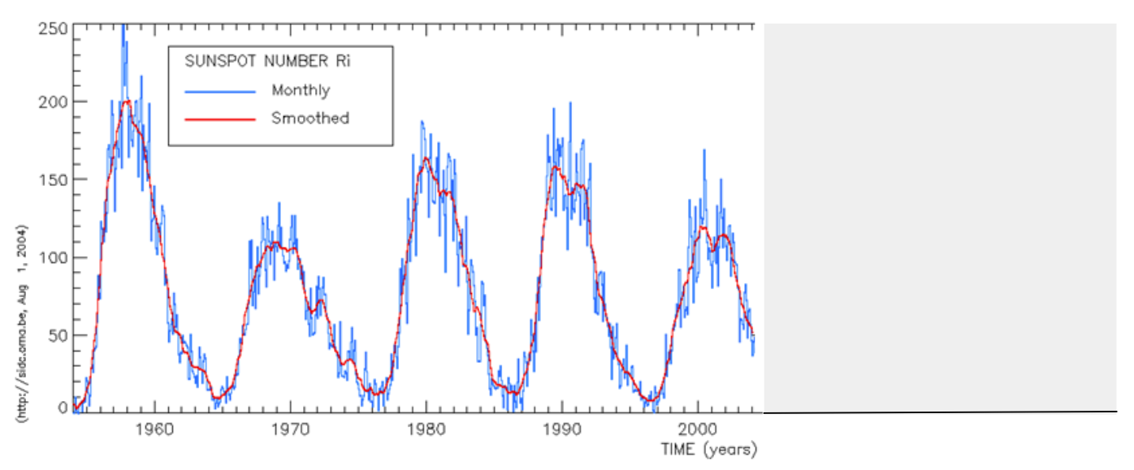
Sunspot Number
- Predict: What would the graph above look like if it was to have a higher frequency?
Sunspot Number

- Predict: What would the graph above look like if it was to have a longer period?

Sunspot Number

- The graphs on the previous page end in 2004. Check the link below to see if the extension you added was how the sun actually behaved from 2004 until now. https://solarscience.msfc.nasa.gov/SunspotCycle.shtml

- What are some reasons humans care about Sunspots? In what ways might they affect our daily lives?

- What can happen to Earth if there are no sunspots for a long period of time?

- What can happen to Earth if there are an unusually large number of sunspots?

Part 6: Additional Cycles

- The Sun has cycles other than the number of sunspots. Look at the images below of the location of sunspots. What kinds of cycles do you notice? How might you measure or quantify these changes? (Write your answer at the top of the next page.)

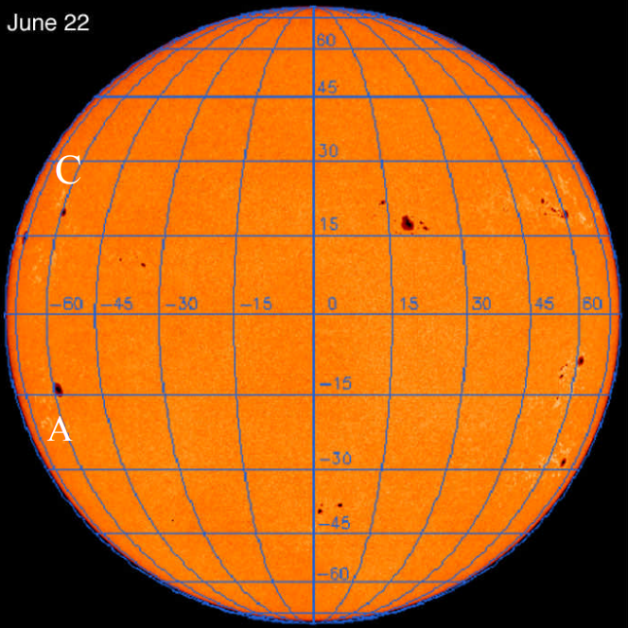 | 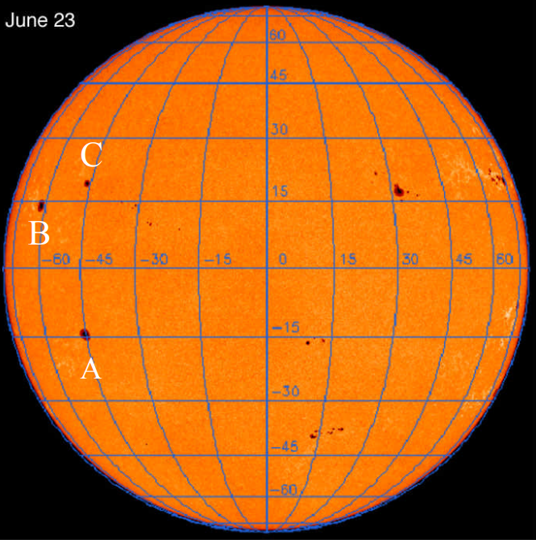
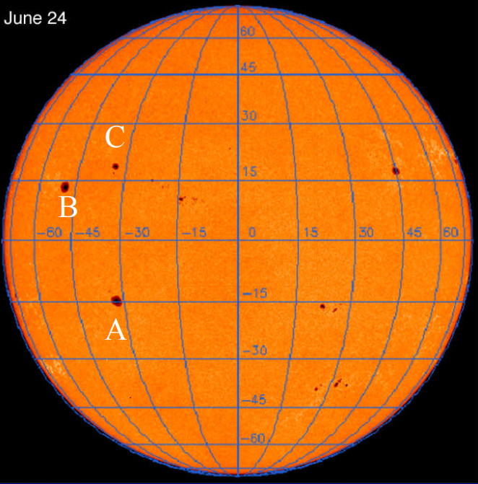 | 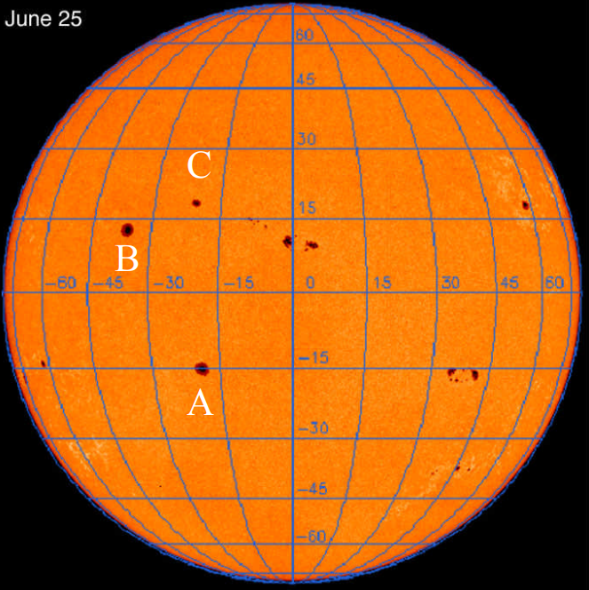

(answer #19 here)

- The following are two additional graphs that demonstrate the surface area and location of sunspots over time. What patterns do you notice in each of the graphs below? Use the words period and frequency in your descriptions.
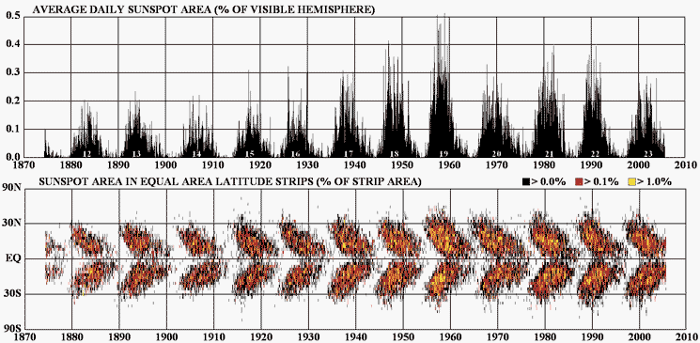

- Think about coherence and continuity of patterns throughout scientific data. Where else in this class have we talked about periodic cycles in the physical world?

