2017 Eclipse: Research-Based Teaching Resources

Lab: Modeling Eclipses

Description: This hands-on, guided-inquiry activity helps students to understand the geometry of lunar and solar eclipses by creating a physical, proportional model of the Earth and Moon system and observing shadows. This resource is designed to supplement Physics by Inquiry for physics teacher preparation and includes elements similar to those found in Ranking Tasks for Introductory Astronomy.

Prerequisite:
- Understand the phases of the moon.

Example activities include the following:
- Physics by Inquiry, Vol 1. McDermott
Section 5: Phase of the Moon Page 349
- Or something comparable--some other examples include:
  - http://www.nasa.gov/centers/jpl/education/moonphases-20100913.html
  - http://www.bobcrelin.com/FOTM-TG.pdf
  - http://webs.wichita.edu/lapo/demon.html

Hints for the Teacher:
- Light source: A 300-W directional flood light works reasonably well.
- If available, use calipers to measure diameters of Earth and Moon balls.
- Clay tends to work a little better than Play-Doh. In either case, the lighter the color, the better, at least for Earth.
- Use cardboard or black foamboard; white foamboard will be too reflective.
- If you can get the light source parallel to the desk or table, so the cardboard can sit on the surface, it makes alignment a bit easier. Then set the cardboard on something like a book with smaller dimensions to allow for movement of the pins up and down for part X.2.
- Blacken, cover, or otherwise dim any light sources as much as reasonable.
- If you don’t have block periods of more than an hour, you’re likely to need a second day. Consider where you’ll store the setups between lessons.
- Starting with X.3.B, these items do not require the setup and so could be done as homework.

Learning Sequence:

Section X. Modeling Eclipses

To understand how solar eclipses occur, we will build off of what we already know about the phases of the Moon. In essence, we will expand our model to think about how the Sun, Earth, and Moon are aligned in order for an eclipse to occur.

Exercise X.1
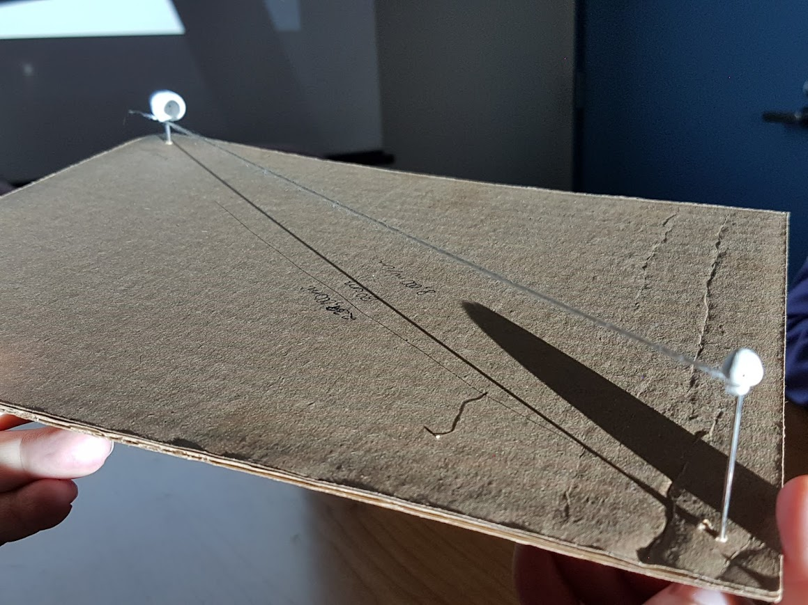
- Build a scale model of the Earth-Moon system using a piece of letter-sized piece of cardboard with two pins or nails inserted at opposite corners of the cardboard. (Insert the nails from the bottom, so that the sharp ends are pointed upward).

- Place small balls of clay on top of the pins or nails to represent Earth and the Moon. The size of each piece of clay will be determined below.

  - Determine the scale of your system by determining the distance between the two pins or nails. Explain how you did this in words or with math. (The average distance between Earth and the Moon is 238,900 miles).

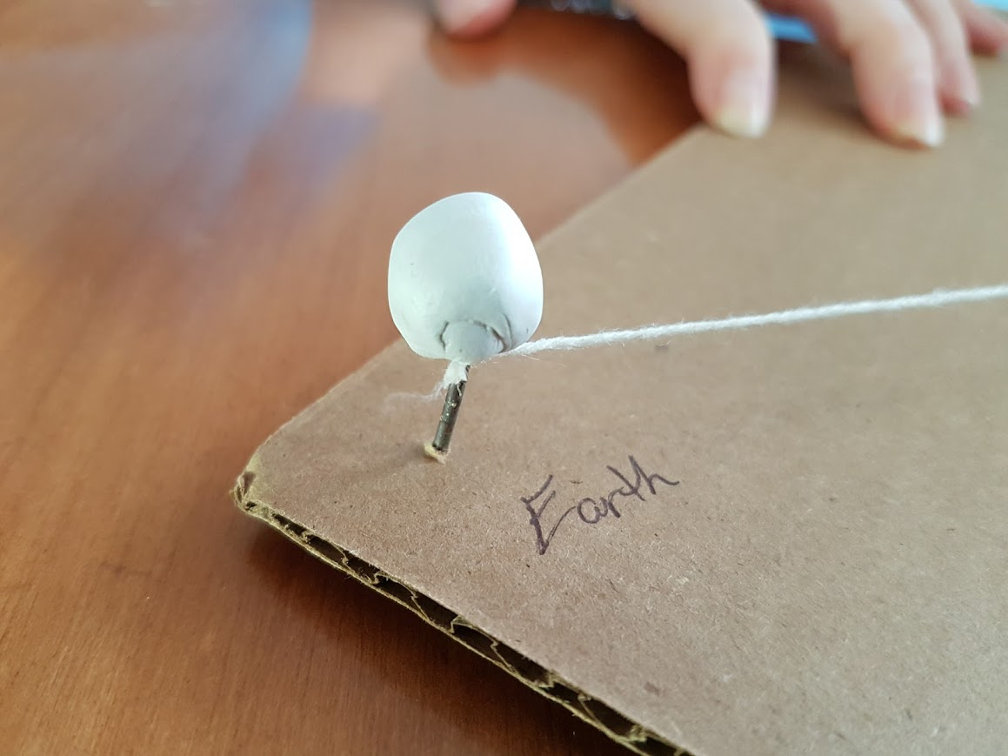
  - Using the scale for your model, make Earth and the Moon proportional sizes. Explain how you did this in words or with math. (Earth radius = 3,959 miles; Moon radius = 1,079 miles).

- Connect Earth and the Moon with a taut piece of string. Ensure that the string always remain attached right at the base of the clay. The cardboard will represent the orbital plane of Earth as it goes around the Sun, and the string will represent the orbital plane of the Moon as it goes around Earth.

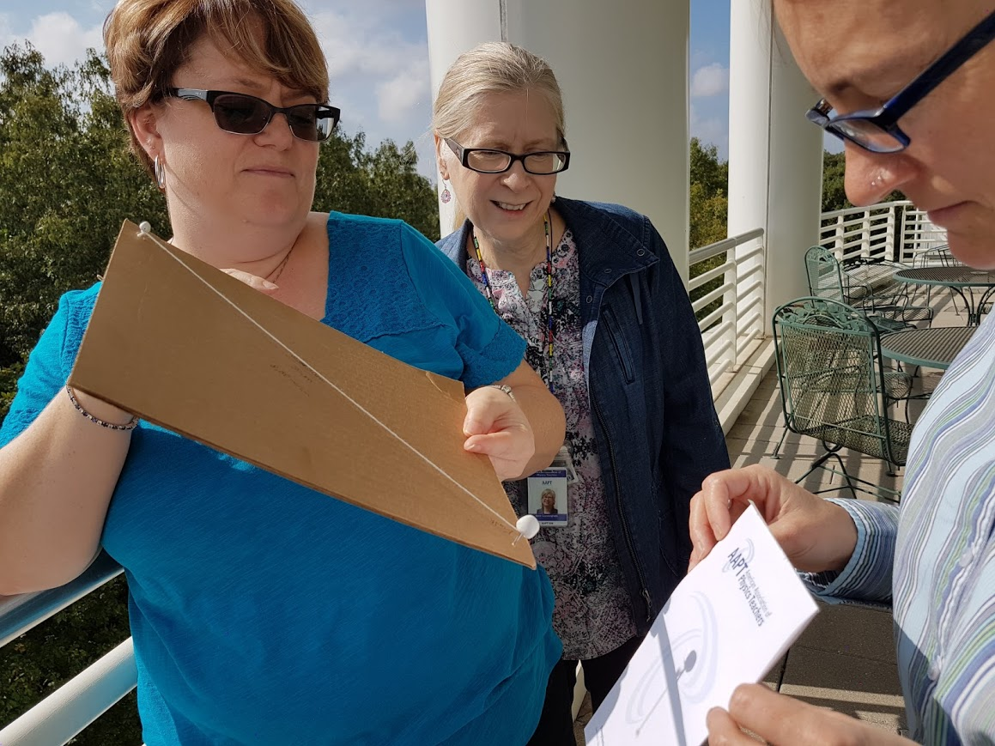
- Begin with the string parallel to the cardboard. Using a diffuse, bright light such as the Sun or a projector beam, place the model so that the Moon is closest to the light, and Earth is farthest away. The Sun, Earth, and Moon should be perfectly aligned so that they all fall in the same line. Observe the shadow that falls onto a piece of paper held vertically just beyond Earth.

  - Where does Earth’s shadow appear? What does it look like?

  - Where does the Moon’s shadow appear? What does it look like?

  - Identify any similarities and differences between Earth’s and the Moon’s shadows.

  - Create a sketch below showing what this setup looks like from a side-view of the Sun, Earth, and Moon system. Include a sketch of how the shadows are produced and where they fall. Label each object.

  - Create a sketch below show what this setup looks like from a top view of the Sun, Earth, and Moon system. Include a sketch of how the shadows are produced and where they fall. Label each object.

  - What is the phase of the Moon during a solar eclipse? Explain how you know.

- You might be aware that it is fairly rare to see a total solar eclipse. (Total solar eclipses can only be observed at the same location about every 375 years, with typically 2 total solar eclipses visible at some point on Earth each year). Elaborate on one or two possible reasons why you might not see total solar eclipses each month.

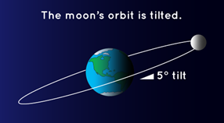
As was noted in the previous exercise, total solar eclipses do not occur each time there is a New Moon. This is due, in part, to the fact that the Moon does not lie on the same plane as the Sun and Earth (the Plane of the Ecliptic).
Credit: NASA

Each month, the Moon passes through the Plane of the Ecliptic at an angle of 5° above and below. In exercise X.1, the string was parallel to the cardboard, and Earth and the Moon were both in the Plane of the Ecliptic. In Exercise X.2, you will make the Moon go above and below the Plane of the Ecliptic.

Exercise X.2

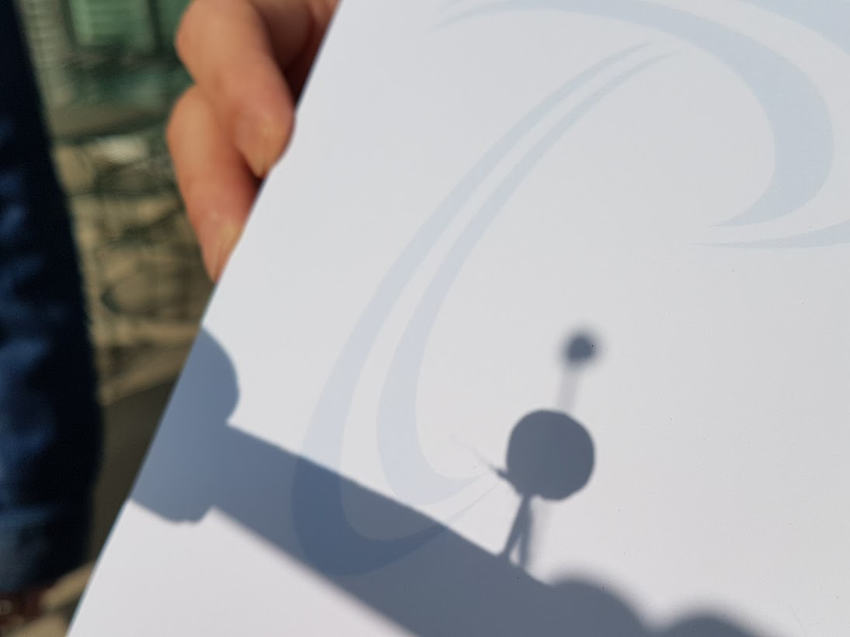
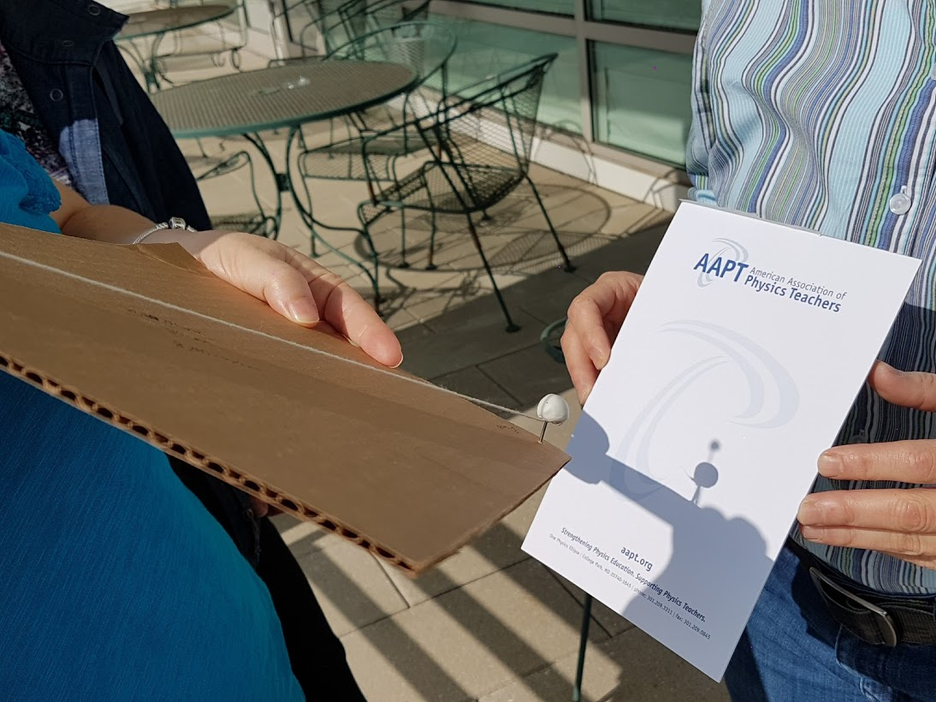
- Push and pull on the nail representing the Moon, so that the string is no longer parallel to the cardboard. Orient the Moon so that its shadow appears to the left of Earth (when observing the shadows on a piece of paper, like in the diagrams below). Slowly rotate the system so that the Moon’s shadow moves toward the right. Observe how this changes the shadows produced on the paper. Draw the progression of the projected images seen on the paper for the following scenarios.

  - The Moon is “higher” than Earth. The Moon passes above Earth’s plane.
Before | During | After

  - The Moon is “level” with Earth. The Moon passes along Earth’s plane.
Before | During | After

  - The Moon is “lower” than Earth. The Moon passes below Earth’s plane.
Before | During | After

B. Which of the above scenarios is total solar eclipse? Explain your reasoning.

C. Consider the scenario you selected that represents a total solar eclipse. Notice, however, that the projected images you drew in all three cases above is not what is actually viewed by people during a total solar eclipse. Using your pen or pencil, place a dot on the surface of Earth and the Moon where they face one another.
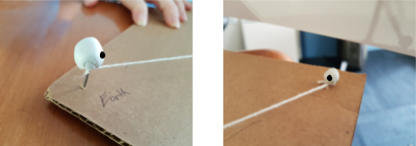

  - Draw a sketch of what would be viewed from Earth when looking toward the Moon during a total solar eclipse.

  - Draw a sketch of what would be viewed from the Moon when looking toward Earth during a total solar eclipse. Try to represent this as accurately as possible.

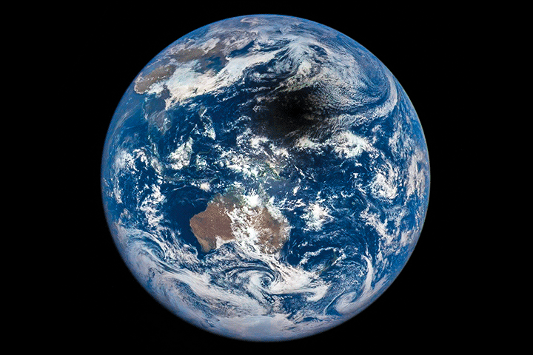
In Exercise X.2, you drew a sketch showing what would have been observed from the Moon when looking toward Earth. NASA has captured images of the shadow on Earth, called the Moon’s umbra. See an animated gif here: https://goo.gl/HcLXuu

One place that our cardboard and clay model of the Moon and Earth fails is in the size of the shadow on Earth.

Exercise X.3

- Compare the size of the umbra on the clay Earth in your model to the size of the umbra shown in the image above from NASA.

  - How are they different?

  - What do you think might account for this difference in size? If you are unsure, try modeling eclipses in front of different types of light sources, including sources that are point sources (such as a smartphone flashlight), sources that are diffuse, more and less intense, and nearer or farther.

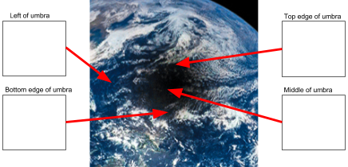
- Because the umbra does not fully cover the surface of Earth that is facing the Sun during a solar eclipse, not everyone has the same view during the eclipse! On the “pop-outs” on the diagram below, sketch what would be observed by people in boats at various points in the Pacific Ocean at the moment this image was taken. Label the Sun and the Moon in your sketches.

- Consider the upcoming eclipse! Look at the map on the following page showing the path of the eclipse. The blue line represents the path in which observers will be able to see the eclipse in “totality” (i.e. the Sun will be fully covered by the Moon.” The pink lines to either side of the blue line show the edges of the path in which observers will be able to see at least a partial eclipse of the Sun.

  - Where will you be on 21 August 2017? What will the eclipse look like to you?

  - Imagine you had a friend in rural, northeastern Montana. Write a letter to you friend describing what s/he will expect to see on August 21, and why (if s/he remains in Montana during the eclipse). In your letter, include the following:

    - What a solar eclipse is.
    - How the Sun, Earth, and Moon must be aligned (including a sketch).
    - What the eclipse will look from his/her location (including a sketch).

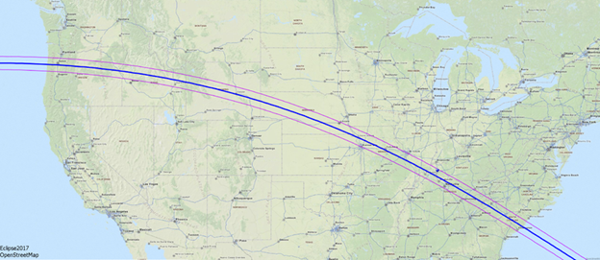
Credit: Wolfgang Strickling

