Magic Stripes
Inspired by The Physics Teacher’s
“Polarization Imaging and Insect Vision”
by Adam Green, Paul Ohmann, Nick Leininger, and James Kavanaugh

Description: Students will observe stress in molded plastic using their own makeshift polariscopes.

Purpose: Students explore polarization of light.
NGSS Connections:
Disciplinary Core Ideas:
- PS4.A: Wave Properties
- PS4.B: Electromagnetic Radiation
Crosscutting Concepts:
- Cause and Effect
- Patterns
- Structure and Function
Science and Engineering Practices:
- Constructing Explanations and Designing Solutions
- Scientific Knowledge is Based on Empirical Evidence
- Obtaining, Evaluating, and Communicating Information
- Developing and Using Models
Performance Expectations: Waves and Their Applications in Technologies for Information Transfer (PS4)
- 1-PS4-3
- 4-PS4-1
- MS-PS4-2

Materials:
- Two small polarizers
- A clear plastic fork
- A slinky
Advanced Preparation:
- Know how to do the slinky demonstration before trying it with your class, as it may take one or two tries to get the slinky to rotate properly. It is easiest to do a single standing wave, rather than to try for a higher normal mode.
Modifications:
- Any clear molded plastic can be used instead of a plastic fork. The fork works well because you can bend it with your hand, inducing extra stress that shows the change in colors, but any firm but bendable clear plastic should show the same properties.
- If your students are having trouble understanding polarization, you can use the fence analogy. If you are shaking a jump rope back and forth through the slits of a fence, could you shake it side to side if the slits of the fence go up and down? Of course not! If the jump rope went through two fences, with the slits perpendicular to each other, could you shake the jump rope at all? You could not. What if the slits in the fences were parallel (ex. they were both up and down)? It would not matter how many fences there are, as long as their slits are parallel they will all allow the jump rope to move up and down.
Lab Activities for Students: Understanding Polarized Light with Magic Stripes
- Take out the two sheets of dark plastic. These are called polarizers. Explore the polarizers, and write down 5 observations you make about them.
Discussing Polarization
- Once the students have made some observations with the polarizers, ask them what hypothesis they can form about how the polarizers work using their observations as evidence. Once some discussion has taken place, tell them that you are going to take a step back and talk about one aspect of how light works which might make the polarizers make more sense.
- Tell your students that light can be thought of as a wave which moves in two directions: side to side, and up and down. Use the slinky to demonstrate. Hold one end of the slinky in each hand, spread apart. Now, rotate your hands in a circular motion so that the center of the slinky rotates in a circle. Make sure that it is not just moving up and down, but fully in a circle. Explain to your students that this is a simple model of what unpolarized light (like the light from the sun) looks like. You can stop shaking the slinky.
- Ask your students what will happen if we found a way to entirely remove the side-to-side component of the light’s motion. Once they provide some guesses, start shaking the slinky again, but only up and down. This might be a good time to refer to the fence analogy described on the first page.
- Repeat this with the up-and-down part of the motion removed, meaning that the slinky only shakes side-to-side (so that the center of the slinky moves towards and away from your chest). Explain that these are examples of polarized light, meaning that the light is only moving one direction.
- 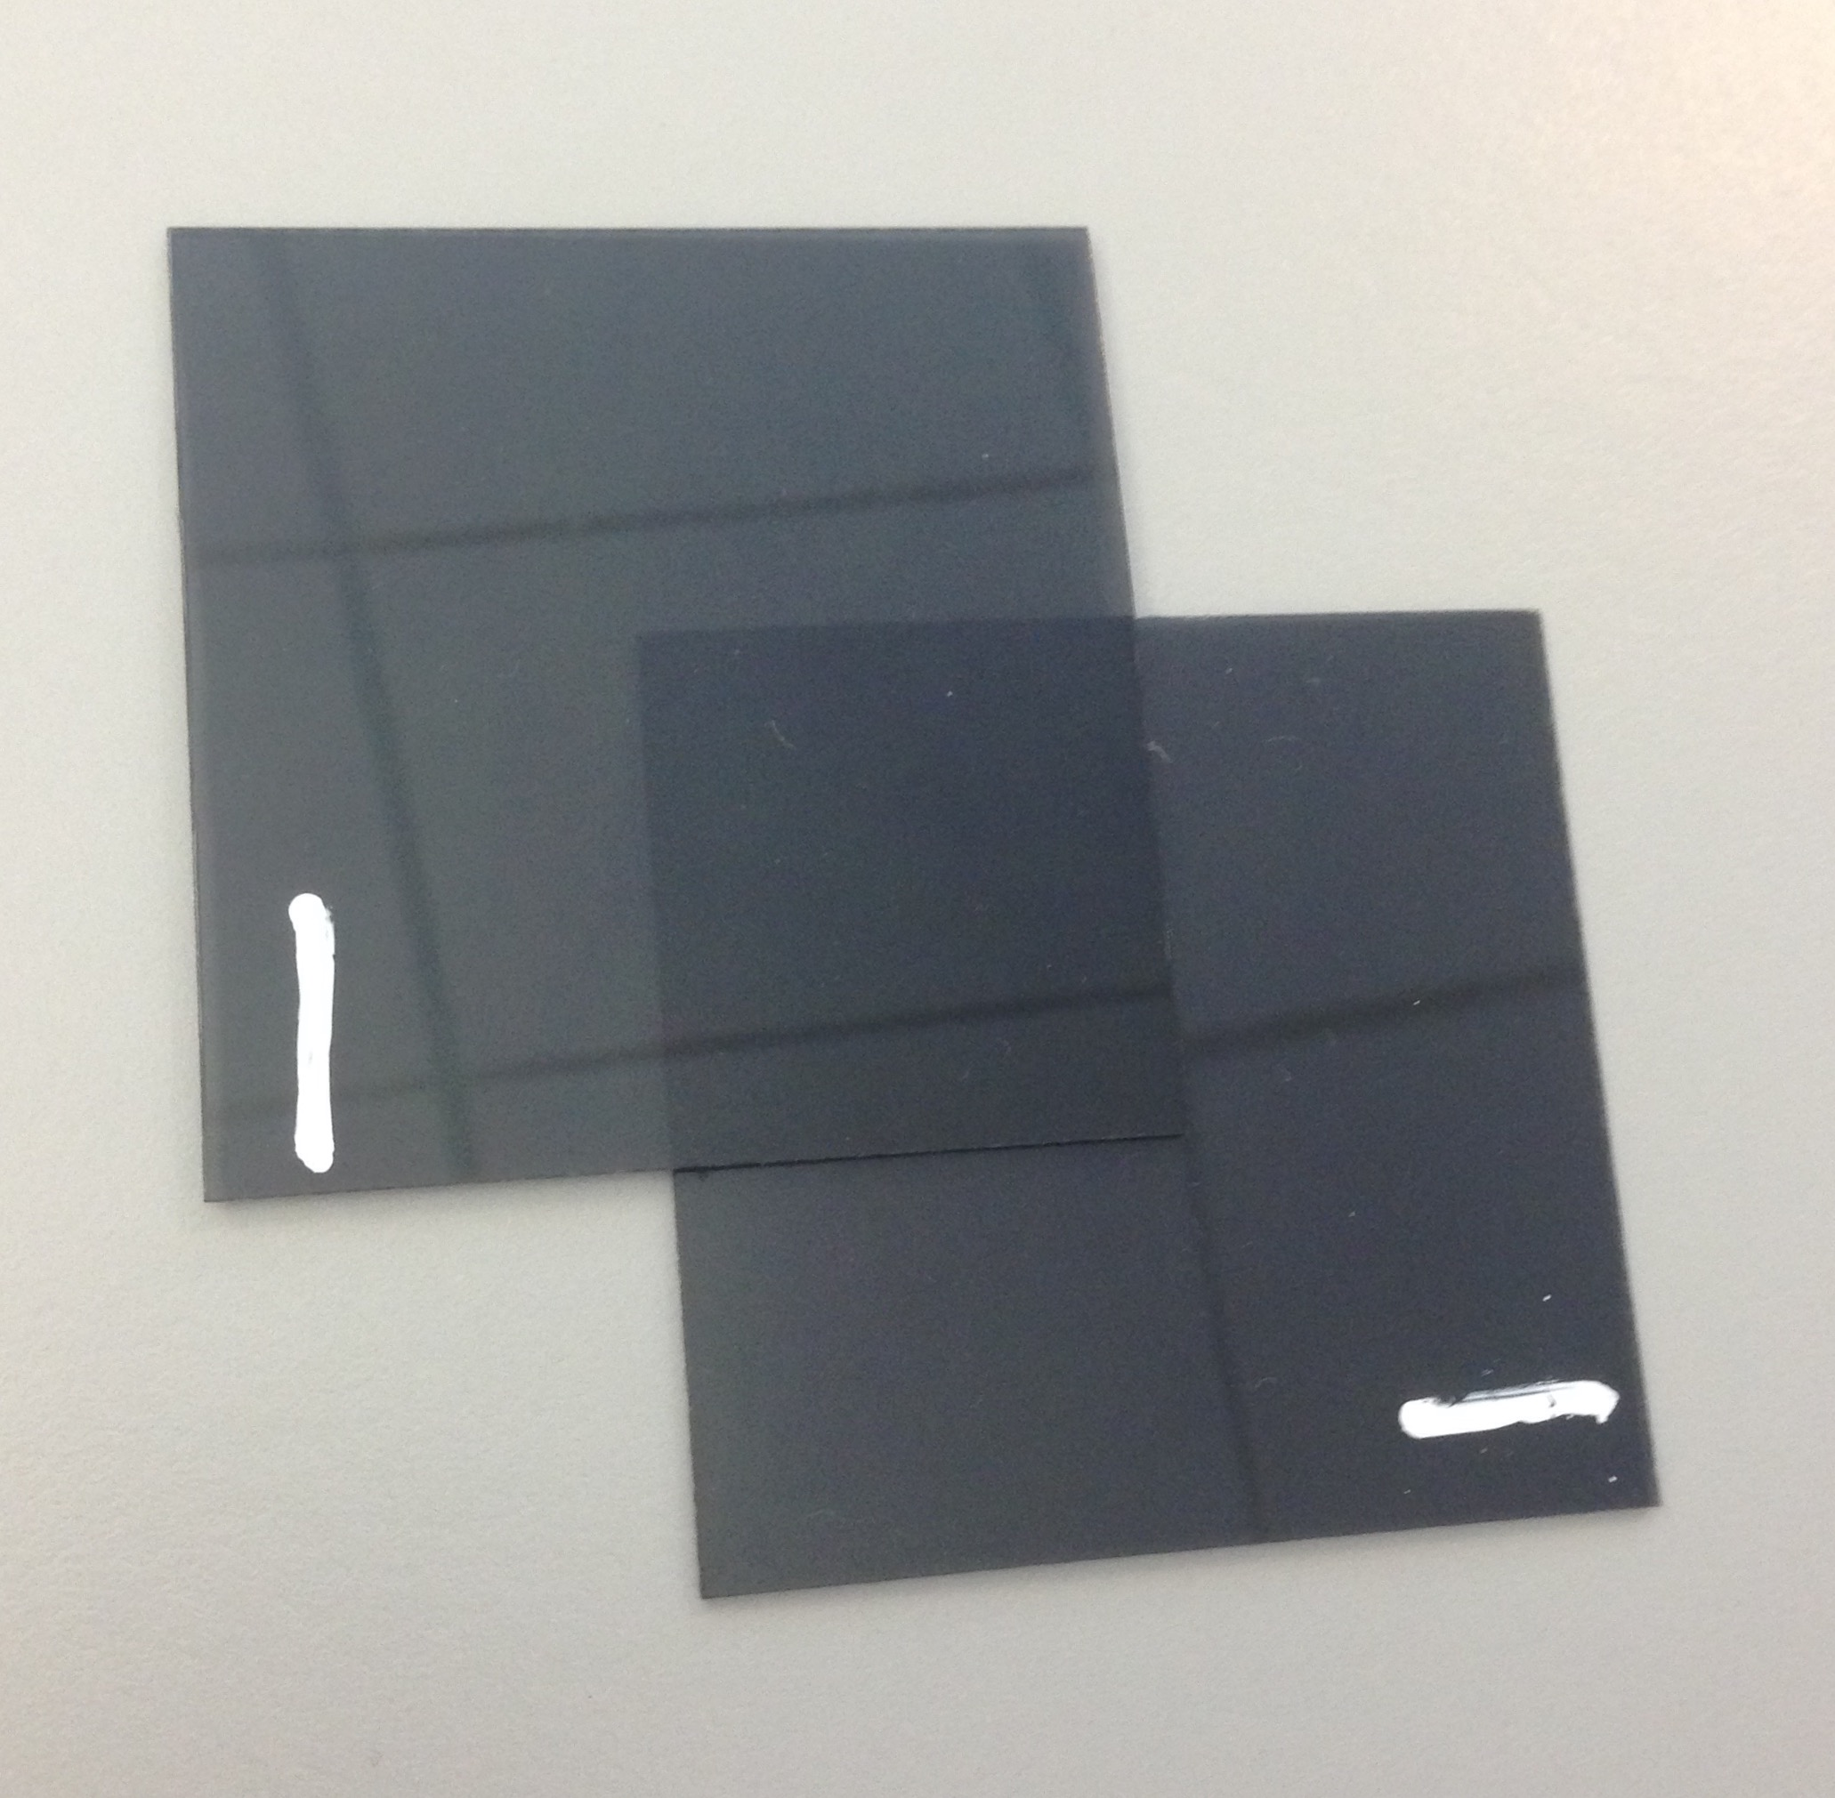Ask your students what would happen if we removed both the up-and-down component and the side-to-side component. Explain that there would then be no light left, and we would not see anything at all.
- Look through each polarizer at your surroundings. Now, look through both polarizers at once. Try rotating one of them. What happens? Remember what your teacher just showed you about what it means to polarize light. What is happening when the two polarizers become opaque (not see-through)? What is happening when they are translucent (partially see-through)? Why might turning one of the polarizers cause a change between these two states?
Students might have trouble understanding how the polarizers work. Teachers might need to walk among the students and remind them of the activity they just did with the slinky. When the lines on the polarizers are parallel, meaning they are in the same direction, then the light can pass through both of them. Remind students of the slinky shaking from side to side, and that light moving like that could pass through sideways slits in one polarizer, and then not be affected by the other. But when the polarizer is rotated so that the slits are perpendicular, meaning that they are crossed, then the first polarizer removes all the light in one direction and then the second polarizer removes all the light in the other direction, meaning that after the second polarizer all the light has been removed! That’s why we can’t see through them.
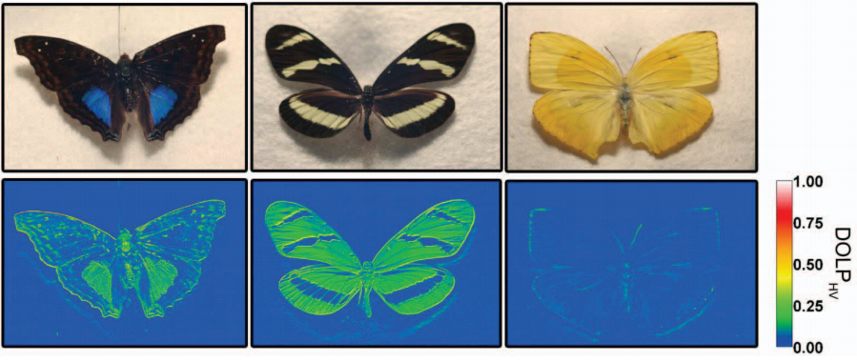
- Next to each image, write whether any light will get through, and if so, what direction it will be polarized in (you may draw the direction if you prefer).
Light will get through, and it will be polarized vertically.
No light will be able to get through.
What happens if the polarizers are tilted with respect to each other? Will any light get through? Why or why not? What if the slanted polarizer is in the front versus in the back? Try it first, and write your observations next to the pictures, but also think carefully about what the polarizers are doing with the light and why it might matter which one is in front.
In this case, the vertical polarizer is in front. Try it! What do you observe? What is actually happening?
Only some light will get through, but which direction it is polarized will depend on which polarizer comes first. If the slanted polarizer is first, then all of the light will be polarized vertically
In this case, the slanted polarizer is in front. Try it! What do you observe? What is actually happening?
If the vertical polarizer is first, then some of the light will be polarized in each direction, because the slanted polarizer actually turns some of the vertically polarized light so it is now polarized at a slant. This means that a component of the light is polarized vertically, and another component is polarized horizontally.
The human eye usually cannot see the difference between these two states, but many animals can see polarity. They may use this skill for navigation, or to identify food or potential mates.
The top images show several butterflies, and the bottom image shows the degree of polarization in the light reflected off the wings. These are characteristic markings that other butterflies or animals may look for.

- Hold the two polarizers so that they are opaque. Now, between the two polarizers, put the tines of the plastic fork. What do you see? What might the colors represent?
- Squeeze the tines of the fork together. Do the colors change? Does this help you figure out what might be causing the colors to appear?
The colors show up because polarized light reveals the stress that exists in molded plastic materials. Bending the tines induces extra stress, which causes the colors to shift. Engineers sometimes use polarizers like this to examine where stress may be in a model of something they are designing. Polarizers that are combined like this are called a polariscope.

