Jelly Filter Science: Exploring Color with Colored Gelatin and Color Vision
Inspired by The Physics Teacher’s
“A Student-Centered Interactive Color Quiz” by Edward P. Wyrembeck
and by the work of Diane Riendeau

Description: Students will explore the effects of color filters by conducting a simple experiment with colored gelatin and by using an interactive PhET simulation.

Purpose: Students will gain a deeper understanding of color addition and subtraction by analyzing how filters are used to selectively transmit or block particular wavelengths of light to produce a desired effect.

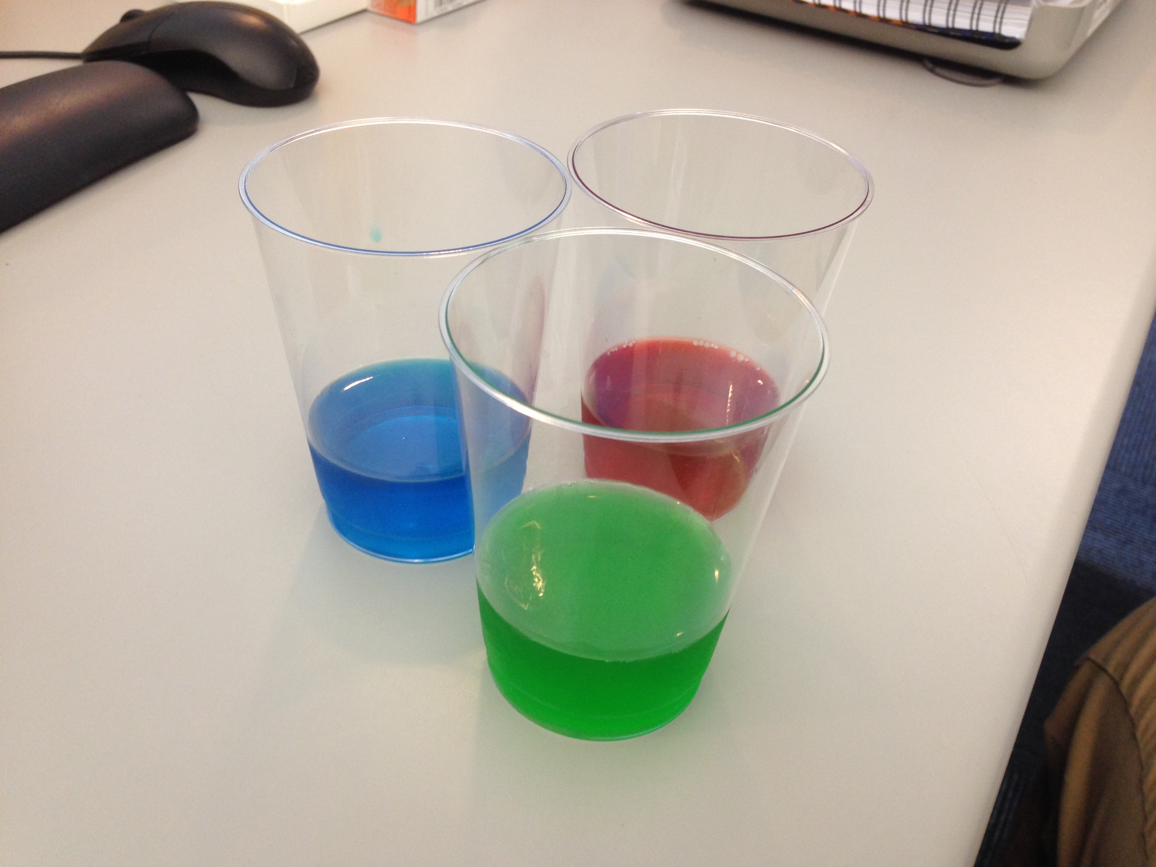NGSS Connections: See detailed list of NGSS alignments on Page 8
Disciplinary Core Ideas:
- PS4.B: Electromagnetic Radiation
Crosscutting Concepts:
- Systems and System Models
- Patterns
Science and Engineering Practices:
- Planning and Carrying Out Investigations
- Constructing Explanations
- Developing and Using Models
Performance Expectations: Waves and Their Applications in Technologies for Information Transfer (PS4)
- 4-PS4-2
- MS-PS4-2

Materials:
- Cherry, Lime, and Berry Blue Jell-O brand flavored gelatin
- Clear plastic cups
- A computer with internet (for simulation/slides) and a projector (or monitor that students can see)

Advanced Preparation:
- Prepare the Jell-O in the bottom of clear disposable cups, about 1”-1.5” thick. Ensure that the Jell-O is set thick in the cups, as it is easier to handle.
Modifications:
- Students can play with the PhET simulation themselves, or it can be a demo done by the teacher. This will depend on the availability of materials and the age of the students.
- Alternate gelatin brands can be used instead of Jell-O brand, but be aware that the colors may not be the same and your results may vary.

Prior Knowledge Required:
Students need a working understanding of the meaning of a “filter”. A filter is a transparent object designed to selectively transmit desired wavelengths of light by absorbing certain wavelengths and allowing the transmission of others. For well-written content support on light filtration, see this tutorial from Florida State University’s Molecular Expressions Project: Light Filtration Tutorial-FSU

Lab Activities for Students: Jell-O Filters and Color Vision

PART 1: Jell-O Filters

Show slide 1: Primary Colors
- An image will be projected at the front of the class. Take a look at this image, and then, in the table provided, write a prediction about what you think the image will look like through the corresponding filter. Then, make a hypothesis (potential explanation) for why you expect to see that. Finally, color the image the way you see it through the filter.
 | Prediction  “How will the image look different?” | Hypothesis  “Why will the image look different?” | Observation
Red Filter | Students will likely make predictions as though they are mixing pigments; they might predict that the red filter will create brown and purple when looking at green and blue. Alternatively, students might assume that it is the same as mixing light. | Students might say things like “red and blue makes purple!” They will eventually realize that a color filter is not the same as mixing pigments.
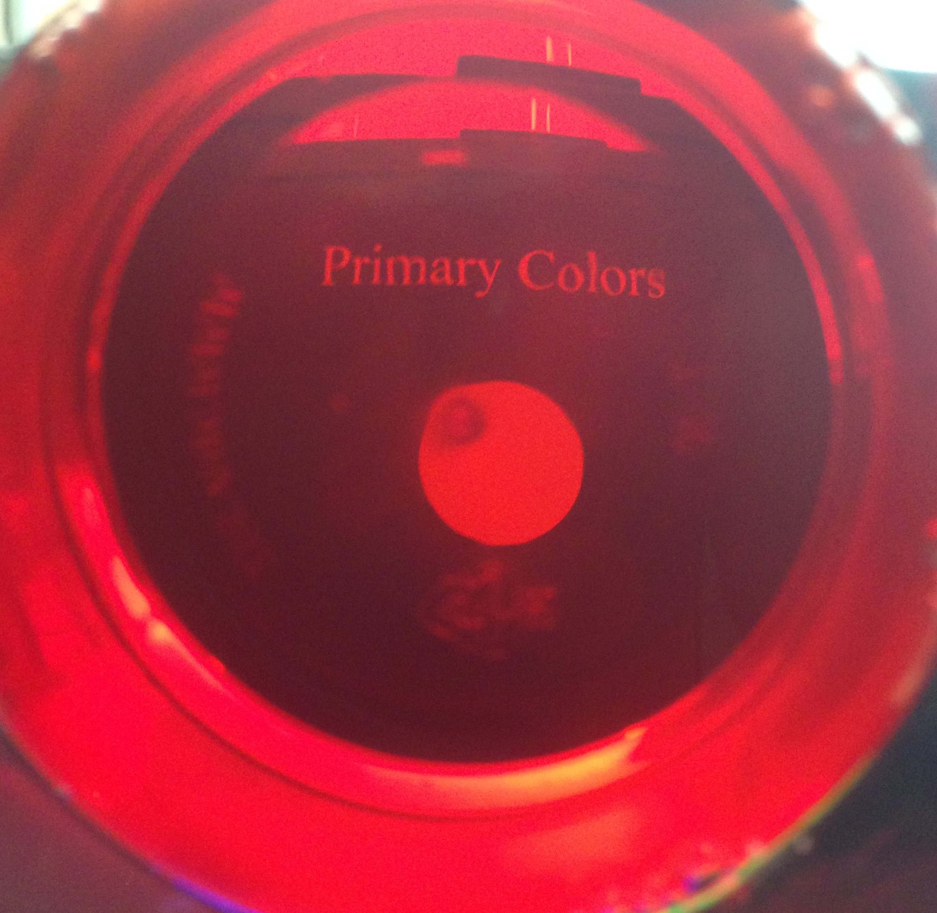
- Was your prediction correct? Why or why not?
- Did your observation support your hypothesis? Why or why not?

Image will look like this: only the red dot will be visible.
- Write predictions and hypotheses for the other two filters.
 | Prediction  “How will the image look different?” | Hypothesis  “Why will the image look different?” | Observation
Blue Filter
Green Filter

Show slide 2: Colored Numbers
- Look at the numbers that are now being projected. Which numbers do you expect to see through which filter? Circle which numbers you expect to see, and then check to see if you are right! Why can you only see those numbers?
Red filter: 1 2 3 4 5 6 7 Should circle 1, 2, 5, 7
Blue filter: 1 2 3 4 5 6 7 Should circle 1, 4, 6, 7
Green filter: 1 2 3 4 5 6 7 Should circle 1, 3, 5, 6
- Look at the image that is now being displayed. Try to predict, again, which circles you will see through which filters. Make drawings of what you expect them to look like. (Hint: Think about what is different in this case compared to the previous cases. What is white light made of? How is it affected by a filter?)
Red: Green: Blue:
PART 2: Exploring color filters with PhET

- Open up the “PhET Color Vision” simulation: PhET Color Vision
You should be able to run it in your web browser without downloading anything else.
Addition of Color This section promotes understanding of RGB color addition.
- Choose “RGB Bulbs.”
- Use the sliders to add or subtract colored light. Describe what the person sees when you mix the following colors:
a. Red + Green: Yellow b. Green + Blue: Cyan
c. Blue + Red: Magenta d. Red + Green + Blue: White

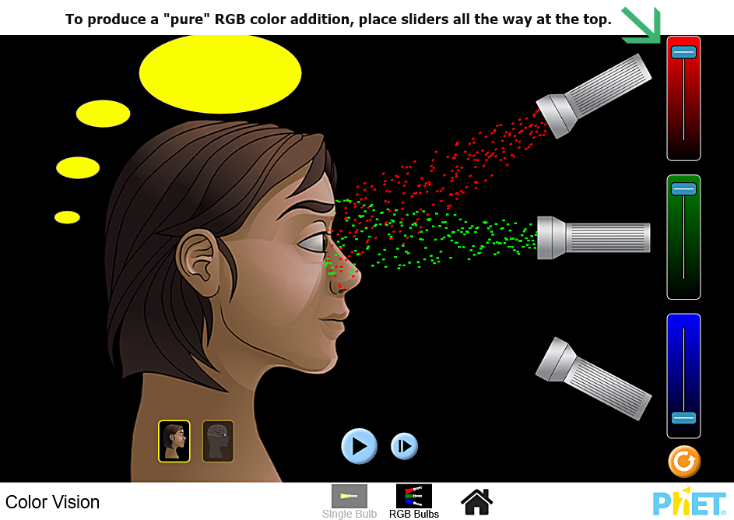

- Use the sliders to make other combinations. What colors and in what amounts (position of the slider) do you need to make the following:
Orange: Full red, half green
Black: No light; students may try all colors at once, but that of course makes white.
White Light In this section, students will understand that white light is made up of a combination of colors of light. It is important for students to understand that filtering light is different from mixing light and mixing pigment.
- Click the button on the bottom labeled “Single Bulb.”
- Click the red button on the flashlight in order to turn it on. What happens when you move around the slider labeled “Bulb Color”? Students will notice that the emitted and perceived colors change together.
- Light is sometimes represented as particles. Click the button that shows the particles being emitted from the flashlight. Since we are seeing just one color, the light particles are only one color. This introduces students to the “particle” display of light in this simulation, which they will need in order to see (in the next task) that white light is made up of all colors.
- Change the flashlight back to a beam, and then change the color to white by clicking the white lightbulb next to the yellow one. What color is the beam now? What color does the person see? White and white
- Try to predict what will happen when we change the setting back to the particles. Will they all be white? How do you know? What color does the person see? The particles contain a spectrum of colors, but the person still sees white. This occurs because our eyes perceive the combination of all colors as “white”. (See screenshot below.) We see sunlight as “white light” because 99% of the electromagnetic radiation emitted by the sun is in the form of visible light, ultraviolet, and infrared.
Light receptors in the human eye detect this incoming radiation along the entire wavelength of the “Visible Light” portion of the Electromagnetic Spectrum (~400-700 nanometers). Thus, sunlight includes every color, which our light receptors add together to equal white.
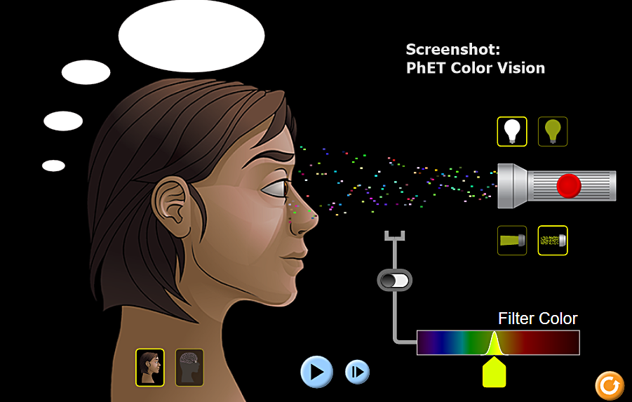

Color Filters

- Turn on the color filter by clicking the switch attached to the bottom spectrum. What color particles make it through the filter? What does the person see? Note: The default filter color is yellow. Advise students to change the bulb color SLOWLY. Only light frequencies close to the wavelength of the filter will be transmitted through. Acceptable responses: light green, spring green, yellow, gold, light orange. (See screenshot below.)

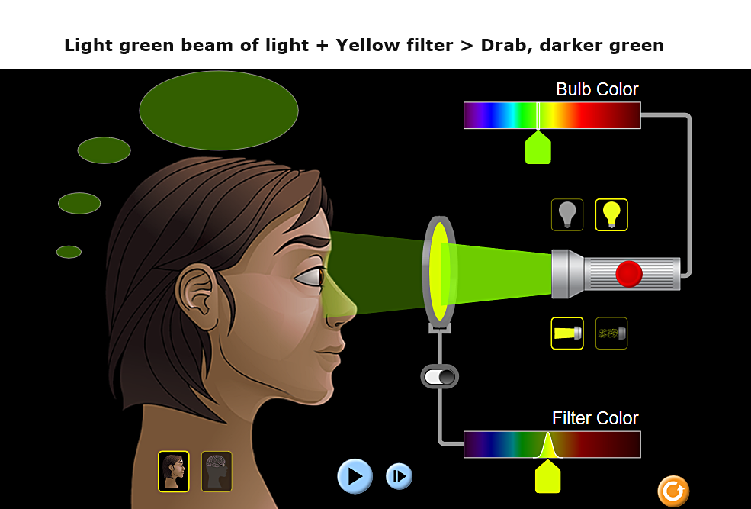
- How is this simulation different from and similar to what you saw with the Jell-O filters. With the Jell-O filters we noticed that the filter only allowed through its own color when looking at the white background.
- Change the flashlight back to being colored, and play with both sliders. What do you notice? What happens when the wavelengths are the same for both the bulb color and the filter color? Different? Very close, but not quite the same?
Advise students to try only one variable at a time – either the bulb color or the filter color. They should notice that a filter will always allow through the same wavelength of bulb color. It will also transmit (allow through) wavelengths that are close to the wavelength of the filter color, but the product will be a slightly different color. If you stray too far from the filter wavelength, nothing will be transmitted.

- What happens if we change the flashlight from “beam” mode to “particle” mode? How does using the Particle Model of Light help us understand what happens with color filtration?
(See Screenshot below) This model provides an excellent way to visualize the particle nature of light. As the red light passes through the orange filter (screenshot below) notice that the stream of particles becomes greatly reduced. The color produced by this combination is a dark brick red. On the molecular level, color filters are selectively absorbing certain wavelengths of light to produce a desired effect. The number of total particles being transmitted is reduced by the filter.

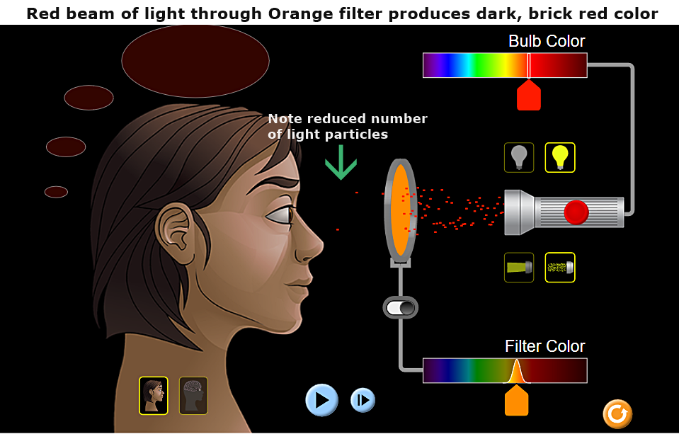

- Recall the activity with the filters and the colored numbers. What colors were allowed through the filters in the following situations? How is this different from what we observe in this simulation? Why might that be? The solutions are the arrows to the right, but the teacher could also allow the students to draw the arrows leading from the colored numbers in order to ensure understanding of mixed light. The simulation does not account for “mixed” colors like magenta; it only allows colors that are “pure” (a single wavelength) and filters that filter based entirely on wavelength.

- Make another comparison to the exercises we did with the Jell-O filter. Change the filter color to red, and then change the flashlight color to green, then red, then blue. Write down what the person sees from each color. Does this match what you saw with the Jell-O filters?
What does the person see when the flashlight is…
Red: _____________ The person sees red.
Green: _____________ The person sees black.
Blue: _____________ The person sees black.

Next Generation Science Correlations

Performance Expectations

Physical Science: Waves
- MS-PS4-2: Develop and use a model to describe that waves are reflected, absorbed, or transmitted through various materials. (Strong Correlation)
- HS-PS4-3: Evaluate the claims, evidence, and reasoning behind the idea that electromagnetic radiation can be described either by a wave model or a particle model, and that for some situations one model is more useful than the other. (Limited Correlation)

Disciplinary Core Ideas: Physical Science – Waves
- MS-PS4.B.1: When light shines on an object, it is reflected, absorbed, or transmitted through the object, depending on the object’s material and the frequency (color) of light. (Strong correlation)
- HS-PS4.B.1: Electromagnetic radiation can be modeled as a wave of changing electric and magnetic fields or as particles called photons. The wave model is useful for explaining many features of electromagnetic radiation and the particle model explains other features. (Strong correlation)
- HS-PS4.C.1: Multiple technologies based on the understanding of waves and their interactions with matter are part of everyday experiences in the modern world (e.g., medical imaging, communications, scanners) and in scientific research. (Limited Correlation)

Crosscutting Concepts

Systems and System Models
- Models can be used to represent systems and their interactions

Structure and Function
- Structures can be designed to serve particular functions by taking into account properties of different materials and how materials can be shaped and used.

Patterns
- Macroscopic patterns are related to the nature of microscopic and atomic-level structure.

Science and Engineering Practices

Constructing Explanations
- Construct an explanation based on valid and reliable evidence obtained from a variety of sources (including students' own investigations, models, theories, simulations, peer review) and the assumption that theories and laws that describe the natural world operate today as they did in the past and will continue to do so in the future.

Developing and Using Models
- Use a model to predict the relationships between systems or between components of a system.

Planning and Carrying Out Investigations
- Plan and conduct an investigation individually and collaboratively to produce data to serve as the basis for evidence.

