Exploring Light with Gelatin Lenses
Inspired by The Physics Teacher’s
“Edible Optics: Using Gelatin to Demonstrate Properties of Light” by Patrick Bunton
And
“Construction of Optical Elements with Gelatin” by Mario Branca & Isabella Soletta

Description: Students will observe refraction and other properties of light by using and manipulating lenses made of clear gelatin. This activity allows them to model the function of the human eye, which is able to change the shape of the crystalline lens to adjust vision for near and far objects.

Purpose: Students will deepen their understanding of the refractive properties of lenses by observing light convergence/divergence in convex and concave gelatin “lenses”.
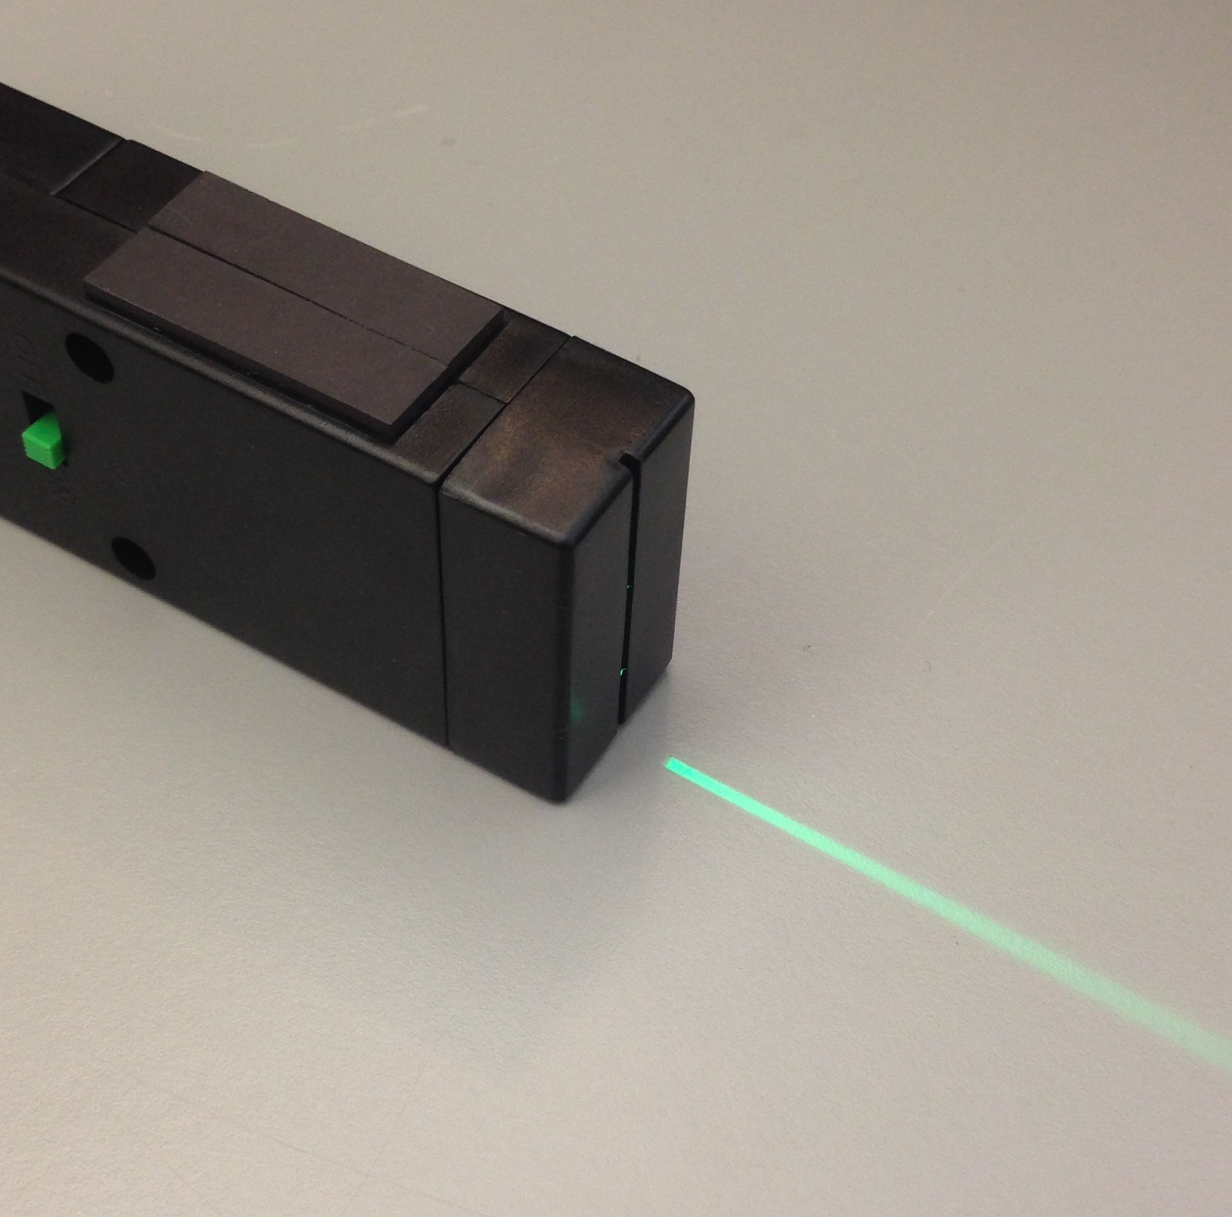
NGSS Connections: See Page 6 for full Standards language
Disciplinary Core Ideas:
- PS4.B: Electromagnetic Radiation
Crosscutting Concepts:
- Patterns
- Structure and Function
Science and Engineering Practices:
- Constructing Explanations and Designing Solutions
Performance Expectations: Waves and Their Applications in Technologies for Information Transfer (PS4)
- HS-PS4-3
- MS-PS4-2

Materials:
- Clear, unflavored gelatin prepared in condensed form (see “Advanced Preparation”) or agar-agar.
  - Gelatin is easy to find and very translucent, but be aware of potential concerns of students who do not want to handle animal by-products, especially pork-based gelatin. Gelatin is very flexible but can be easily broken when attempting to transfer it.
  - Agar-agar can be found in many Asian sections of grocery stores. Agar-agar is significantly more durable, but often is not as translucent as gelatin.
- A flashlight and a sheet of cardboard, or
three bright lights that emit in a narrow beam
- A knife or polymer clay “cookie cutters” in various geometric shapes.

Advanced Preparation:
- Prepare the gelatin or agar-agar, and cut it into the shape of convex and concave lenses. It is best to prepare the gelatin in a large, flat container no more than an inch or two thick, to make carving the lenses easier. Use water when making the gelatin, instead of juice. Once the gelatin has set, place the container in hot water for a few seconds for easy removal of the gelatin after cutting into shapes.
Cardboard with slits cut to allow narrow light beams
- Cut lenses either by providing students with pieces of gelatin for them to cut themselves or prepare convex and concave lenses for them. Cutting the lenses may take some practice. Uniform convex and concave lenses can be prepared by using large circular cookie cutters and segments of the circle shape.
- If you do not have a bright light that emits in a narrow beam, use the cardboard to create one set of three slits and one lone slit to allow only 1 or 3 narrow beams of light to escape at any time (see illustration above). In order to ensure that the light rays come out as parallel as possible, place the flashlight in a stationary position at least 12-16 inches from the cardboard.

Modifications:
- You can also use laser pointers instead of the above set-up. Different colors give the best effect.
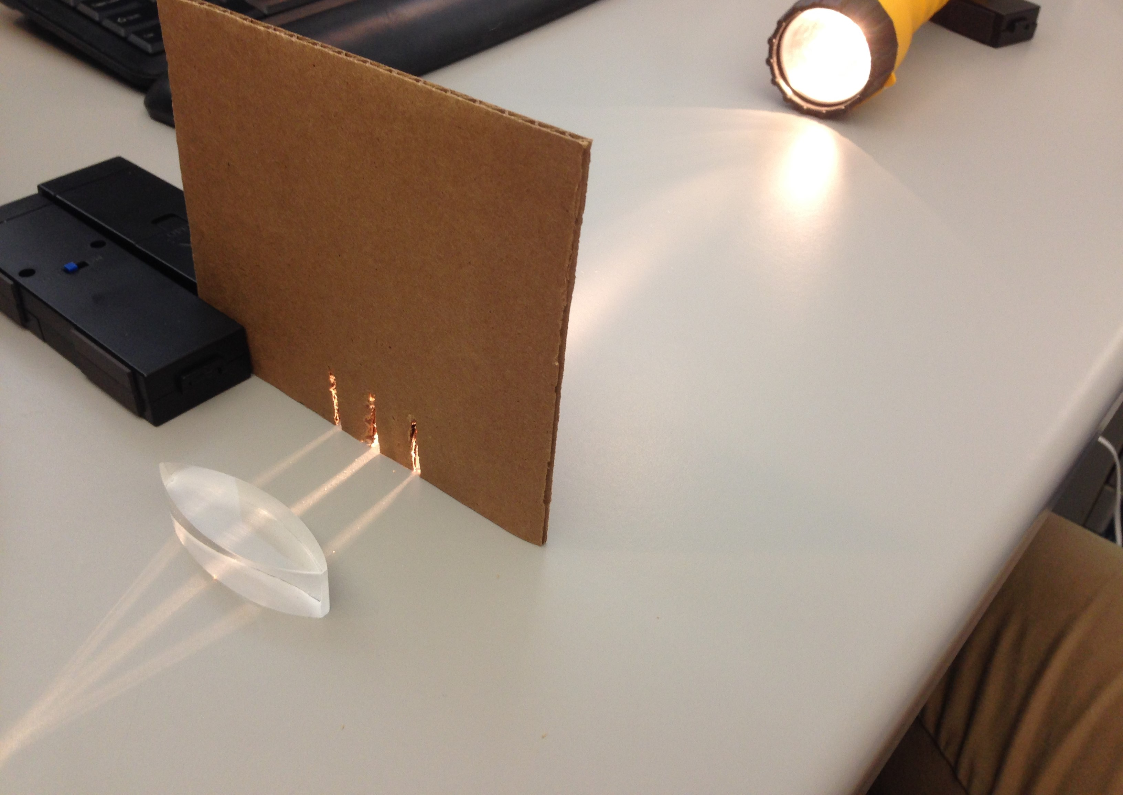
- Extend this activity by using triangular pieces of gelatin to observe total internal reflection.
- Extend this activity by having students quantitatively derive Snell’s law by analyzing the angle of light as it passes through the geometric shapes (See Example below)

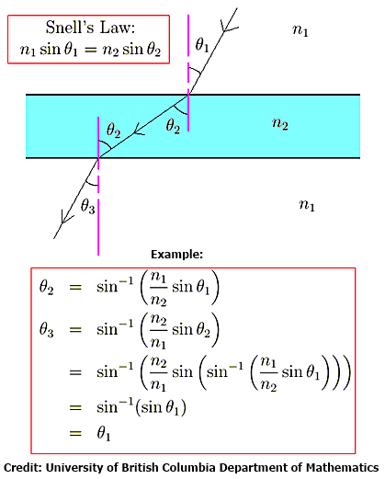

Lab Activities for Students: Gelatin Lenses

PART 1: Observing properties of convex lenses
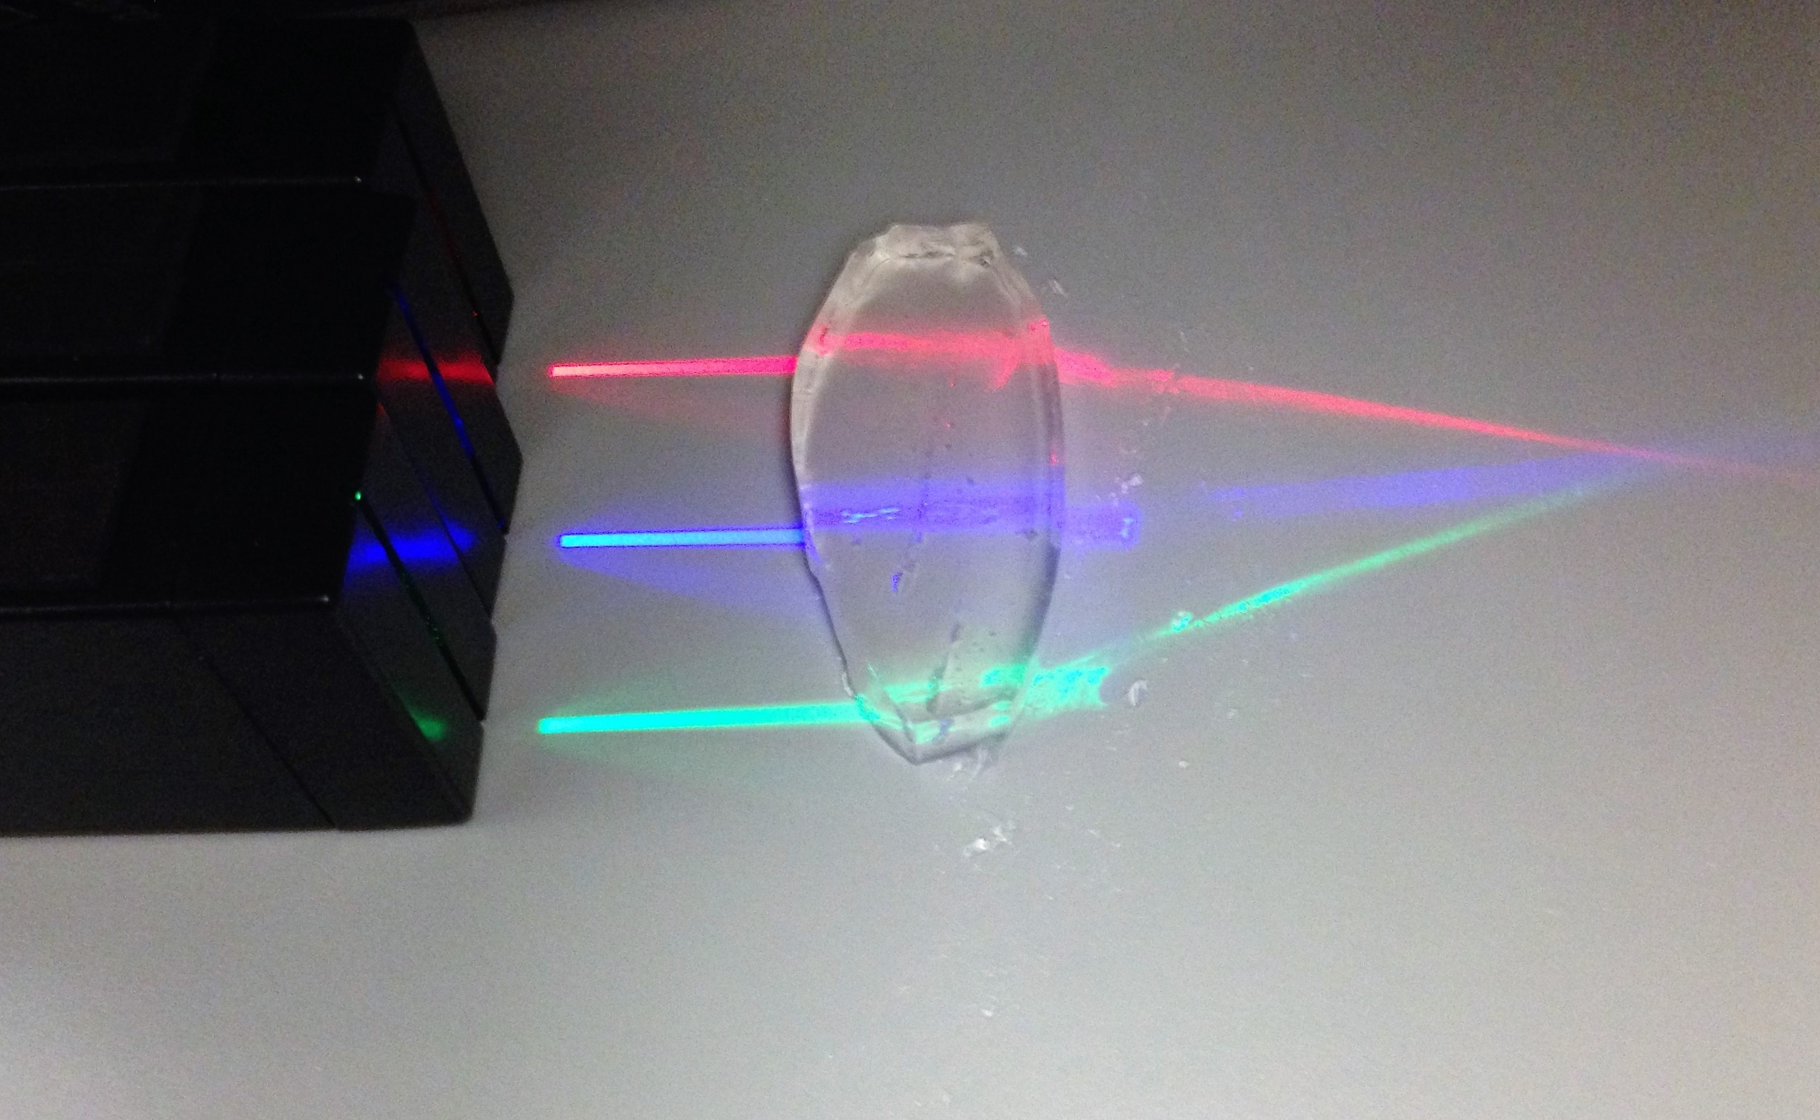
- Lay on the table the lens that is thin on the top and bottom, and thick in the middle. This is called a “convex” lens. Take your three parallel beams of light and line them up so that their beams enter the lens at the bottom, middle, and top. What happens? Measure the distance and complete the picture below, writing down the distance from the center of the lens to the intersection. This distance is called the “focal length” of the lens.
Once the students draw the ray diagram, ask them to think about why they are seeing the light convergence, and ask that they connect it with the water pearl exercise (if they did both). Where does the light from the top go? Where does the light from the bottom go? How does this manifest when we look through the water pearl?
Students needing extra support in the conceptual basis for this activity could benefit from The Physics Classroom free online tutorial: “Refraction by Lenses”
http://www.physicsclassroom.com/class/refrn/Lesson-5/Refraction-by-Lenses

- Now we will see what happens when we use just one beam of light. Switch to the single slit, and move the slit and the light back and forth so that the beam of light travels up and down the lens. Make note of the changes in the angle at which the light exits when you are at different positions on the lens. Are there more than three angles the light can exit at? The students should realize that as the beam of light strikes different positions on the lens, the angle at which it exits will be different for every position. As the light gets closer to the center from either side, it will be closer to straight because a ray that travels through the exact center of the lens takes a straight path.
- Switch back to the three beams of light. Place a marker where the beams intersect, and draw a picture of the lens and three beams. Label the distance from the center of the lens as “focal length.” Now, gently squeeze the bottom and top of the lens, but not so hard that it cannot return to its original shape. Has the intersection of light beams moved? Is it now closer than the marker, or farther? Draw another picture of the light beams and label the focal length again, but also mark whether the new focal length or shorter or longer than the original. What does this tell us about how the size and shape of a lens affect its focal length?

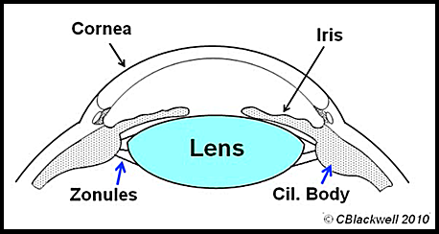
- The activity above models how the human eye responds to focusing on near versus far objects. Using the images below and to the right, describe how the shape of your eye’s lens changes as you “accommodate” to the various distances of objects.
Figure 1
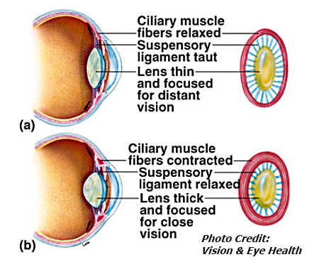
The gelatin lens activity allows students to model the focusing action of the eye. The focusing muscles of the eye, located in the ciliary body, form a ring around the inside front of the iris (Figure 1). When we want to focus on a distant object, our ciliary muscles are relaxed and the lens of our eye is flatter in shape. When we need to focus up close, the ciliary muscles contract and the lens becomes rounder. This bends the light more to allow near focus (Figure 2). We call this ability of the eye to adjust its focal length "accommodation". When you squeeze the gelatin lenses to make them rounder, you are modeling the process of accommodation in the human crystalline lens.

Figure 2

PART 2: Observing properties of concave lenses

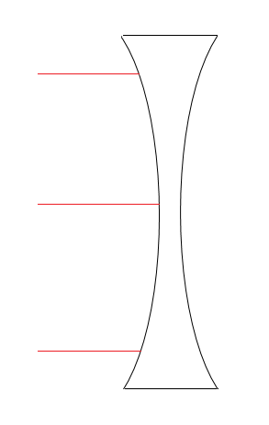
- Repeat step 1. Make the appropriate drawing below. How is this different from the convex lens? What is missing from this lens that the convex lens had?
Students should realize that what’s “missing” is a point where the rays converge (intersect). This intersection point is known as the focal point, and it was visible in their convex lens explorations. A concave lens, however, diverges the rays. A concave lens still has a focal point, but it won’t be visible in this exploration. You can use ray diagrams to locate the focal point of a diverging lens.
The red lines are the solutions.
We call this a “diverging lens,” because the light passing through it separates, or “diverges.”

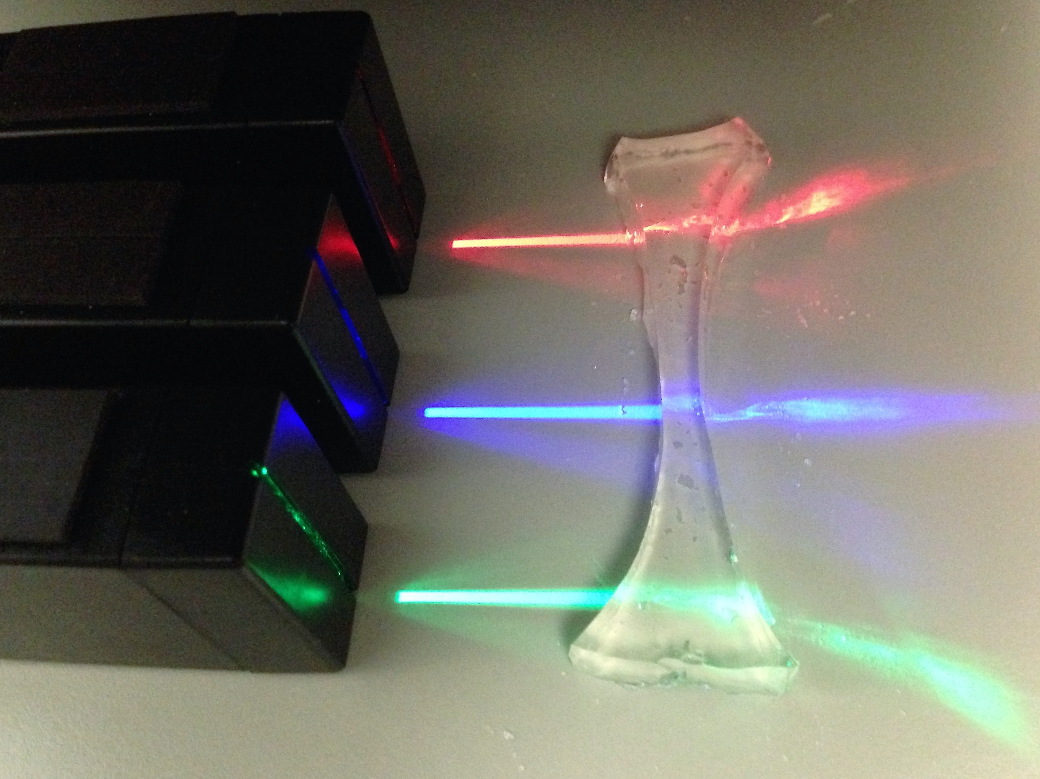

NGSS Standards: See next page
A note about the standards: The path of light through a transparent object and the wave model of light are specifically referenced within the NGSS middle school standards. Understanding of these concepts is essential to meeting Performance Expectations in High School Physical Science as well, so we are including them in our NGSS Standards alignment.

Performance Expectations
Middle School Physical Science: Waves and Electromagnetic Radiation
- MS-PS4-2: Develop and use a model to describe that waves are reflected, absorbed, or transmitted through various materials.
High School Physical Science: Waves and Electromagnetic Radiation
- HS-PS4-3: Evaluate the claims, evidence, and reasoning behind the idea that electromagnetic radiation can be described either by a wave model or a particle model, and that for some situations one model is more useful than the other.

Disciplinary Core Ideas
Middle School Physical Science: Electromagnetic Radiation
- MS-PS4.B.1: When light shines on an object, it is reflected, absorbed, or transmitted through the object, depending on the object’s material and the frequency (color) of the light.
- MS-PS4.B.2: The path that light travels can be traced as straight lines, except at surfaces between different transparent materials (e.g., air and water, air and glass) where the light path bends.
High School Physical Science: Wave Properties
- HS-PS4.A.1: The wavelength and frequency of a wave are related to one another by the speed of travel of the wave, which depends on the type of wave and the medium through which it is passing.

Crosscutting Concepts:
Patterns
- Patterns can be used to identify cause and effect relationships
- Empirical evidence is needed to identify patterns.
Structure and Function
- Complex structures and systems can be visualized, modeled, and used to describe how their function depends on the relationships among its parts; therefore, complex natural structures/systems can be analyzed to determine how they function.
- Investigating or designing new systems or structures requires a detailed examination of the properties of different materials, the structures of different components, and connections of components to reveal its function and/or solve a problem.

Science and Engineering Practices
Constructing Explanations and Designing Solutions
- Apply scientific principles and evidence to provide an explanation of phenomena, taking into account possible unanticipated effects.
Developing and Using Models
- Develop and use a model to describe and/or predict phenomena.
- Use a model to provide mechanistic accounts of phenomena.

