Jelly Science: Exploring Light with Water Pearls
Inspired by The Physics Teacher’s
“Physics Fun with Jelly Marbles” by Gordon Gore
and
“Water Pearls Optics Challenges for Everybody” by Marina Milner-Bolotin

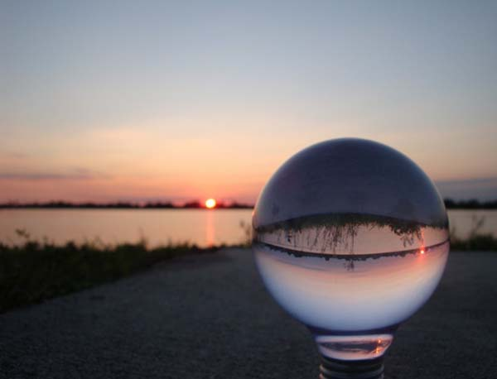
Description: Students explore how a lens forms images by using water pearls, a hydrating polymer product that expands in water and behaves as a convex lens.

Purpose: Students will observe refraction and learn about focal length of a lens, image inversion, and magnification through a lens.

NGSS Connections: See Page 8 for Detailed List
Disciplinary Core Ideas:
- HS-PS4.B.1: Electromagnetic Radiation
Crosscutting Concepts:
- Cause and Effect
- Patterns
- Structure and Function
Science and Engineering Practices:
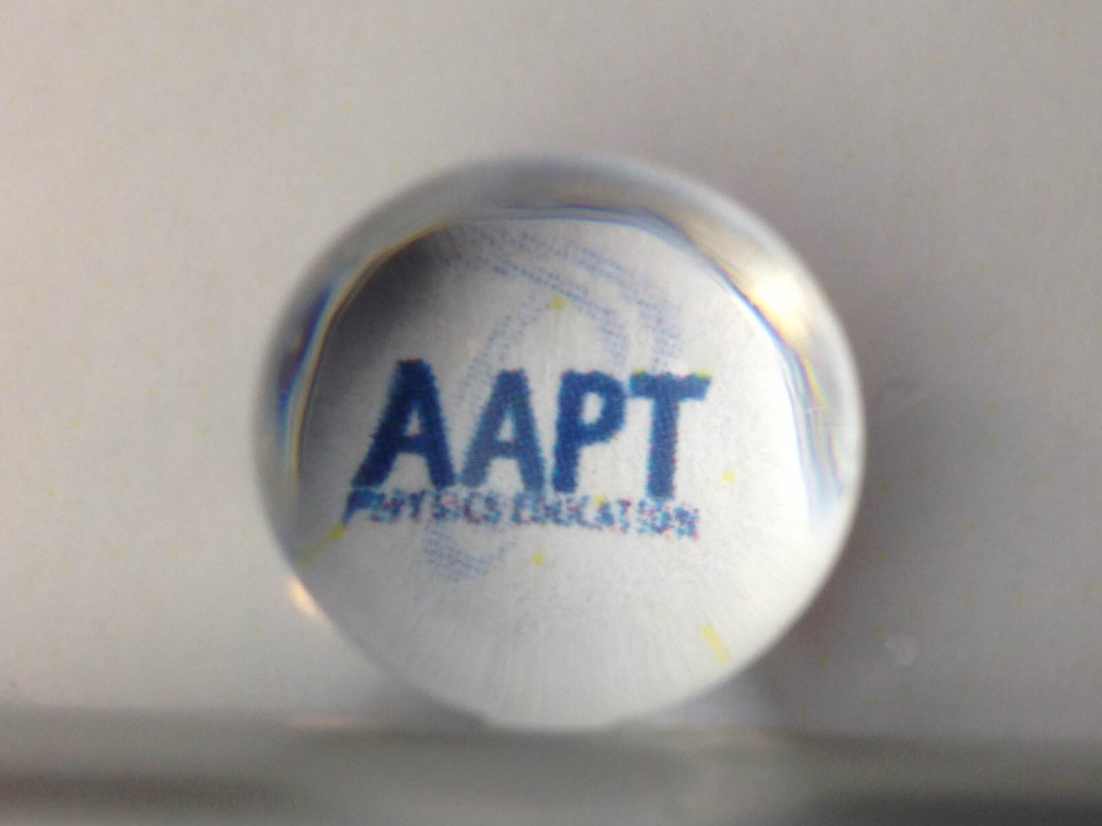
- Constructing Explanations and Designing Solutions
- Obtaining, Evaluating, and Communicating Information
Performance Expectations: Waves and Their Applications in Technologies for Information Transfer (PS4)
- HS-PS4-1
- MS-PS4-2

Materials:
- [Jumbo] Water Pearls
- Flashlight
- Clear cup 2/3 full of water
- Clear cup 1/3 – 2/3 full of clear oil or dish soap
- A smooth-edged knife (for teacher’s use only!)
- Fishbowl or spherical bowl full of water (suggested)

Advanced Preparation:
- Place the unexpanded water pearls in a bowl of water. Be aware that they expand a lot, so only do a few at a time!
- If you have a fish bowl or circular, clear vase, fill it with water so that you have a similar shaped lens as the water pearls. This way, the students have a larger version of their lens they can use if they are having trouble!
Modifications:
- In addition to doing investigations with the water pearl using the flashlight, dim the lights in the room and use a laser beam to see if you can help students to observe refraction within the pearl itself. (Caution: Use care when using a laser beam around children. Ensure that the laser beam remains below eye-level).
- Use Jumbo-sized water pearls (about the size of a ping pong ball when expanded) if possible, as it makes observation and experimentation a little bit easier.

Lab Activities for Students: Jelly Lens

PART 1: Looking at images through the water pearl

- Hold the water pearl between two fingers, and look through it at arm’s length. Try pointing it at a window and observe the image in the water pearl. What do you see? How does the image you see in the water pearl look different from the image you see when looking with your naked eye?
The image should be upside down and backwards. Try to make sure students are aware of both changes, since “upside down” is far more obvious than “backwards.”

- Now, place your water pearl on the table on top of the emoji on the last page of this worksheet. What does it look like? Draw a picture here of what you see:

The image should be the same, but magnified.

- Slowly pull the water pearl away from the emoji. What happens?
After a very short distance, the image should become dramatically distorted and then flip.

- How far does it have to be before the image changes dramatically? What does it look like once it is pulled far away?
It should get distorted at a distance that is twice the radius from the center. Ie. If you are using a water pearl that is 2 cm in diameter, the image will be very distorted at about 2 cm from the center of the pearl, or 1 cm from the surface of the pearl closest to the image. Try to get your students to be aware that the image distorts at “half the length of the water pearl” or similar.

- After the image flips, look carefully at it through the water pearl for a little while. Draw the new image:
(This is to make sure that students draw it both upside down and backwards).
What is different? Try looking at your drawing through the water pearl. Does it look like the original picture? Obviously it won’t look exactly like the logo because it is a drawing, but this is an easy way the students can check that they drew it upside down and backwards.

PART 2: Observing light pass through the water pearl

- Have a friend hold a flashlight pointed down at a blank piece of paper. Place the water pearl on the paper. Slowly lift the water pearl up from the paper, and watch the shadow of the pearl. Make sure your hand doesn’t get between the flashlight and the pearl, or between the pearl and the paper! Use your thumb and index finger. After raising it just a little bit, you should see a dot of light appear in the shadow! Move the pearl up and down a tiny bit.
What happens to the dot of light? About how far away from the paper does the pearl have to be to see the dot?
See if you can get the dot to be as small and as bright as possible. If you can, measure the distance from the pearl to the paper at this point! This is called the focal length of the lens.

Might need to mount the flashlight. Make sure the students bring the pearl away very slowly, otherwise they could easily miss the focal point. You can give them a hint that it is “very close to the paper.” Alternately, this could be a demonstration that the teacher does, with the students having the opportunity to try it out themselves afterwards if they want to. An easier way to do this is by cutting a hole in a plastic spoon that is just barely larger than the diameter of the water pearl, and using that to move the pearl up and down under the light. This makes it much easier to a) see what is going on underneath, and b) avoid dropping it

PART 3: Observing water pearls immersed in liquid

- Get a clear cup mostly full of water, and place your water pearl gently into it. What happens? Why might the water pearl do that when it is in the water? (Hint: What do you think the water pearl is made of?)
The water pearl should entirely or mostly disappear when it goes into the water. This is because it has the same index of refraction as the water, meaning that it bends light the same amount as water. So while the light bends when it changes medium from air to water, it does not bend when it changes medium from water to water pearl and then back to water. Since the path of the light does not change, there is no way for us to see that there is anything else in there.

- Fish your water pearl out of the cup. Make sure not to spill! Put the water pearl in the other cup containing the oil or soap. Can you see it? What does it look like? Is this different from how it looked in the water?
This will depend on what you use, but the water pearl should be more visible now because the index of refraction is not exactly the same as the medium it is now inside. This works better with clear oils or soaps, since it illustrates better that the pearl is not just invisible in water because it is “clear.”
- Look at an image through the fishbowl full of water. How does it compare to the image we see through the water pearl? What happens if you move the image closer and farther away from the fishbowl? Is this what you expected?
The fishbowl acts as a large version of the water pearl, where things far away should be upside down and backwards and things that are close should be magnified. This part is not necessary, but it might be useful to illustrate certain things if students are having trouble understanding the properties of the water pearl due to its small size.

PART 4: Changing the shape of the water pearl
- Ask your teacher to cut the water pearl in half. Look through it again. Has it changed? What is different?
Cutting the water pearl in half changes it from a biconvex lens to a plano-convex lens. The surroundings should still be upside down and backwards. Using the sharpest knife possible helps make the water pearl still see-through after it is cut, but don’t allow students to handle the knives.
- Repeat the directions for numbers 2 and 3. Compare the images. Is the image bigger or smaller once the pearl has been cut in half?
The image should be smaller – there is less magnification.
- Repeat the directions for number 6. Is there any change? Does the pearl have to be any closer or farther from the paper to make the dot the smallest and brightest it can be? Try to measure again, and compare the numbers. About how much has it changed?
The pearl would be farther away in order to make the light focus – about twice as far, in fact. The focal length doubles.

Image for Observation with the Water Pearl for numbers 2-5:

Additional Material:

Teachers may create additional demos/activities:

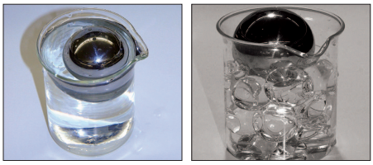
Half fill the beaker with water pearls and place the heavy steel ball on top. When you cover the water pearls with water, the heavy steel ball will appear to float.

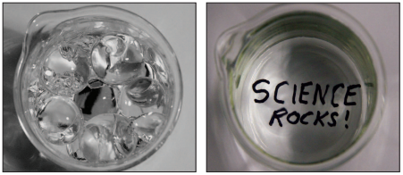
Fill a beaker with water pearls, and place under it a piece of paper with a secret message. It will be illegible until the beaker is filled with water, at which point the message will be revealed!

Extension Activity: What if Our Brains Couldn’t Reorient Inverted Images?

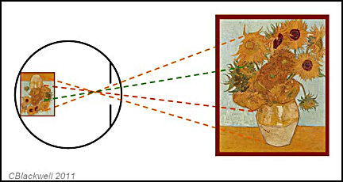

Human and mammalian eyes are similar to water pearls in that they invert the images we see (drawing above). As light rays refract through the human cornea and again through the human crystalline lens, our vision produces an inverted (and backwards) image on the retina of our eyes. This inverted image gets sent through the optic nerve on a pathway to the occipital lobe of the brain, where it is reoriented to be “rightside up”. It’s an evolutionary marvel, and it all happens instantaneously in the healthy human eye.

In 1950, two German scientists, Theodor Erismann and Ivo Kohler, did a strange experiment. Both scientists worked at the School of Cognitive Psychology, University of Innsbruck, Austria. Dr. Erismann, a physicist and psychologist, wondered what would happen if the human brain saw only inverted images. He knew that the human lens produced inverted images on the retina, but wanted to know two things:
- What if we could only “see” the inverted images? What would the world look like and how would the inversion affect our perception?
- With time, could the human brain adapt itself to the altered perception and automatically make adjustments?
Dr. Kohler, the research assistant, wore binocular prism glasses (inversion goggles) for 124 days in an experiment that would probably be considered unethical today. The findings: Dr. Kohler began to adapt to the “new” world in his movements and responses to visual stimuli.

Activity: (Can be done as a flipped lesson)

Reading: M. Abrahams, “Experiments Show We Quickly Adjust to Seeing Everything Upside Down”, The Guardian, 12 November 2012.
https://www.theguardian.com/education/2012/nov/12/improbable-research-seeing-upside-down

Videos:

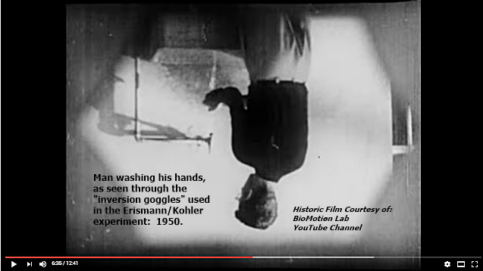

- BioMotion Lab Historic Video: Erismann and Kohler – Inversion Goggles
https://www.youtube.com/watch?v=jKUVpBJalNQ
This 13-minute historic video documents the classic experiment conducted in 1950 by Ivo Kohler and Theodor Erismann. The older man in the video is Dr. Erismann, physicist and psychologist at the University of Innsbruck, Austria. The younger man is his research assistant, Dr. Kohler, who wore the inversion goggles for 124 days. It’s not just the image inversion that’s noteworthy. It’s also the effect on Dr. Kohler’s locomotion and perception of the space around him. Watch him try unsuccessfully to fend of the fencing thrusts!

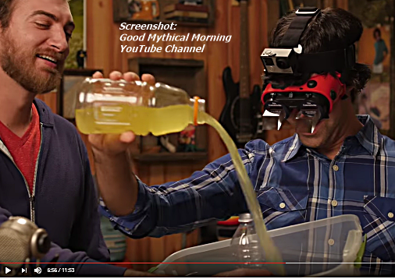

- Good Mythical Morning YouTube Channel: Upside Down Glasses Challenge
https://www.youtube.com/watch?v=OJTC_E2Nlgg
This hilarious 12-minute video shows the engaging duo, Rhett and Link, wearing a pair of prismatic glasses to turn the world upside down and backwards. They engage in a series of three tasks: 1) Write your name on a whiteboard; 2) Pour juice from one container to another, and 3) Step over three low hurdles. Interesting takeaway: Link was able to quickly adjust his perception to write his name. Rhett couldn’t write his name at all wearing the inversion goggles, but was able to pour the liquid with fair accuracy, while Link spilled the entire container.

Teachers: Inversion goggles are readily available online at a cost between $30.00 and $75.00. But you may not want the risk of injury they pose to your students.

Assessment: Reflecting on the lesson
- Models such as the water pearls are useful for helping us understand physical phenomena, but can never duplicate the real thing with complete accuracy. How are the water pearls similar to image production in the human eye, and how are they different?
They are similar in that both the water pearls and the human lens refract light. Depending on the focal length, either lens can produce an inverted image or magnify an object. (It’s true: if you take a human lens or a mammalian lens out of the eyeball, it will produce images in a very similar way to the water pearls. If students don’t believe you, show them the PBS Learning Media interactive, “Cow’s Eye Dissection”)
http://www.pbslearningmedia.org/resource/lsps07.sci.life.stru.coweye/cows-eye-dissection/

They are different in that the human lens is encased in an eyeball that focuses the light on the retina, then sends nerve impulses along the optic nerve. These impulses travel through a neural pathway in our brain that ends up in the occipital lobe, where the images are again inverted to be “rightside up”. The human eye took millions of years to evolve. Also, the human lens is an oblate spheroid (more oval-shaped), while the water pearls are almost perfectly spherical in shape.

- Do you believe Dr. Erismann’s claims that the human brain could successfully reorient itself over time, even if we saw images upside down? How would our reaction time and locomotion be affected? How can you support your answer? Responses will vary. Ask students to think about the ethics of this sort of experimentation on human subjects. Can we ethically perform a valid experiment that could be replicated? If not, how could Dr. Erismann’s claim be supportable?

Next Generation Science Standards
Performance Expectations
Middle School Physical Science: Waves and Electromagnetic Radiation
- MS-PS4-2: Develop and use a model to describe that waves are reflected, absorbed, or transmitted through various materials.
High School Physical Science: Waves and Electromagnetic Radiation
- HS-PS4-1: Use mathematical representations to support a claim regarding relationships among the frequency, wavelength, and speed of waves traveling in various media.
Disciplinary Core Ideas
Middle School Physical Science: Electromagnetic Radiation
- MS-PS4.B.1: When light shines on an object, it is reflected, absorbed, or transmitted through the object, depending on the object’s material and the frequency (color) of the light.
- MS-PS4.B.2: The path that light travels can be traced as straight lines, except at surfaces between different transparent materials (e.g., air and water, air and glass) where the light path bends.
High School Physical Science: Electromagnetic Radiation
- HS-PS4.B.1: Electromagnetic radiation (e.g., radio, microwaves, light) can be modeled as a wave or as particles called photons. The wave model is useful for explaining many features of electromagnetic radiation, and the particle model explains other features.
Crosscutting Concepts:
Patterns
- Patterns can be used to identify cause and effect relationships
- Empirical evidence is needed to identify patterns.
Cause and Effect
- Cause and effect relationships can be suggested and predicted for complex natural and human-designed systems by examining what is known about smaller scale mechanisms within the system.
Structure and Function
- Complex structures and systems can be visualized, modeled, and used to describe how their function depends on the relationships among its parts; therefore, complex natural structures/systems can be analyzed to determine how they function.
- Investigating or designing new systems or structures requires a detailed examination of the properties of different materials, the structures of different components, and connections of components to reveal its function and/or solve a problem.

Science and Engineering Practices
Constructing Explanations and Designing Solutions
- Apply scientific principles and evidence to provide an explanation of phenomena, taking into account possible unanticipated effects.
Developing and Using Models
- Develop and use a model to describe and/or predict phenomena.
- Use a model to provide mechanistic accounts of phenomena
- Evaluate limitations of a model for a proposed object or tool.

