Glowstick Science: Glowstick Color Lab
Inspired by The Physics Teacher’s

“Glow Sticks: Spectra and Color Mixing” by Jennifer Birriel and Ignacio Birriel
and
“As Easy as R, G, B” by Leonard Parsons
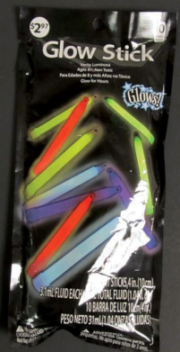
Description: Students will investigate RGB color addition of light in a hands-on experiment that uses liquid from glow sticks. This cross-disciplinary lesson blends physics, chemistry, and life science.

Purpose: The purpose of this activity is to promote understanding of the difference between mixing the primary colors of light (red, green, and blue) and mixing pigment. Glow sticks produce an example of chemiluminescence, a reaction in which energy is released in the form of light without heat. Activated glow sticks are light emitting objects, thus, mixing different glow stick colors will produce RGB color addition (which is not possible with paint or other pigmented light reflecting objects).

NGSS Connections: See Detailed NGSS Standards on Page 8
Disciplinary Core Ideas:
- PS1.B Chemical Reactions
- PS4.B Electromagnetic Radiation
- LS1.D Sensory Information Processing
Crosscutting Concepts:
- Cause and Effect
- Structure and Function
Science and Engineering Practices:
- Constructing Explanations

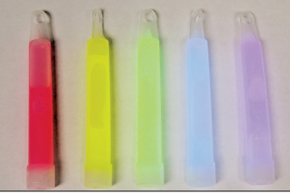
Materials:
- Glow sticks (red, green, and blue)
- Protective latex/non-latex gloves
- Protective goggles
- A toothpick or unbent paper clip
- A pipette/dropper
- A sharp knife
- Transparent plastic overhead sheet
- Yellow, magenta, and cyan highlighters
- Clear or translucent plastic cups
- Various colors of markers
- Optional: Printer ink (cyan, yellow, magenta)

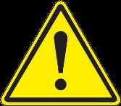
Wear gloves and safety goggles when handling the chemicals in a light stick. H2O2 is an oxidizing agent that can cause skin irritation. The fluorescent dyes are considered toxic and must not be ingested. Caution! Never ever try to open a glow stick up with your mouth. When opening a glow stick and breaking the glass vial inside make sure you wear safety goggles to prevent shards of glass or chemicals from reaching the eye.
SAFETY

Advanced Preparation:
- The chemicals inside of glow sticks can cause mild inflammation with direct contact to the skin. Ensure that children wear gloves, and wash their hands thoroughly after performing this activity. Contact poison control immediately if the liquid swallowed.
- The chemicals in this lab do stain clothing, so it might be advisable to let children (and parents) know ahead of time, so that they wear something appropriate.
- Immediately before class, thoroughly prepare an appropriate number of glow sticks by cracking the tube inside them, shaking vigorously, and then cutting off the end with your knife and pouring the liquid into a cup. Each group should have one cup each with red, green, and blue liquid. If possible, remove any shards of glass from the cup that fell out of the glow stick with the liquid. Still, ensure that the students do not stick their hands in the cups as there may still be glass and the liquid itself is mildly corrosive.
- Make the room as dark as possible during the lab.

Background Information:

Glow sticks consist of two separate compartments with two different chemical solutions. One solution, contained within an inner glass cylinder, is hydrogen peroxide. In the case of most glow sticks, the other solution surrounding the glass cylinder contains a diphenyl oxalate compound along with a fluorescent dye. The inner glass cylinder keeps the two solutions separated to prevent their reaction. The action of snapping the glow stick breaks the glass cylinder, allowing the two solutions to mix and initiate the chemical reaction. The reaction occurs between the H2O2 (hydrogen peroxide) and the diphenyl oxalate. When the two solutions are mixed the hydrogen peroxide oxidizes the diphenyl oxalate ester, which produces phenol plus an unstable compound called 1,2- dioxetanedione. This unstable ester breaks apart releasing energy and CO2. The energy gets transferred to the dye molecule causing the electrons to jump to higher levels. The dye molecule finally relaxes back to the ground state, with the release of a photon of light at a specific frequency which our eyes can see because it falls in the visible range of the electromagnetic spectrum. See the figure below for an illustration:

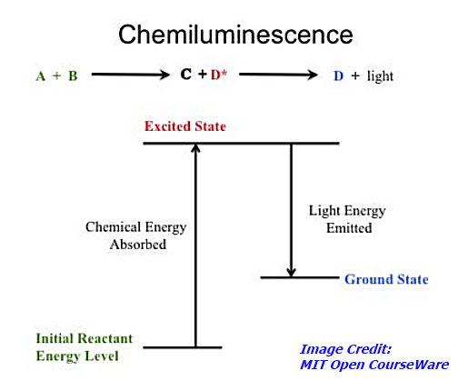
Misconceptions
Students in the secondary grades often have difficulty believing that color is not an intrinsic property of an object, but rather is an interpretation of the reflective and absorptive properties of an object's surface and the wavelength of the light it reflects or emits. For example, humans see the wavelength range of 600-700 nm as orange or red; dogs see it as brown or goldish-brown (see chart below). You and Fido may both be looking at a "red" ball, but it's brown to Fido. So the color isn't innate to the ball; it's the result of wavelength perception in human vs. canine eyeballs.
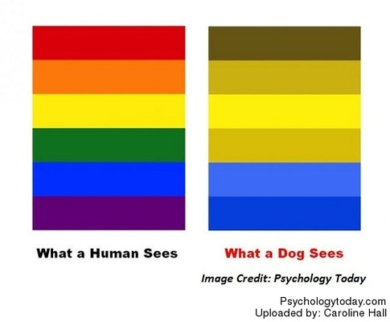
Another area of documented difficulty is in understanding that most objects contain atoms that are capable of selectively absorbing or reflecting one or more frequencies of light. When visible light strikes an object and a specific frequency becomes absorbed, that frequency of light will never make it to our eyes.

Lab Procedures for Students: Glowstick Color Lab

Pre-Lab:

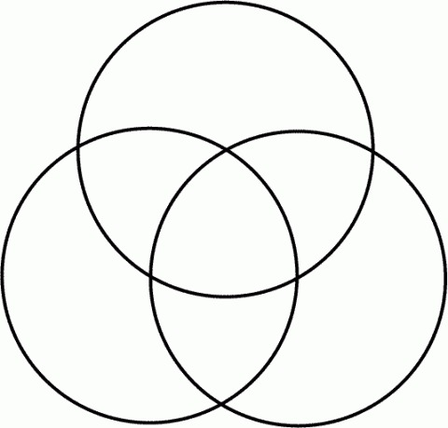
- Below, use the provided highlighters (magenta, cyan, and yellow). Fill each circle with one color, and observe what happens when they get mixed up together. Use yellow first, so as to avoid staining the yellow marker with the other colors. The combined colors should ideally be red, green, blue, and black. You can do this part of the activity by combining drops of printer ink mixed into water instead of using markers to mix pigment.
In the following activity, you will learn about the difference between mixing pigment (things like markers, paint, and ink – things that do not give off their own light) and mixing light by combining different colors of glow stick.
- The primary colors of light are red, green, and blue. Make a prediction what you will see when you mix each of the colors: Students will likely predict that light will mix like pigment, ie….
Red + Green = ________________ Students might guess brown or purple; correct is yellow.
Green + Blue = ________________ Students might guess teal or turquoise; correct is cyan.
Blue + Red = ________________ Students might guess purple; correct is magenta.
Red + Blue + Green = ________________ Students might guess brown; correct is white.
Lab: Teachers will need to turn off overhead lights for this. Ensure that students are all wearing gloves and protective goggles. Each group should have one shared worksheet under the plastic, as well as one other for each student where they can write their predictions and results.

- Wait until all of the lights are off. You should have in front of you three cups containing each of the three colors of glow liquid, with a dropper in each. Place your worksheet under the plastic, so that it is protected. Teachers: For safety, prepare the cups and droppers ahead of time.
- Take your dropper, and first place 1 drop of each color liquid (use 2 drops of blue because it is dimmer) in the corresponding box on the top row of the worksheet. You should be able to observe the glowing liquid!
- Look at the second row. On the other version of your worksheet, write the color you expect to be created by each combination (what you wrote above). Make sure you mark this on the worksheet as a prediction, because you will now see if you are correct!
- Mix 1 drop each of the indicated colors in each box of the second row (again, use 2 drops of blue). Use your toothpick or paperclip to mix the liquid together. What colors are formed? Were your predictions correct? Write the actual colors in their boxes on your worksheet, under your prediction. Use the markers to color a spot in each box with the color that you observed. As above, the glow stick liquid will mix like light rather than like pigment.
- Make new predictions for the colors you will create in the third row. Write them here as well as on your worksheet: All three combinations will make white once mixed thoroughly.
Magenta + Green = ________________
Yellow + Blue = ________________
Cyan + Red = ________________
- Try it! Were your predictions right? What is going on here? Does the glow stick liquid mix like pigment, or does it mix differently? Why? Because the glow liquid gives off its own light (it is luminous), it mixes like light, not like pigment. Combining all of the colors would give white light!
- Turn the lights back on!
Post-Lab:

- What names are given to the three colors in the first row of the chart? The Primary colors of light
- Why are these three colors important when adding colors of light? They are the primary colors of light – the three specific frequencies of light (colors) the cones in our retinas are able to discern. All other colors can be formed by combinations of these three colors.
- What names are given to the three colors that are produced in the second row of the chart? Magenta, cyan, and yellow: the Secondary colors.
- What color is produced in the bottom row in all three cases? What were the original colors required to produce this color? White. In all three cases, students combined all three: red, green, and blue.
- When two colors of light are added together to produce white light they are called complementary colors. List all three pairs of complementary colors of light. Cyan + Red, Yellow + Blue, Magenta + Green
- Compare your lab results to the pre-lab predictions that you made. Answer the following questions again, now that you have completed the lab:
What color will you get when you mix a green light and a red light? ____________________ Yellow
What color will you get when you mix a green light, a red light, and a blue light? ______________ White
What color will you get when you mix a yellow light and a blue light? ____________________ White

- You have likely heard that “yellow and blue make green.” Does that hold true in this case? Describe a situation in which yellow and blue combine to give green. How is this different from what you did in this lab? No, the primary colors of light (red, green, blue) behave differently when mixed, producing white when yellow and blue are mixed. On the other hand, any pigment – including paint, highlighter, or printer ink – will produce green when yellow and blue are mixed.
- When you add red, blue, and green paint together do you get the same result that you did in this lab? How are the activities in this lab different from mixing paints together? (Hint: think about the materials you used!) No – mixing paint is mixing pigment, whereas this lab demonstrates the mixing of light because the luminescent dye is a light emitter. Paint is not luminous; it can reflect certain colors of light but not emit its own.

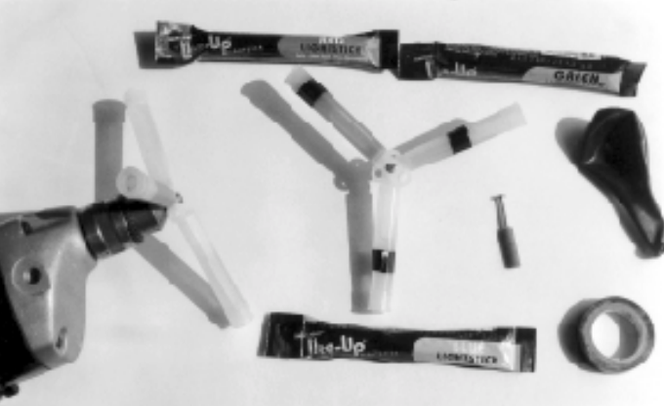
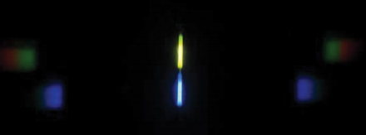
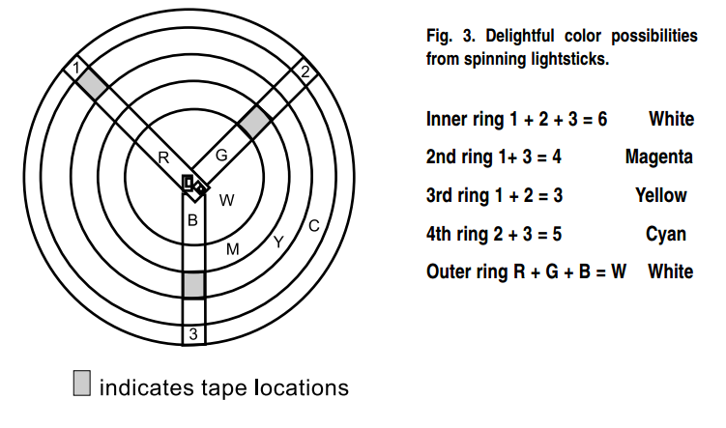

Red | Blue | Green
Magenta | Yellow | Cyan
Magenta + Green | Yellow + Blue | Cyan + Red

Next Generation Science Standards
Note to Teachers: Although the NGSS Core Ideas related to this Digi Kit are located within the Middle School section, the concepts explored are also appropriate for high school conceptual physics courses.

Performance Expectations
Middle School Physical Science: Matter and Interactions
- MS-PS1-2: Analyze and interpret data on the properties of substances before and after the substances interact to determine if a chemical reaction has occurred. (Strong correlation)
Middle School Life Science: Structure and Processes
- MS-LS1-8: Gather and synthesize information that sensory receptors respond to stimuli by sending messages to the brain for immediate behavior or storage as memories. (Limited correlation)
Disciplinary Core Ideas
Middle School Physical Science: Chemical Reactions
- MS-PS1.B.1: Substances react chemically in characteristic ways. In a chemical process, the atoms that make up the original substances are regrouped into different molecules, and these new substances have different properties from those of the reactants.
- MS-PS1.B.3: Some chemical reactions release energy, others store energy.
Middle School Physical Science: Electromagnetic Radiation
- MS-PS4.B.1: When light shines on an object, it is reflected, absorbed, or transmitted through the object, depending on the object’s material and the frequency (color) of the light.
Middle School Life Science: Structures and Processes – Information Processing
- MS-LS1.D.1: Each sense receptor responds to different inputs (electromagnetic, mechanical, chemical), transmitting them as signals that travel along nerve cells to the brain. The signals are then processed in the brain, resulting in immediate behaviors or memories.
Crosscutting Concepts:
Structure and Function
- Investigating or designing new systems or structures requires a detailed examination of the properties of different materials, the structures of different components, and connections of components to reveal its function and/or solve a problem.
Cause and Effect
- Cause and effect relationships can be suggested and predicted for complex natural and human-designed systems by examining what is known about smaller scale mechanisms within the system.
Science and Engineering Practices
Constructing Explanations
- Apply scientific principles and evidence to provide an explanation of phenomena and solve design problems, taking into account possible unanticipated effects.

