Rocket Science: Using Conservation of Energy to Predict Max Height

Student Worksheet

Purpose: Measure the impulse generated by a rocket engine. Use kinematics and the principle of conservation of energy to predict the maximum height of a rocket.

Guiding questions: Consider before beginning: If impulse for a drag-free, vertically-launched rocket can be determined, how could the final height of the rocket be determined? Explain.
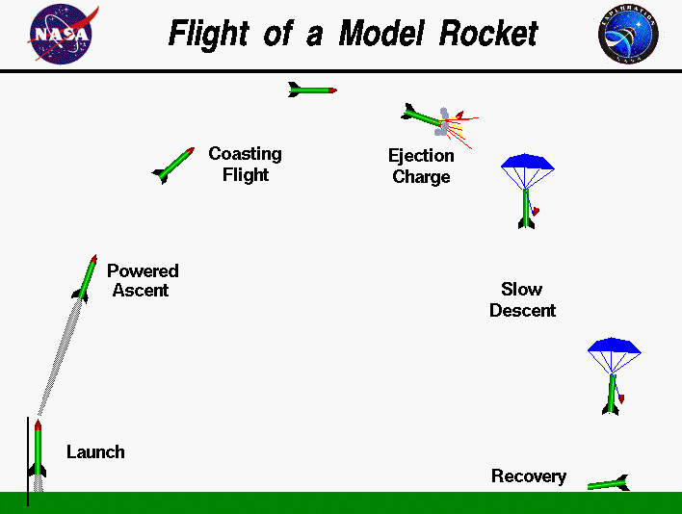
https://www.grc.nasa.gov/www/k-12/rocket/rktflight.html
In this laboratory activity, you will predict the maximum height of a rocket that is moving vertically, neglecting drag. To more fully understand the motion of a model rocket, refer to the image to the right, showing the “standard” stages of model rocket flight. Note that this image shows a parabolic flight focus on vertical launches only.

For each of the following stages, draw a proportionally-accurate force diagram showing relevant forces acting on the rocket. At this time, neglect drag.

Launch  (Engine begins burn, rocket not moving) | Powered Ascent  (Engine fully burning, rocket accelerating upward) | Coasting Flight I  (Engine no longer burning, rocket still moving upward)
Coasting Flight II  (Rocket momentarily at rest) | Ejection Charge  (Parachute releases) | Slow Descent I  (Terminal velocity not yet reached)
Slow Descent II  (Terminal velocity reached) | Recovery I  (Rocket is impacting ground) | Recovery II  (Rocket is at rest on ground)

Application Lab: Activity 1 - Measuring the Impulse of the Burn

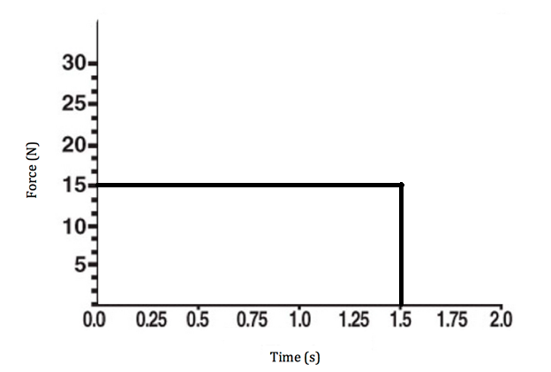
- When a rocket takes off, it is fueled by a burning engine. As the engine pushes the exhaust downward, which way must the rocket go? Why? Explain this in terms of Newton’s Laws and conservation of momentum.

- Consider, for example, a situation in which a constant force is applied to a rocket.

  - How much force is applied during the engine burn in this graph?
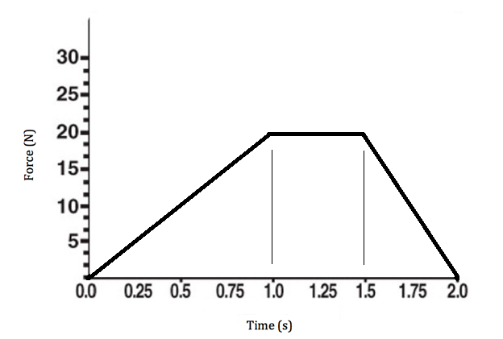
  - For how much time was the force applied?
  - How much impulse did the engine produce? Show work.

You might have noticed that by calculating the impulse of the engine that you were actually just multiplying the length by the width of the rectangular area made by the graph – impulse is the area of a Force-Time graph! Calculating the area under a curve is known – in calculus – as integration.

- How would you calculate the impulse of an engine with a Force-Time graph like the one to the right? Calculate it, and show work!

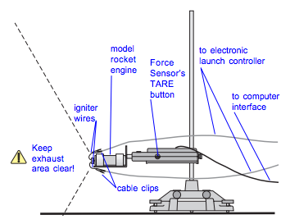
- Using a rocket engine test bracket, force meter, and data analysis program, create a Force-Time graph for a single-stage engine. Often times, the curves produced by these graphs are called thrust curves. Sketch the graph below. Use the integration tool to estimate the area under the curve, and list the total impulse. Follow all instructions and safety precautions explained by your teacher!

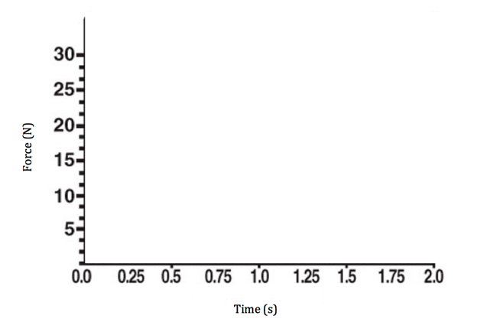

- If possible, get data from multiple trials or other groups who tested the same type of engine (ensure that the engines are from the same batch). List your impulse values below:

Trial | Total Impulse
1
2
3

- How do the values of impulse compare across engines of the same type? If there are any differences, are they different by a significant amount? Provide a rationale.

- Refer to the engine user manual or an online guide from the company that produced the engines you tested. How does your data compare to “commercial specifications” provided by companies? Consider both total impulse as well as time and magnitude of peak force. Explain.

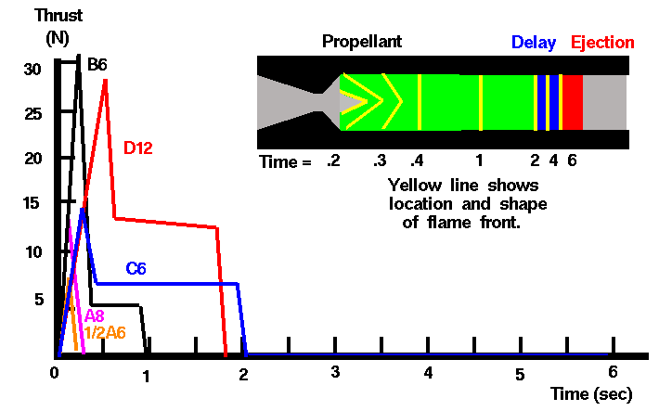

No matter the model rocket engine, most single-stage engines demonstrate the same force-time curve. Carefully study the yellow lines within the engine diagram above, representing the flame fronts, inside of the engine. You your observations to answer the following questions about the graphs:

- Why is there an initial quick increase in force, a maximum peak, and then a nearly constant thrust thereafter, until the engine burns out? (Hint: Consider the surface area of the flame front).

- How must an engine be designed to get greater thrust? If possible, look at a variety of engines with their associated thrust curves.

Example Estes engine thrust curves: http://www2.estesrockets.com/pdf/Estes_Time-Thrust_Curves.pdf

- Provide at least three possible sources of error (in manufacturing, the investigation’s procedure, or in the equipment used).

Application Lesson: Activity 2 - Predicting the Burn Phase

- From your thrust curve in Activity 1, determine the average total impulse (I) produced by the engine you will use to launch you rocket later in this activity. Record this value here:

- From your thrust curve in Activity 1, determine the average burn time (t_{b}) of the engine you will use to launch your rocket later in this activity. Record this value here:

- For this activity, assume that friction is negligible. Using the values from questions (1) and (2) above, determine the average net force (F_{net}) acting on the rocket.

- Determine the average mass of your rocket during its flight. (Hint: The mass of the rocket + engine at the start of the launch is not the same as the mass of the rocket + engine at the end of the rocket’s flight!) Feel free to use fresh and burned engines from Activity 1, and to use an electronic or triple-beam balance. List your average mass, and explain how you got it.

- Draw a diagram of the rocket and the forces acting on it during the burn. Ignore drag. Identify the net force, F_{net}, acting on the rocket. (Hint: There is more than thrust acting on the rocket!)

- Using F_{net}, estimate the average acceleration on the rocket during the burn. Show work.

- Determine the maximum velocity during the burn phase (v_{maxb}) from the burn time and average acceleration.

- Starting at rest, calculate the average velocity of the rocket during the burn phase.

- Determine the height gained during the burn from the average velocity and burn time.

Application Lesson: Activity 3 - Predicting the Coast Phase

- Assuming no drag, estimate the time that elapses from the moment of maximum velocity at the end of the burn, to the moment the rocket vertically stops moving at the peak of its trajectory.

- Calculate the average velocity during the coast phase. (Is it the same as the average velocity during the burn phase? Explain.)

- Determine the height gained during the coast phase.

Application Lesson: Activity 4 - Predicting Maximum Height

- Estimate the maximum height achieved from both the burn and the coast phases.

- Explain how you accomplished this.

Application Lesson: Activity 5 - Calculate Work, Energy, and Power
For each of the following questions, show calculations and provide a narration explaining the origin of each of your numbers, and why you chose the process you chose.

- Calculate the work done on the rocket by the motor during the burn phase.

- Calculate the power output of the rocket during the burn phase.

- Calculate the potential energy of the rocket at burn-out.

- Calculate the kinetic energy of the rocket at burn-out.

- Calculate the total energy of the rocket at burn-out.

- Given the total energy with which you calculated that the rocket started, draw an energy pie chart representing the forms of energy at each point in its trajectory.

Launch  (Engine begins burn, rocket not moving) | Powered Ascent  (Engine fully burning, rocket accelerating upward) | Coasting Flight I  (Engine no longer burning, rocket still moving upward)
Coasting Flight II  (Rocket momentarily at rest) | Ejection Charge  (Parachute releases) | Slow Descent I  (Terminal velocity not yet reached)
Slow Descent II  (Terminal velocity reached) | Recovery I  (Rocket is impacting ground) | Recovery II  (Rocket is at rest on ground)

- Using estimated final height of the rocket, calculate the potential and kinetic energy at the peak of its vertical motion.

- Compare the work done by the motor, the total energy at burn-out, and the potential energy at the highest point. How do they compare? Explain what Law this data demonstrates.

Application Lab: Activity 6 - Measuring Actual Rocket Values

- Go outside and prepare to launch your rocket!

- Use a method you determine with your teacher to be appropriate and safe to estimate the maximum height of the rocket, as well as the time from takeoff to maximum height. Explain your process below, and include data and calculations.

- How did predicted and actual total height values compare to one another? Why might these be different?

- Calculate the average velocity of the rocket during its upward motion. How does this compare to the average velocities for the separate burn and coast phases that you predicted? Why?

- Calculate the average velocity during the descent phase.

- Calculate the actual potential energy at the height reached by the rocket.

- How many g-forces did the rocket experience during launch?

- How do the predicted potential energy at the peak of the rocket’s motion compare to one another? What must account for this difference? (Work done by drag!)

- Calculate the average force of drag on the way up.

