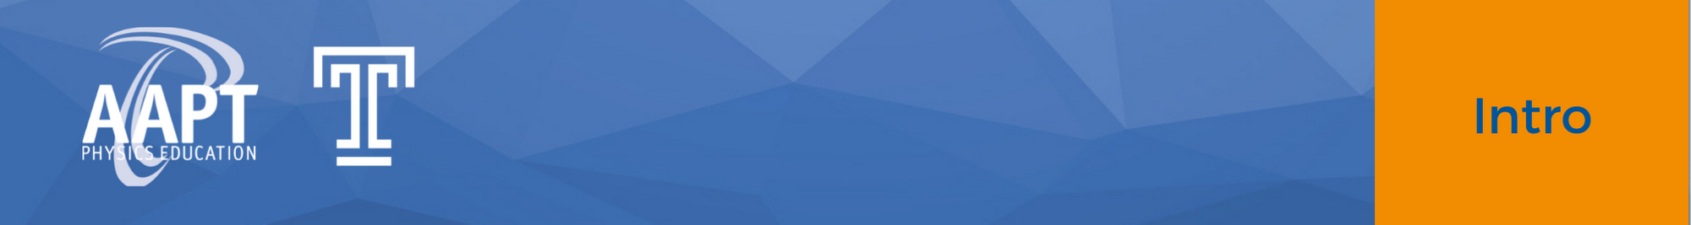
Concept Questions: Eclipse Fundamentals

Description: These simple questions with selected response answers test specific concepts relating to geometry of the Earth, Sun, and Moon as well as observations of solar eclipses. This resource is designed to be used either as homework or in small discussions with methods such as Peer Instruction, Teaching with Clickers, or CAE Think-Pair-Share.

Prerequisite:
- Understand the phases of the moon.

Concept Questions:
- Which of the following choices correctly describes the alignment of the Sun, Earth, and Moon during a solar eclipse?
  - Sun, Earth, Moon
  - Sun, Moon, Earth
  - Earth, Sun, Moon

- What is the phase of the Moon during a solar eclipse?
  - New Moon
  - First quarter
  - Crescent
  - Gibbous
  - Full Moon

- During a solar eclipse, what objects must be present in the sky?
  - The Moon only
  - The Sun only
  - Both the Moon and the Sun

- What is the Moon doing in the sky during a solar eclipse?
  - Rising
  - Setting
  - Covering the Sun
  - The Moon will not be in the sky

- If you are far from the path of the Moon’s shadow on the day of a solar eclipse, what will you observe in the sky?
  - The Sun being covered by the Moon
  - The Moon entering Earth’s shadow
  - No eclipse at all

- When the Sun, the Moon, and Earth are all aligned with each other, which of the following is a possible phase of the Moon?
  - New
  - First quarter
  - Crescent
  - Gibbous

- Why don’t solar eclipses occur each month?
  - The Moon is not always perfectly aligned with Earth to cast a shadow on it.
  - The Moon’s orbital period is not exactly one month.
  - Solar eclipses DO occur each month somewhere on Earth!

