**Pre-Tutorial Activity: Solar Energetic Particles**

Tracking High-Energy Protons from

Coronal Mass Ejections

**Intended audience:** Students in college/university course in modern physics or relativity (sophomore level) or an honors level college/university course in introductory physics.

**Description:** Students should be provided this pre-tutorial activity before the class meeting in which they are given the corresponding tutorial with the same title. The tutorial itself gives students the opportunity to apply their knowledge of kinematics and dynamics to determine when particles were accelerated by an interplanetary shock wave from a coronal mass ejection (CME). Students analyze (1) coronagraph images taken by the NASA’s SOHO (Solar and Heliospheric Observatory) and (2) proton flux graphs recorded by a Geostationary Operational Environmental Satellites (GOES) detector during a CME event that sent high-energy protons toward Earth. Students discover that the CME shock waves that accelerated the protons did so at a point near the Sun. This pre-tutorial activity provides some background information surrounding CMEs and the shock waves produced by CMEs.

**Prerequisite ideas (for the tutorial):**

* The emission of a signal (e.g., a light flash) and the reception of that signal must be treated as two distinct events, with different times as well as different locations.
* Students will need to apply kinematics concepts of constant speed motion as well as relate non-relativistic kinetic energy to mass and speed (*K =*  ½*mv*2).
* Students may need a refresher on the meaning of flux – the rate of flow of a fluid, radiant energy, or particles across a given area.

**Pre-Tutorial Activity:** Tracking Solar Energetic Particles   
from Coronal Mass Ejections

1. **Background: What are coronal mass ejections and how do we detect them?**

Coronal Mass Ejections (CMEs) are eruptions of clouds of plasma and magnetic field that are occasionally produced by the Sun. They can occur with or without solar flares. As the CME propagates through the background solar wind, a shock wave may develop along the leading edge of the CME. This shock wave can accelerate particles in space up to high energies producing a burst of high energy particles that travel throughout the solar system. These events are known as Solar Energetic Particle (SEP) Events. These particles can damage spacecraft, pose a hazard to astronauts in space, and can even affect airplane crew, passengers, and electronics flying over the polar regions.

Fig. 1(a) – (d) below shows the evolution of a CME. The latter two images, recorded by SOHO (Solar and Heliospheric Observatory), are *coronagraphs* displayed in the far ultraviolet light wavelength, which allows astronomers to view CMEs more clearly.

*Fig. 1: Flare and Coronal Mass Ejection. This sequence of four images shows the evolution over time of a giant eruption on the Sun. (a) The event began at the location of a sunspot group, and (b) a flare is seen in far-ultraviolet light. (c) Fourteen hours later, a CME is seen blasting out into space. (d) Three hours later, this CME has expanded to form a giant cloud of particles escaping from the Sun and is beginning the journey out into the solar system. The white circle in (c) and (d) shows the diameter of the solar photosphere. The larger dark area shows where light from the Sun has been blocked out by a specially designed instrument to make it possible to see coronal emissions. (credit a, b, c, d: modification of work by SOHO/EIT, SOHO/LASCO, SOHO/MDI (ESA & NASA))*

In order to better interpret what the above coronagraphs show, watch this 3-minute video of a massive CME on July 23, 2012, which, fortunately, did not travel in a direction toward Earth. (You may use the clickable link provided here or scan the QR code at right: [NASA-Goddard: Many Views of a Massive CME](https://www.youtube.com/watch?v=sg3NAdOYp8Q&t=8s).)

Another brief (1.5-minute) video is provided here, illustrating another CME that occurred in 2015. (You may use the clickable link provided here or scan the QR code at right: [NASA Goddard: Arching CME Eruption on June 18, 2015](https://www.youtube.com/watch?v=icitZubDmFI).) A qr code on a white background

***To prepare for the in-class tutorial:***

Carefully watch the three points during this particular video—at times indices 0:31, 0:53, and 1:05—when you can clearly see a shock wave develop. In the space below, for one of these three eruptions, (a) carefully sketch the shape of the CME soon after it erupts and (b) trace as clearly as you can the entire leading edge of the CME (that is, the farthest extent of the CME in all directions that it is traveling).

[NOTE: The leading edge of the CME indicates the approximate location of the shock wave it produces. During the in-class tutorial you will be determining the location of the shock wave of a CME as depicted in coronagraphs recorded by SOHO.].

1. **Background: Why do we care about tracking SEP events?**

Severe SEP events can cause disruption of satellite systems, harm to astronauts through radiation exposure, and disrupt radio communications on which pilots rely to fly safely near the poles. An extreme radiation storm event making a direct hit on Earth is capable of causing loss of satellite control and cause a radiation risk to passengers in high-flying aircraft. SEP events are rated on a scale from S1 (minor) to S5 (extreme), as shown in Fig. 2 below. Since 1996, the Space Weather Prediction Center has tracked and communicated space weather conditions and maintained a warning system for SEP events and other space weather activity.

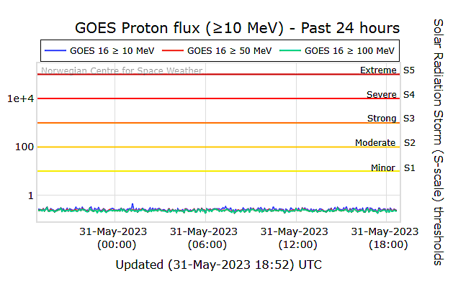

*Fig. 2: Solar Energetic Particle (SEP) Event classification. SEP storm severity, classified from S1 (minor) to S5 (extreme), correlates with Proton Flux, which is displayed along the vertical axis in units of pfu’s (Proton Flux Units). These graphs are updated from GOES-16 every 5 minutes. As this particular graph shows, there wasn’t much solar emission activity on May 31, 2023.*

**What happens if a Severe-scale SEP Event traveled directly on a trajectory to Earth?**

The SEP Proton Flux graph shown in Fig. 3 below represents three days in late October 2003, an event referred to as “The Halloween Storms.” This SEP event was part of a series of CMEs and solar flares occurring from mid-October to early November 2003. This graph shows two CMEs from the series, classified as S-4 (see Fig. 2 above). Almost every airplane flying near the poles was re-routed to lower altitudes to avoid ionizing radiation. Astronauts on the International Space Station took shelter in their service module. Many low Earth orbiting satellites were temporarily “lost.” Some went off-course during this solar storm.

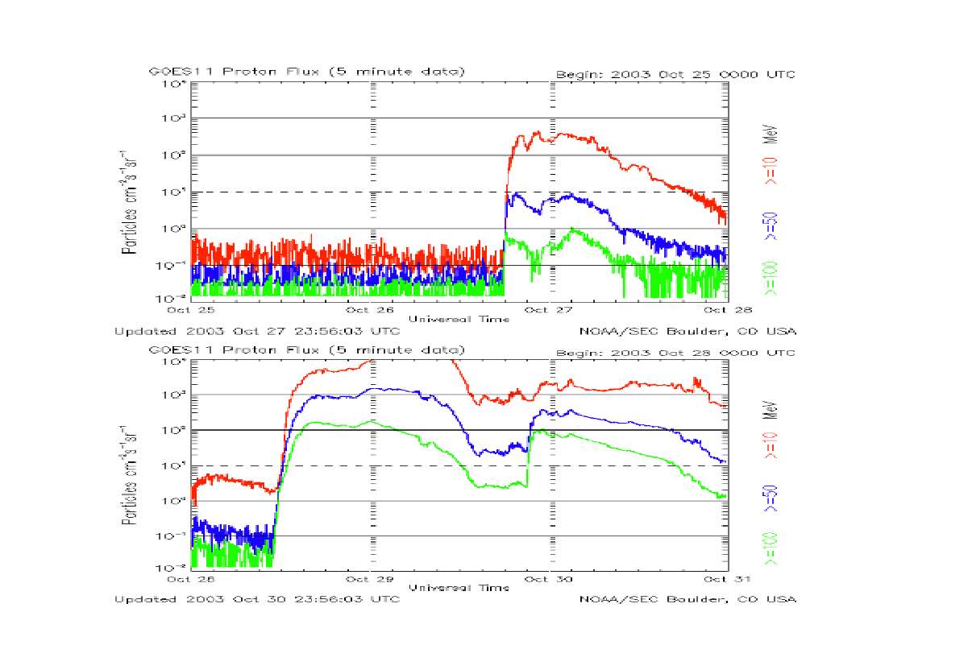

*Fig. 3: SEP proton flux detected during the “Halloween Storms” in late October 2003. The graph illustrates evidence of two SEP events, both classified as S-4 (see Fig. 2).*

Use the QR code or the clickable link to access an article that describes more precisely what happened in the 2003 event: [Space Weather Archive: The Day the Earth Lost Half Its Satellites](https://spaceweatherarchive.com/2021/10/28/the-day-earth-lost-half-its-satellites-halloween-storms-2003/). The remaining figures in this handout provide further background on the “Halloween Storms” of 2003.

**Eerie Science: Halloween Solar Storm, October 29, 2003**



