Lecture Tutorial: Tracking High-Energy Protons from
Coronal Mass Ejections

Description: This guided inquiry tutorial gives students the opportunity to apply their knowledge of kinematics and dynamics to determine when particles were accelerated by an interplanetary shock wave from a coronal mass ejection (CME). Students analyze (1) coronagraph images taken by the NASA’s SOHO (Solar and Heliospheric Observatory) and (2) proton flux graphs recorded by a Geostationary Operational Environmental Satellites (GOES) detector during a CME event that sent high-energy protons toward Earth. Students discover that the CME shock waves that accelerated the protons did so at a point near the Sun. This resource is designed to supplement a standard university level mechanics course at either the introductory or advanced level. A follow-up companion activity (provided separately) guides students to both apply knowledge of relativistic kinematics and to use linear interpolation skills.

Prerequisite ideas:
● The speed of light (in vacuum) is equal c = 3.0 × 10⁸ m/s (2 significant figures is fine).
● The emission of a signal (e.g., a light flash) and the reception of that signal must be treated as two different events, with different times as well as different locations.
● Students will need to apply kinematics concepts of constant speed motion as well as relate
(non-)relativistic kinetic energy to mass and speed (K = ½mv²).
● (In the companion activity, not included here:) Students need to recognize how relativistic kinetic energy relates to rest mass and speed (K = [γ – 1]mc², where γ = [1 – (v/c)²]^{–½}).

Some instructor notes:
● Although the explanatory text in the tutorial handout should be fairly straightforward, the overall procedure through which the students are guided in the course of the tutorial is as follows:

- Section I (Interpreting coronagraph images): Students inspect images with and without “streaks” caused by incident particles. They recognize that the arrival of these particles occur at the location of SOHO at the times indicated by the printed time stamp. Students also recognize that any events recorded on a coronagraph image that occur near the Sun must have happened approximately eight (8) minutes before the time indicated on the coronagraph itself.

- Section II (Interpreting graphs of representing proton flux): Students are then given graphical data for the detection of solar protons (at a GOES detector) having kinetic energy 165 MeV. Students estimate the arrival of these protons to within ± 1 minute.

- Section III (Tracking the acceleration event of solar protons): Finally, students use a non-relativistic treatment (i) to calculate speed and travel time of these protons, and (ii) to approximate, relative to the outer edge of the Sun, where the protons started to be accelerated by the CME shock wave.

● To check students’ work throughout the activity, section by section:

- Section I.D (on p. 2): The instructor “checkpoint” at the conclusion of Section I is critical for checking that students can properly relate the clock reading on a coronagraph image to the time of an event (near the Sun) that is recorded on that image.

- Section II.A (on p. 3): Students should recognize that the 165-MeV protons first arrive at SOHO at approximately 16:23 UT, with the proton flux generally increasing in value as time progresses.

- Section III.A (on p. 4): Students are expected to use (non-relativistic) kinetic energy ideas to find that the 165-MeV protons have a speed of 0.593c, or 1.78 × 10⁸ m/s.

(Note: Treating the protons as non-relativistic is fine for the purposes for this tutorial. A relativistic treatment yields 0.526c, from which the non-relativistic result differs by less than 15%. A companion activity, not included here, guides students to treat the protons as relativistic.)

- Section III.B and III.C (pp. 4–5): Continuing with the non-relativistic treatment of the 165-MeV protons, students should find:

- Part B.1: The protons take (just under) 14.0 minutes (13 min 57 sec) to travel the 149 million km from the Sun to SOHO.
- Part B.2: The CME shock wave began to accelerate the protons at about 16:09 UT, or 14 minutes earlier than 16:23 UT.
- Part B.3: The acceleration event at 16:09 UT would have been recorded on a SOHO image with time stamp of about “16:17 UT” (taking into account the ~8 min travel time for light).
- Part C: Luckily, our image set includes a coronagraph with time stamp of “16:18 UT,” just 1 minute off from 16:17 UT. From this image the shock wave, assumed to be at the farthest extent of the CME, is just over 3 solar diameters (about 3.2d) away from the Sun. That is our result for approximate location where the solar protons began to be accelerated by the CME shock wave

● For students who finish this tutorial, if time allows, encourage them to reflect on their work and to identify any assumptions they may have made along the way. For instance:

- Students may recognize that they needed to assume that a clock near the Sun’s location must be in the same rest frame as the SOHO clock in order to have those clocks be synchronized, despite the orbital motion of Earth (and hence SOHO) about the Sun.

- Students should recognize that they treated the velocity of the high-energy protons as purely radial in direction (from the Sun to Earth) and constant in magnitude. However, the protons follow a more helical path following the field lines of the interplanetary magnetic field, causing the actual travel time for the protons to be longer than the value approximated by the students.

In this activity, you will analyze a set of coronagraph images captured by the NASA’s SOHO (Solar and Heliospheric Observatory), which is a camera that takes images of the Sun. The coronagraph can record coronal mass ejections (CMEs) that can come toward Earth, damaging satellites above Earth and causing aurorae in the upper atmosphere. The leading edge of a CME can contain such strong electric fields that they propel solar protons with sudden accelerations.

Interpreting coronagraph images
An instructor will provide you and your partners a series of images taken in September 2017 from SOHO. The images, labeled “1” through “10” and taken at 12-minute time intervals, record the evolution of a CME, indicated by the bright region that rapidly expands from frame to frame. The shock wave that accelerates solar protons is located at the leading edge of the CME.

A. The opaque disk at the center of each frame—which blocks direct light from Sun—contains a white circle that indicates the size of the Sun itself.

With your partners, verify that the opaque disk at the center of each image would correspond to a spherical region (centered around the Sun) that would be approximately 5 solar diameters across.

Turn your attention now to images “3” through “6,” which show the progression of the CME. With your partners, analyze these images by carrying out the following steps:

- Mark on these images the farthest extent of the CME. We will assume that these locations that you marked indicate the leading edge of the CME shock wave.

- On each image “3” through “6,” measure the (approximate) distance from the center of the Sun to the leading edge of the shock wave. (It is fine to use a number of solar diameters, e.g., “6.5d”).

The time stamps on the SOHO images are given in Universal Time (UT), which is defined to be the time in Greenwich, England (along the prime meridian, zero degrees longitude). For the coronagraphs in our image set, the SOHO time stamps range from 15:54 UT to 17:42 UT. These images, though, record events occurring very near the Sun, millions of km away.
- Imagine a clock located very near the Sun—perfectly synchronized at every instant with the clock on SOHO—and that this clock was visible on each SOHO image. For each SOHO image, how (if at all) would the reading on this clock differ from the SOHO time stamp for that image?

Hint: SOHO is about 1 million km away from Earth and 1 AU is about 150 million km, so the distance between the Sun and SOHO is about 149 million kilometers.

C. To help you check your work in part B above, consider the following dialogue between the following students who are discussing their ideas about a hypothetical clock located at the Sun:

Arturo: “We obviously cannot put a clock on the Sun and expect it to stay intact! But if we could place a clock very near the Sun, and, if we could actually see this clock in these SOHO images, wouldn’t it show the same time as that on SOHO time stamp?”

Cristiana: “Well, doesn’t light need time to travel from the Sun to SOHO in order to be recorded on these SOHO images? That would mean each SOHO image is recording what’s happening at the Sun several minutes before the time shown on the SOHO time stamp.”

Do you agree more with Arturo’s or Cristiana’s ideas? Discuss your reasoning with your partners.

Are your results in part B consistent with your group’s discussion about the student dialogue (above)? If not, resolve any inconsistencies.

D. Apply your findings from parts B and C above: On each SOHO coronagraph in the image set is a space labeled “Clock at Sun.” In each of these spaces, write down the clock reading (in UT) that would be displayed on a clock very near the Sun, if it were visible in that SOHO image. Discuss your results with your partners.

Please STOP here for an instructor to visit your group and check your work thus far in analyzing the coronagraph images.

Interpreting graphs representing proton flux
Solar protons can acquire hundreds of MeVs of kinetic energy from a CME shock wave. The graph below shows the proton flux detected by a Geostationary Operational Environmental Satellites (GOES) detector for the September 10, 2017, CME event, recorded from 16:00 UT to 17:00 UT.
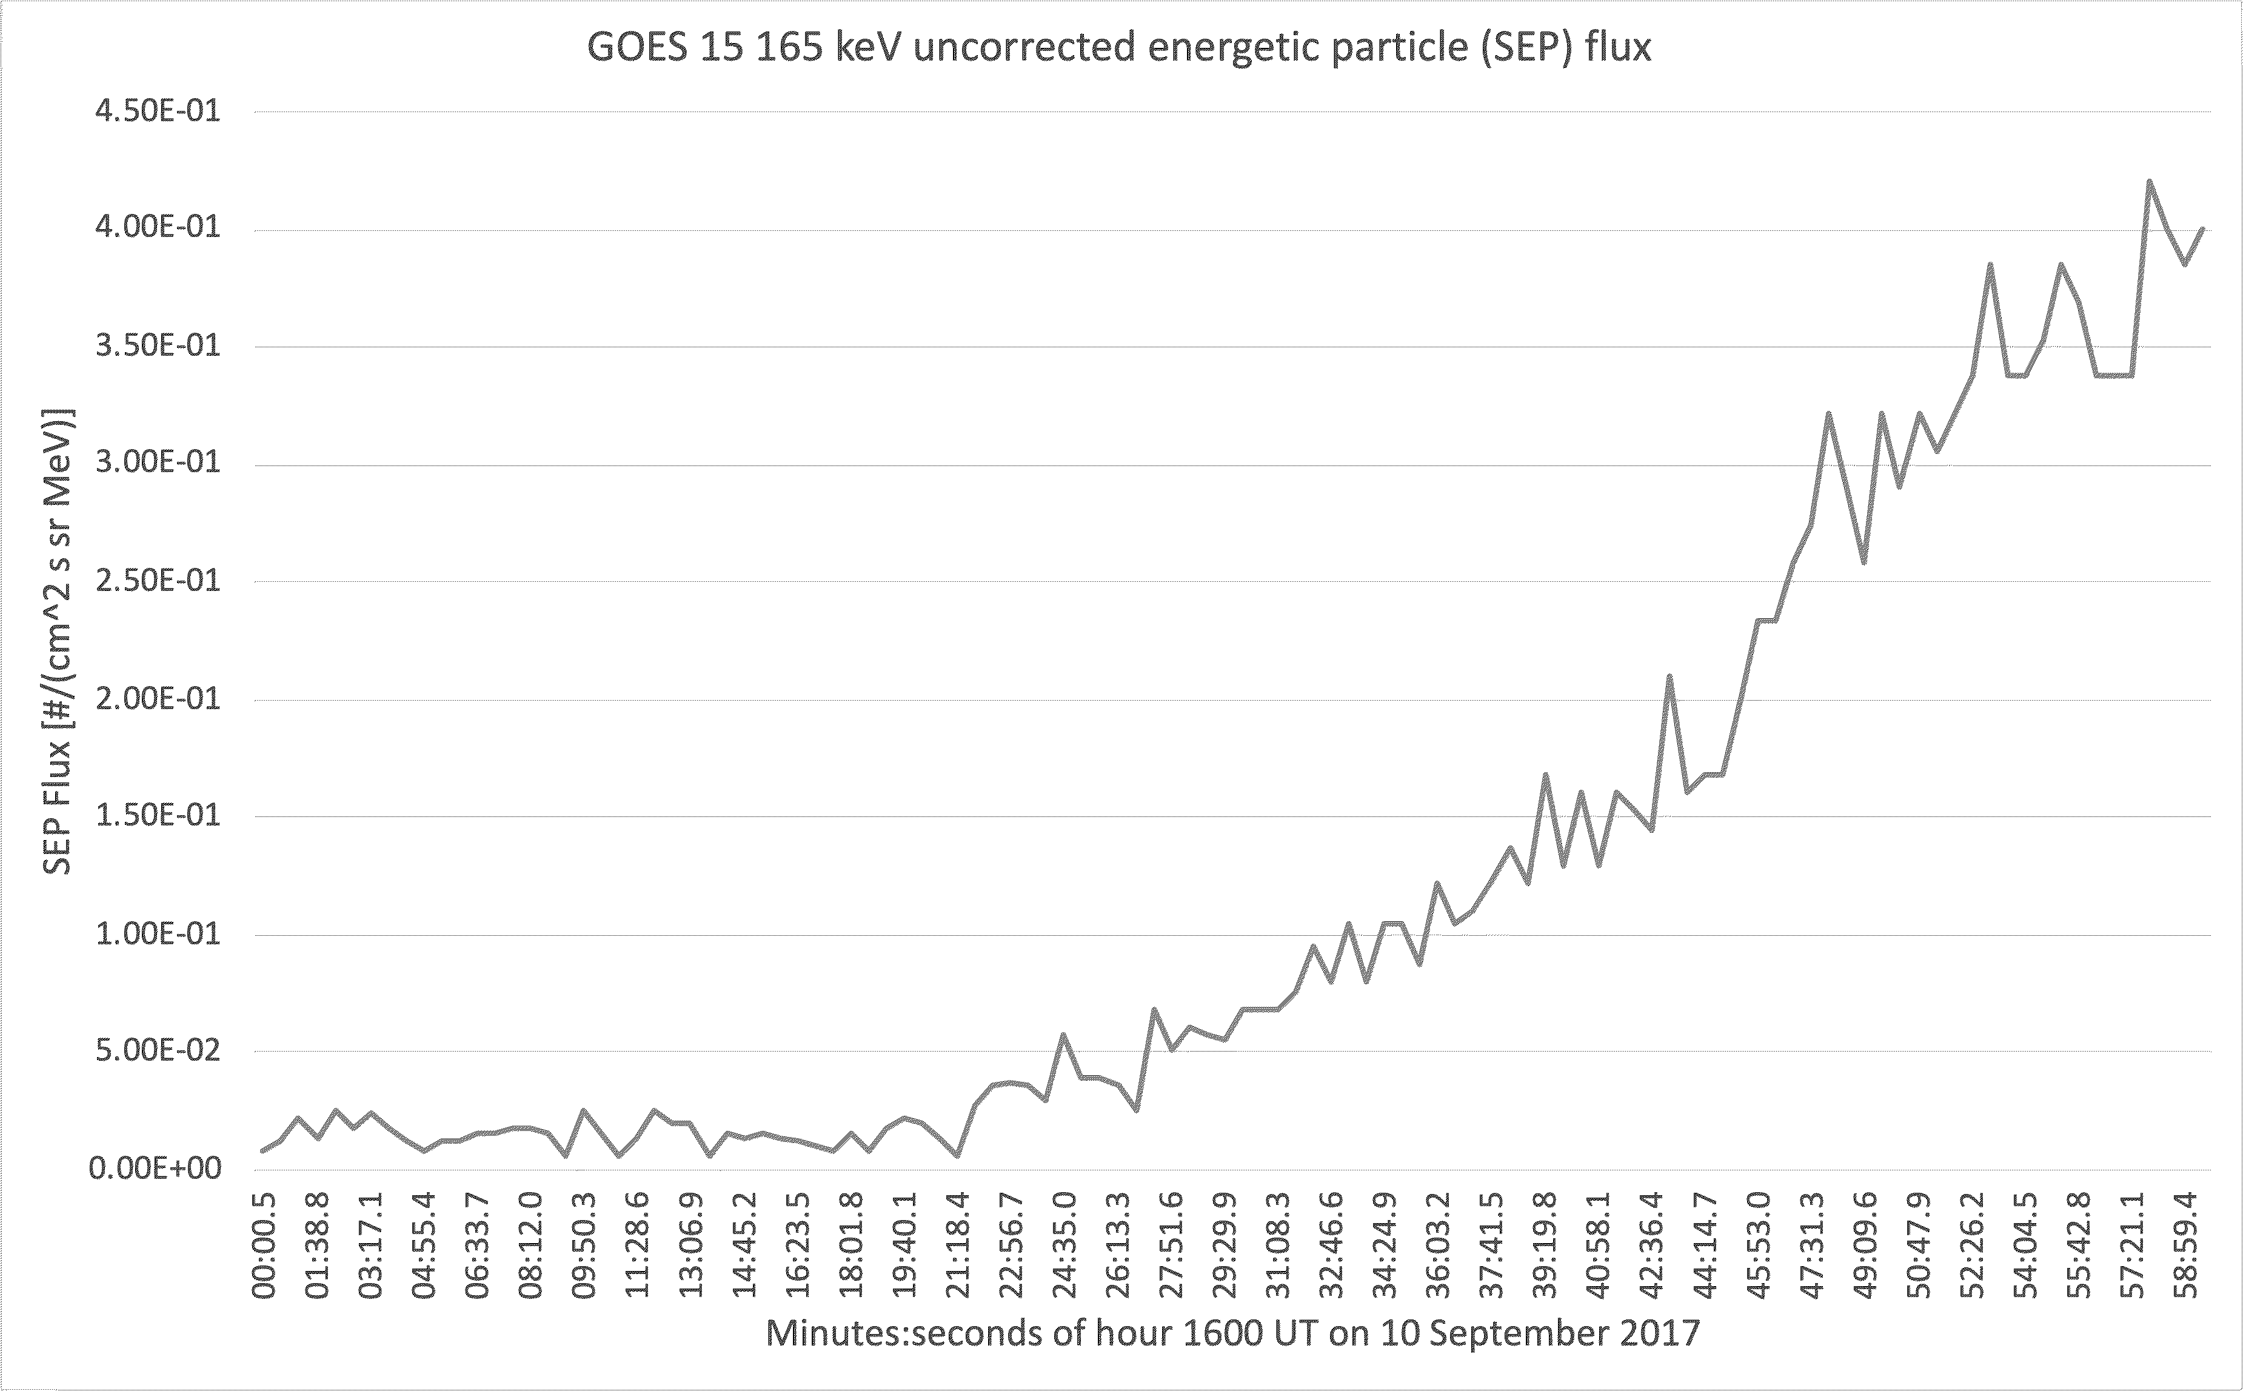

A. The above graph can be used to deduce—to within ± 1 minute—the earliest arrival of the 165-MeV protons at GOES. With your partners, carry out this analysis by doing the following:
- Estimate the background level of proton flux from the graph, and sketch a horizontal line on the graph to indicate this level.
- Sketch a smooth best-fit curve that you think best represents the proton flux recorded during the latter half of the hour between 16:00 UT and 17:00 UT.
- Identify where the best-fit curve intersects the line representing the background level of proton flux, and hence estimate at what time (± 1 minute UT) the 165-MeV protons arrived at GOES.

B. With your partners, discuss how the SOHO coronagraphs for this same time interval—images #2 through #6, specifically—corroborate the data shown in the graph.

(Hint: Although the CME itself first appears in image #3, what differences do you notice between images #3 and #4 that suggest that protons have already started to arrive at SOHO by image #4?)

Tracking the acceleration event of solar protons
For the rest of this tutorial, we will estimate where—that is, how many solar diameters from the Sun—the 165-MeV protons began to be accelerated by the CME shock wave.

A. With your partners, use (non-relativistic) kinetic energy ideas to determine the speed (relative to the Sun and Earth) of the 165-MeV protons. Express your answer in two ways, both (i) as a multiple of the speed of light, c, and (ii) in m/s.

NOTE: Use m_{p} = 938 MeV/c² as the mass of a proton, and c = 3.00 × 10⁸ m/s.

(i) as multiple of c:

(ii) in m/s:

B. We can assume to a good approximation that CME shock started to accelerate these protons when those protons were very near the Sun (that is, only a few solar diameters away from the Sun).
Use your results above and the evidence shown in the SOHO coronagraph images to determine the following quantities. By doing so, you and your partners will estimate how far from the Sun the high-energy protons were suddenly accelerated by the CME shock wave.

- Determine the approximate time interval for the 165-MeV protons to travel from the Sun to the Earth (and hence from the Sun to SOHO).

- Deduce the approximate time, in UT, at which the shock wave from the CME began to accelerate the solar protons.

- What would have been the (approximate) time stamp on a SOHO image (in UT) that would have captured the event of the solar protons being accelerated?
(Hint: The answer here is not the same as that from question 2 above…. Apply your findings from Sections I.B and I.C here.)

- Finally, you and your partners should find that one of the SOHO images in the image set has a time stamp that agrees to within 1 or 2 minutes of your result in question B.3 (on the preceding page). (Lucky us!)

Identify this image and use it to estimate the farthest extent of the CME shock wave at the time you determined in question #2 above. This result, expressed as a multiple of solar diameters away from the Sun, will describe approximate where the solar protons started to be accelerated by the CME shock wave.

Note: You should find that the shock wave accelerated the protons at a distance less than 4.0d from the (surface of the) Sun. The protons therefore traveled the vast majority of the distance between the Sun and Earth after having been accelerated by the shock wave!

