Lab: Energy in a Magnetic Field (and Solar Flares)

Description: The Next Generation Science Standards (NGSS) place great emphasis on the concept fields. At the high school level, students should gain an understanding that energy can be stored in fields. This understanding is essential for understanding solar flares and other aspects of energy transfer in the Sun. The sequence of activities in this laboratory activity leads students to construct an understanding of how energy is stored in fields through direct observation of magnetic field strengths and configurations for different orientations of the magnets. It relates those field strengths to the force exerted by the participant on the magnets to put them into that configuration. , and asks students to represent their understanding of energy flow through the use of pie charts and LOL diagrams. These activities lead to the conclusion that the amount of energy in the field is positively correlated with the magnitude of the field strength. Students use this idea to discuss a solar flare and to understand a 2020 scientific result regarding flare energy.

The lab activity is fully qualitative (the numerical value of the energy density of the field, $\frac{B^{2}}{2μ_{0}}$ in MKS units, is not addressed). This resource can be used to supplement Physics by Inquiry for physics teacher preparation and includes elements similar to those found in Ranking Tasks for Introductory Astronomy.

Purpose: This lesson was developed to promote understanding of:
- Energy flows into and out of magnetic fields.
- The relationship between field energy and field strength.

Prerequisite:
- Recognizes the general shape of a magnetic field for a dipole
- Understands force as a quantity with a direction (vector)
- Ensure that students are comfortable with the use of the Magna-AR app. Ensure that they visit https://www.magna-ar.net/ and familiarize themselves with the Tutorial.
- Teachers should read the “Additional Reading” for background information on magnetic reconnection.

Materials Required:
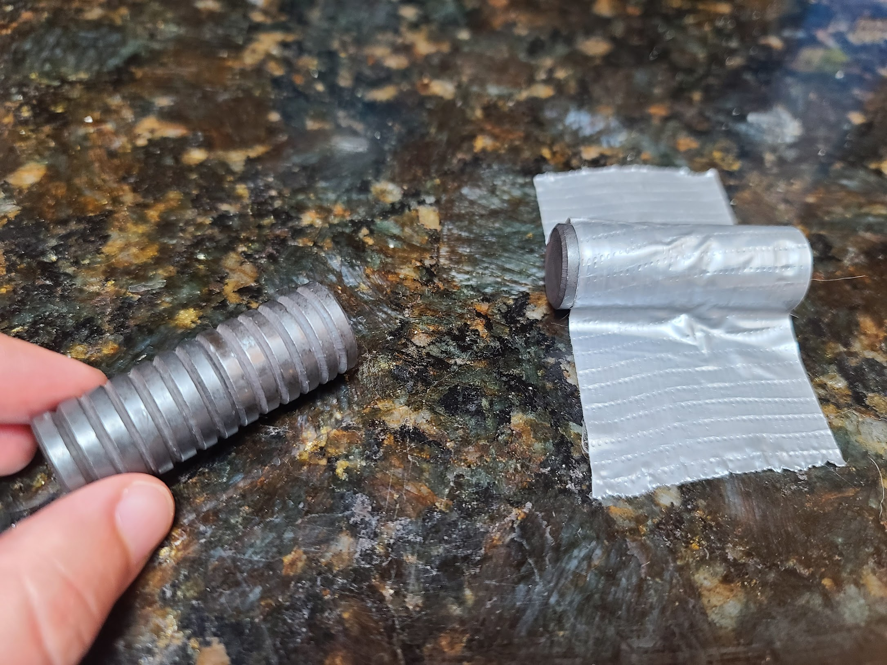
- Two stacks of ceramic button magnets taped together (“logs”) so that when the magnetometer on your smartphone is about 4 cm away from each log along the log, it reads approximately 2,000 microTesla (approximately 8-10 magnets).
- Duct tape
- Mobile devices to run Physics Toolbox Sensor Suite or Magna-AR app (available from Google Play and the Apple App store)
- Copies of this tutorial for students, with a separate document for the “Magnetic Field Change in a Solar Flare.”

NGSS Connections:
- High School Earth/Space Science: HS-ESS1-1
- High School Physical Science: HS-PS3-2
- High School Physical Science: HS-PS3-5
- Science and Engineering Practices: Developing and using models, analyzing and interpreting data
- Crosscutting Concepts: Cause and effect: Mechanism and explanation; Systems and system models; Energy and matter: Flows, cycles, and conservation

Part 1. Magnetic Field Magnitudes around Magnets
Place one stack of magnets on a flat surface. Use a smartphone with the Physics Toolbox Sensor Suite or Magna-AR app to investigate the magnitude of the magnetic field around the magnet. Note: Use the “Spheres” option inside of Settings → Visualization Settings for this activity.

- Where is the field the strongest? How do you know?

- Where is the field the weakest? How do you know?

Part 2. Forces and Magnetic Field Magnitudes for Different Arrangements of Magnetic Poles
- Hold two stacks of magnets with like poles facing each other (i.e., North and North, or South and South). Move them slowly toward each other until you feel a force on the magnet. Continue to move the magnets closer until they are approximately 2 cm apart. Describe how the force changes as the magnets get closer and closer to each other. Be as descriptive as possible.

- Tape the magnets to the table to keep them stationary and 2 cm apart, even though the repelling force may be strong. Use Physics Toolbox Sensor Suite or Magna-AR app to investigate the magnitude of the magnetic field in the region close to the gap between the magnets. What do you observe? How does the magnetic field magnitude near the gap compare with the field magnitude of a single magnetic pole without another nearby?

- Flip one of the stacks of magnets so that the opposite poles are facing one another (i.e., North and South). Move them slowly toward each other until you feel a force on the magnet. Continue to move the magnets until they are approximately 2 cm apart. What do you feel? Be as descriptive as possible.

- Tape the magnets to the table to keep them stationary, even though the attracting force may be strong. Use Physics Toolbox Sensor Suite or Magna-AR app to investigate the magnitude of the magnetic field in the region close to the gap between the magnets. What do you observe? How does the magnetic field magnitude near the gap compare with the field magnitude of a single magnetic pole without another nearby?

Part 3: Energy and the Magnitude of the Magnetic Field
Consider a physical system that includes your body and two stacks of magnets with the like poles pointing toward each other.

When you do work on a system by pushing the like poles together, chemical/potential energy that makes your muscles work is converted to allow your hands to exert a force on the magnets. Your hands cause the magnets to move (motion/kinetic) toward one another, until you come to a point when you are no longer moving and also no longer able to push them together any further.

- At the moment you can no longer push the magnets together any further, and your hands have stopped moving, you have expended chemical energy, and there is no more kinetic energy. What happened to the magnetic field magnitude in the region between the magnets? What has happened to the energy you expended? (Where did it “go”? Is there a different type of energy that we should now think about? How do you know?)

- Draw a series of qualitative pie charts below to show how the total energy of the system changes as you push the magnets together. Ensure that you label the appropriate forms of energy—such as chemical energy, kinetic energy, other types of energy—and that your results are consistent with your answer in A.

Magnets 10 cm apart. Pushing has not yet begun. | Hands begin to push and move magnets together. Magnets 5 cm apart. | Hands continue to push and move magnets together. Magnets 3 cm apart. | Hands continue to push magnets together. Magnets 2 cm apart. | Hands continue pushing but magnets are now staying 1 cm apart.

- Draw a series of qualitative pie charts below to show how the total energy of the system changes if your hands were to release the magnets (so that the magnets are now free to move on the tabletop). Ensure that you label the appropriate forms of energy, and that your results are consistent with your answer in A.

Hands push magnets together, but no longer moving. Magnets 1 cm apart. | After being released, magnets are 3 cm apart and still sliding across the table.

- How would this series of energy transformations be different for stacks of magnets attached by their opposing ends that were then separated by your hands, and then released?

Part 4: Magnetic Fields in the Sun and Magnetic Reconnection

Earth has a magnetic field, but so do many other planets and stars, including the Sun. In fact, magnetic fields are present throughout the universe, and our galaxy appears to have a large-scale galactic magnetic field. These magnetic fields are very important to the dynamics of objects and to the space environment in which they are located.

Our Sun is a prime example of the important role that magnetism plays in the cosmos. Solar activity, such as sunspots and solar flares, are fundamentally magnetic in origin. Solar flares are the biggest explosions in the solar system, and they can affect technological systems here on Earth.

Take a look at a video of a solar flare on the Sun taken by NASA’s Solar Dynamics Observatory on December 10, 2017. The images in the video were made using extreme ultraviolet light, which shows material with temperatures of a million degrees or more. As the flare releases magnetic energy, the surrounding material gets very hot and glows: : https://youtu.be/ybfAvEVpBMo.

- Given your previous investigations, as energy leaves the magnetic field of the Sun and converts it into heat, what should happen to the strength of the magnetic fields on the Sun? Why?

- Read “Magnetic Field Change in a Solar Flare.” Using the data from the New Jersey Institute of Science, what happens to the magnetic field strength of the solar flare over time? (Look at the data for the red and white points, in particular, and provide quantitative data to justify your response).

- Watch the video from NASA’s Magnetospheric Multiscale (MMS) mission to study the process in which solar flares release energy, called magnetic reconnection: https://www.youtube.com/watch?v=0vY4nDPrEKg. What would be the consequence for Earth and the universe if stars were unable to release their magnetic energy?

Magnetic Field Change in a Solar Flare

On December 10, 2017, the Sun produced an X-class flare (the strongest category). NASA’s Solar Dynamics Observatory captured an image of the flare.

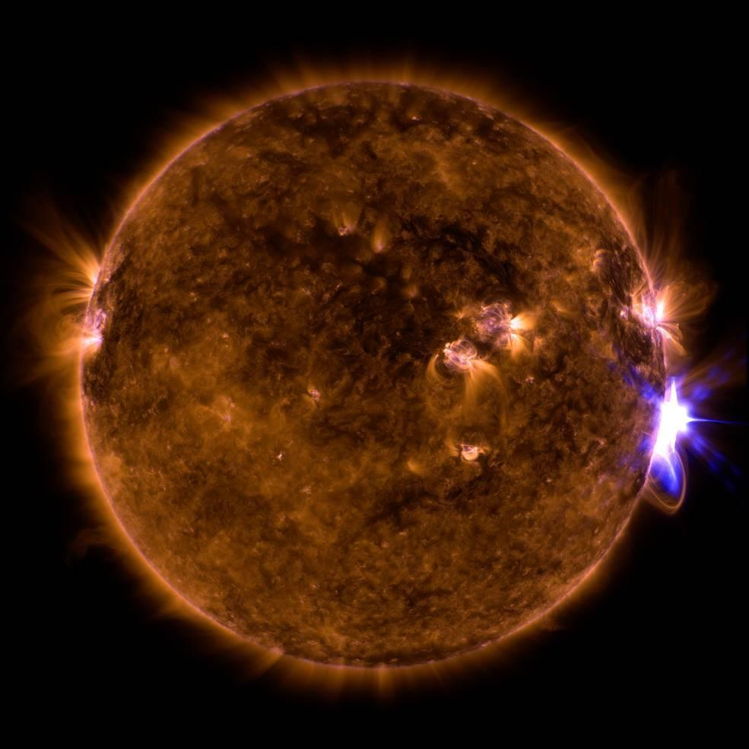
Image courtesy of NASA GSFC/SDO
https://www.nasa.gov/feature/goddard/2017/active-region-on-sun-continues-to-emit-solar-flares

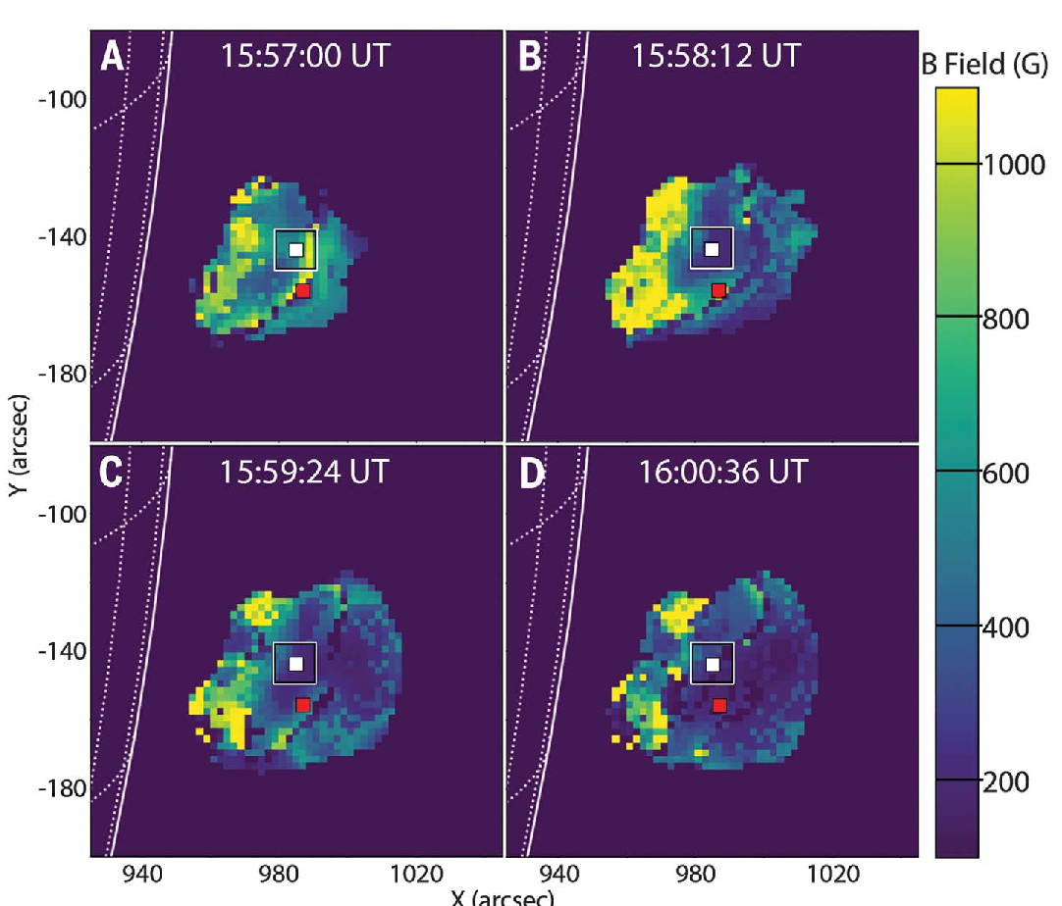
However, those were not the only observations. A scientific team from the New Jersey Institute of Technology used microwave observations from a telescope array to map the strength of the magnetic field from a small area corresponding to the solar flare that was released from the surface of the Sun. They published their results in the journal Science, in January 2020. To the right is the figure showing the magnetic field map.

The solar surface is indicated by the solid white line to the left of each image, and the strength of the magnetic field is color-coded according to the scale on the right-hand side of the figure. Each panel shows the time the image was taken (75s apart). The physical size of the image is much larger than the size of the Earth. The panels each have a red and white square on them.

The figure below shows the magnetic field strength at each of those positions with the red and white square as a function of time. The measurements at the red square are shown in red, while the measurements at the white square are in black. The vertical lines are the uncertainties in the measurements.

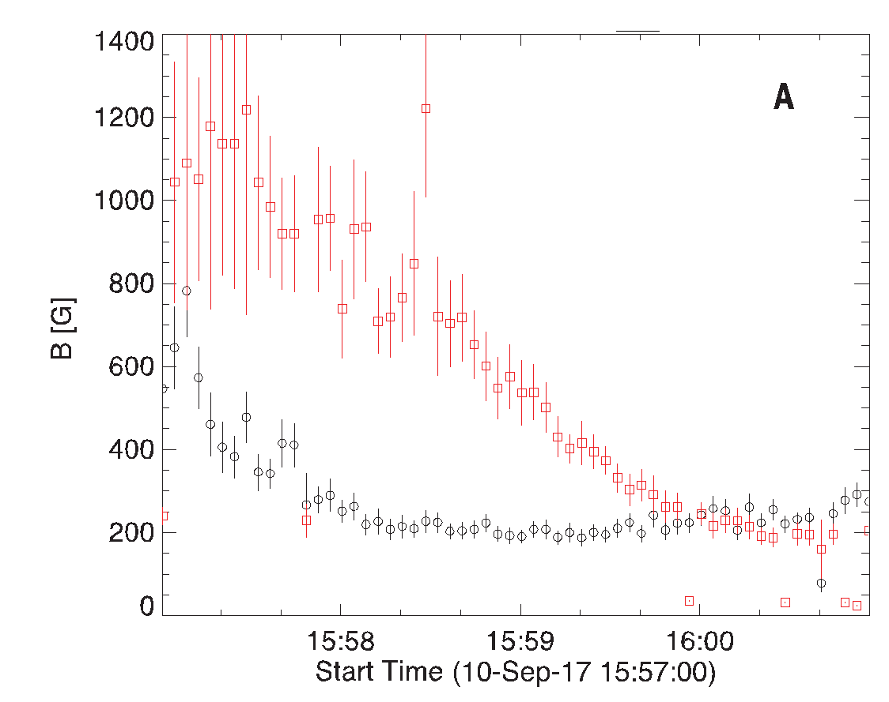
The scientific team was also able to calculate the amount of energy released into the plasma by the solar flare. Their calculations showed that the energy released by the observed reduction of the magnetic field strength was sufficient to power the flare. This is the first time such direct observations of the change in magnetic energy have been able to account for the actual energy released during a solar flare.

Reference

Fleishman, G. D., Gary, D. E., Chen, B., Kuroda, N., Yu, S., & Nita, G. M. (2020). Decay of the coronal magnetic field can release sufficient energy to power a solar flare. Science, 367(6475), 278-280.

Additional Reading

Just how does a magnetic field in space release its energy? This is a very complicated question, and the answer is important for understanding solar flares, why the solar corona is so much hotter than the solar surface, how energy from the solar wind is stored and released near Earth during magnetic storms, and even how many astrophysical systems and other stars behave.

One important thing to understand is that most of the visible matter in the universe is in the plasma state—it consists of electrically charged particles (mostly protons and electrons), not neutral atoms as we see on Earth. Plasmas are essentially perfect conductors since the charged particles are free to move. In practice, this means that the magnetic field and the plasma must move together, since any change in the magnetic field would produce an electric current in the plasma to cancel the change according to Faraday’s Law of induction. Thus, the magnetic field stays “frozen” into the plasma. As plasma moves and churns, like in the boiling convection in the upper layers of the Sun, the magnetic field gets twisted up and the strength increases, which means that the energy in the field increases. It is the plasma motion that is doing this work, strengthening the field, just as your hands do the work to strengthen the magnetic field when you push two like poles together or pull two unlike poles apart.

If you push two north poles together, you can just let go of the magnets and they will fly apart, releasing the energy in the magnetic field. But plasmas can’t “let go” of the magnetic field like that since the field moves with the plasma. Something else has to happen. Scientists call that something “magnetic reconnection,” which is a process that allows the magnetic field to break free of the plasma and relax to a lower energy configuration. Magnetic reconnection allows the energy stored in the solar magnetic field to be quickly released in a solar flare and it allows Earth’s magnetic field to become intertwined with the solar wind as it flows by, which also allows the energy from coronal mass ejections (huge clouds of plasma and magnetic field hurled into space by the Sun) to be transferred to Earth’s magnetosphere and ionosphere. This energy powers magnetic storms and changes in the space environment that we call space weather.

NASA created the Magnetospheric Multiscale (MMS) mission to study magnetic reconnection with a team of four spacecraft flying in close formation with the fastest measurements ever in flown in space. These very high-resolution measurements of the plasmas and fields in space are allowing scientists to understand details of magnetic reconnection that will help us understand many phenomena in the universe, as well as have practical uses for helping to predict space weather. Watch a video about this mission here: https://www.youtube.com/watch?v=0vY4nDPrEKg

If it were not for magnetic reconnection, then the energy stored in magnetic fields would just increase in time, since there would be no way to release it effectively or quickly. Stars would freeze as all of the energy of motion in the plasma that makes up the star was converted into magnetic energy. Scientists have known for some time that this process must occur, but there have been many questions about just how it works. The problem is that reconnection happens on very small scales compared to the size of the system. This means that it is really difficult to observe it in nature, and laboratory experiments just provide all the answers (there are many things, like black holes, the atmosphere of stars, and the highest energy cosmic rays, that scientists can’t make in a lab). The best place to observe magnetic reconnection directly turns out to be near-Earth space.

